Wet Torrefaction of Biomass Waste into Levulinic Acid and Hydrochar Using H-Beta Zeolite Catalyst

Andrii Kostyniukª∗, Blaž Likozar^{a,b,c,d}
ªDepartment of Catalysis and Chemical Reaction Engineering, National Institute of Chemistry, Hajdrihova 19, Ljubljana, 1001, Slovenia
^{b}Faculty of Polymer Technology, Slovenj Gradec 2380, Slovenia
^{c}Pulp and Paper Institute, Bogišićeva 8, Ljubljana 1000, Slovenia
^{d}Faculty of Chemistry and Chemical Technology, University of Ljubljana, Večna pot 113, Ljubljana 1000, Slovenia

Table S1
Composition of the wood cellulose pulp residue (WCPR).
Glucan (wt% dry) | Lignin AIL − ash | Lignin ASL | Ash | Total
62.26 | 30.90 | 0.14 | 1.4 | 94.7
Lignin AIL | Acid Insoluble Lignin
Lignin ASL | Acid Soluble Lignin

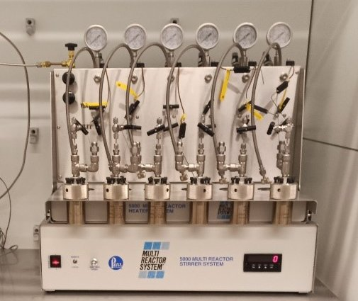
Fig. S1. Stainless steel (Parr) batch reactors utilized for WT of WCPR.

Table S2
Chemical analysis and structural properties of the H-Beta zeolite catalyst.
Catalyst | SiO₂/Al₂O₃  ratio | S_{BET}ª  (m²/g) | S_{micro}ª  (m²/g) | S_{meso}ª  (m²/g) | V_{micro}^{b}  (cm³/g) | V_{total}^{b}  (cm³/g) | V_{meso}^{b}  (cm³/g) | PD^{c}  (nm) | Average crystallite size^{d}  (nm) | Crystal size^{d}  (nm) | Particle size^{e}  (µm)
H-Beta | 28.0 | 548.9 | 441.2 | 107.7 | 0.232 | 0.321 | 0.089 | 5.2 | 16.7 | ≈500 | ≈3
ªBET method. ^{b}t-plot method. ^{c}PD − average pore diameter measured from the desorption branch according to the BJH method. ^{d}The crystallite size and relative crystallinity were calculated from the seven most intensive diffraction peaks of XRD spectra. ^{e}SEM analysis.

Table S3
Acid properties of the H-Beta zeolite catalyst.
Acid site density by NH₃-TPD (mmol_{NH3}/g_{cat}) |  |  |  | Diversity of acid sites by pyridine-DRIFTS (%)
Total | Weakª | Strong^{b} | Strong/Weak | BAS | LAS | BAS/LAS ratio
1.01 | 0.45 | 0.57 | 1.2 | 54.9 | 45.1 | 1.2
a − determined at average temperature T = 202.9 °C.
b − determined at average temperature T = 348.7 °C.
BAS − Brönsted acid sites.
LAS − Lewis acid sites.

Limitations of the proposed approach:

Experimental constraints. Our study was conducted under specific experimental conditions, such as temperature, pressure, amount of water, and catalyst loading. These conditions may not fully represent real-world scenarios, potentially limiting the generalizability of our findings.

Sensitivity to feedstock variation. The effectiveness of wet torrefaction and hydrochar production using H-Beta zeolite catalyst may vary depending on the composition and characteristics of the biomass feedstock. Our experiments focused on a particular type of biomass waste (WCPR), and the results may not be directly applicable to other feedstocks.

Catalyst stability, regeneration, and separation. Although H-Beta zeolite showed promising catalytic activity in our study, its long-term stability and potential for regeneration and separation were not extensively investigated. The durability of the catalyst under prolonged use and the feasibility of regeneration processes are important considerations for practical applications but were beyond the scope of our current work.

Quantifiable justification of potential process improvements:

Reduction of energy consumption. Our proposed wet torrefaction process offers significant potential for reducing energy consumption compared to traditional thermal treatment methods. By utilizing H-Beta zeolite catalyst, which enhances the conversion efficiency of biomass into valuable products like levulinic acid and hydrochar, we predict a significant reduction in energy requirements per unit of biomass processed.

Waste minimization. By converting biomass waste into valuable products such as levulinic acid and high-quality hydrochar, our process contributes to waste minimization and resource utilization. We expect a significant decrease in the generation of residual waste per unit of biomass processed, indicating the potential for significant waste reduction compared to landfill disposal or conventional incineration methods.

Sustainable solutions. The utilization of H-Beta zeolite catalyst represents a more sustainable solution for biomass conversion, as zeolites are abundant, naturally occurring materials with high catalytic activity and recyclability.

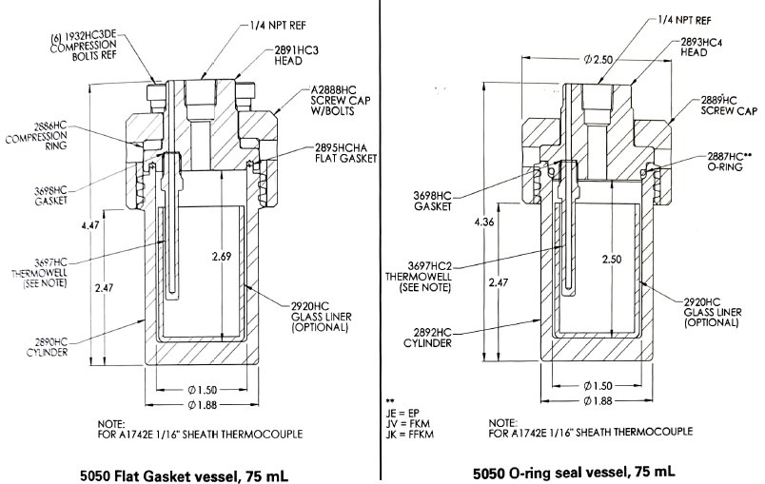
Fig. S2. 5050/5051 vessel body diagram, PTFE and O-ring seals.

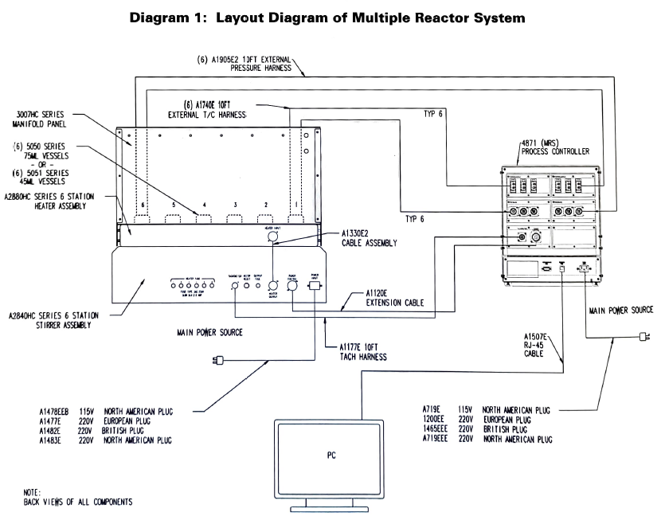
Fig. S3. Layout diagram of multiple reactor system.

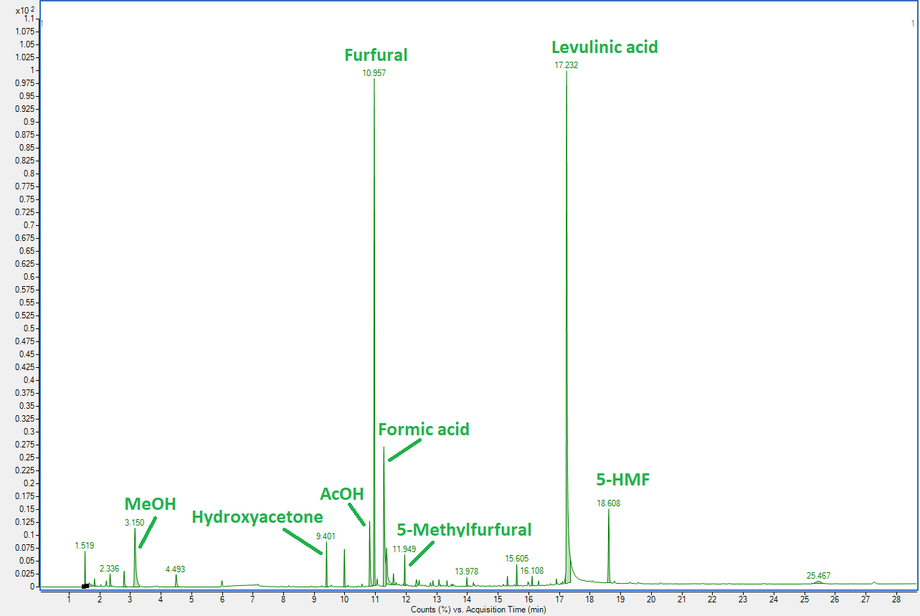
Fig. S4. The typical GC-MS spectra of liquid products after WT of WCPR in the presence of H-Beta zeolite catalyst.

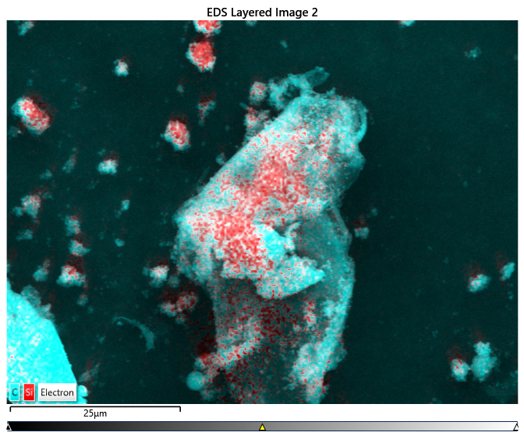
Fig. S5. EDS layered image of WT+Beta_260 after 30 min.

Table S4
Comparison of higher heating value (HHV) and ultimate composition of biochar from different precursor biomass types following wet torrefaction under optimal reaction conditions.
Biomass | T, °C | Time, min | Biomass-to-liquid ratio, g:g | HHV,  MJ/kg | Ultimate analysis (wt%) |  |  |  |  | Ref.
 |  |  |  |  | C | H | O | N | S | Ref.
Bamboo sawdust | ‒ | ‒ | ‒ | 17.7 | 49.2 | 6.6 | 43.1 | 0.4 |  | (Dai et al., 2017)
Bamboo sawdust | 230 | 30 | 1:10 | 20.8 | 53.4 | 6.2 | 40.2 | 0.1 |  | (Dai et al., 2017)
Rice husk | ‒ | ‒ | ‒ | 16.2 | 40.8 | 5.7 | 40.5 | 1.2 | ‒ | (Zhang et al., 2017)
Rice husk | 240 | 60 | 1:20 | 18.1 | 45.8 | 5.2 | 33.1 | 0.4 | ‒ | (Zhang et al., 2017)
Corn stalk | ‒ | ‒ | ‒ | 17.7 | 44.5 | 6.3 | 46.4 | 0.3 | ‒ | (X. Wang et al., 2018)
Corn stalk | 220 | 30 | 1:15 | 21.2 | 53.3 | 6.0 | 40.0 | 0.4 | ‒ | (X. Wang et al., 2018)
Bamboo sawdust | ‒ | ‒ | ‒ | 17.7 | 49.2 | 6.6 | 43.1 | 0.4 | ‒ | (Y. Wang et al., 2018)
Bamboo sawdust | 240 | 30 | 1:10 | 20.9 | 64.8 | 4.4 | 30.3 | 0.2 | ‒ | (Y. Wang et al., 2018)
Beech | ‒ | ‒ | ‒ | 17.4 | 44.9 | 5.0 | 40.9 | 0.1 | 0.04 | (Jian et al., 2019)
Beech | 200 | 10 | 1:20 | 19.1 | 48.9 | 5.4 | 40.9 | 0.2 | 0.03 | (Jian et al., 2019)
Wheat straw | ‒ | ‒ | ‒ | 17.1 | 45.0 | 4.6 | 37.6 | 0.6 | 0.1 | (Jian et al., 2019)
Wheat straw | 200 | 10 | 1:20 | 19.3 | 49.7 | 5.0 | 38.4 | 0.6 | 0.1 | (Jian et al., 2019)
Spruce | ‒ | ‒ | ‒ | 20.4 | 50.3 | 6.2 | 43.4 | 0.1 | <0.02 | (Bach et al., 2015)
Spruce | 225 | 30 | 1:5 | 23.0 | 57.0 | 5.9 | 37.1 | 0.1 | <0.02 | (Bach et al., 2015)
Birch | ‒ | ‒ | ‒ | 20.0 | 48.9 | 6.4 | 44.6 | 0.1 | <0.02 | (Bach et al., 2015)
Birch | 225 | 30 | 1:5 | 22.9 | 56.9 | 5.9 | 42.6 | 0.1 | <0.02 | (Bach et al., 2015)
Olive trimmings | ‒ | ‒ | ‒ | 19.8 | 48.3 | 6.1 | 40.0 | 1.5 | ‒ | (Volpe and Fiori, 2017)
Olive trimmings | 250 | 30 | 1:10 | 27.2 | 60.3 | 6.3 | 28.2 | 1.8 | ‒ | (Volpe and Fiori, 2017)
Olive pulp | ‒ | ‒ | ‒ | 21.7 | 50.3 | 5.8 | 39.2 | 1.6 | ‒ | (Volpe and Fiori, 2017)
Olive pulp | 250 | 30 | 1:10 | 27.6 | 62.9 | 6.3 | 24.8 | 1.7 | ‒ | (Volpe and Fiori, 2017)
Eucalyptus bark | ‒ | ‒ | ‒ | 18.1 | 45.2 | 6.4 | 48.4 | ‒ | ‒ | (Gao et al., 2016)
Eucalyptus bark | 300 | 120 | 1:10 | 28.9 | 72.7 | 5.1 | 22.2 | ‒ | ‒ | (Gao et al., 2016)
Palm oil empty fruit bunches | ‒ | ‒ | ‒ | 19.5 | 48.3 | 6.7 | 43.7 | 1.0 | 0.3 | (Parshetti et al., 2013)
Palm oil empty fruit bunches | 350 | 30 | 1:6.7 | 27.2 | 66.0 | 4.2 | 28.4 | 1.1 | 0.3 | (Parshetti et al., 2013)
Grape pomace | ‒ | ‒ | ‒ | 20.0 | 49.1 | 6.3 | 42.3 | 2.3 | ‒ | (Pala et al., 2014)
Grape pomace | 275 | 30 | 1:4 | 28.3 | 68.3 | 5.9 | 23.5 | 2.3 | ‒ | (Pala et al., 2014)
Wheat straw | ‒ | ‒ | ‒ | 17.6 | 45.0 | 5.7 | 44.6 | 0.4 | 0.4 | (Ma et al., 2018)
Wheat straw | 240 | 60 | 1:10 | 23.9 | 60.7 | 5.6 | 29.5 | 0.6 | 0.4 | (Ma et al., 2018)
Dried olive pomace | ‒ | ‒ | ‒ | 22.5 | 53.5 | 6.8 | 38.6 | 1.1 | ‒ | (Missaoui et al., 2017)
Dried olive pomace | 250 | 30 | 1:6 | 27.6 | 67.8 | 6.5 | 24.3 | 1.4 | ‒ | (Missaoui et al., 2017)
WCPR | ‒ | ‒ | ‒ | 20.1 | 48.3 | 6.2 | 40.3 | 0.1 | 0.5 | This study
WT+Beta_220 | 220 | 30 | 1:10 | 30.3 | 78.9 | 3.4 | 12.0 | 0.1 | 0.1 | This study

Regarding the future development of wet torrefaction of wood cellulose pulp residue in the presence of a catalyst, we would like to propose the following suggestions:

Further optimization: Consider exploring additional parameters or conditions to optimize the process further. This could include variations in catalyst loading, reaction time, temperature, or the use of different catalyst materials.
Product characterization: Conduct more in-depth characterization studies on the obtained products to better understand their properties and potential applications.
Scale-up studies: Evaluate the scalability of the process and its feasibility for industrial applications. Conduct pilot-scale experiments to assess the reproducibility and efficiency of the developed strategy on a larger scale.
Byproduct utilization: Investigate opportunities for utilizing byproducts or waste streams generated during the process. This could involve valorization approaches to convert these byproducts into valuable chemicals or materials.
Techno-economic analysis: Perform a techno-economic analysis to assess the economic viability and competitiveness of the developed strategy compared to existing biomass conversion technologies.

By addressing these aspects, the future development of the investigation can be guided towards enhancing the efficiency, sustainability, and practical applicability of the proposed strategy.

Deoxygenation (DO) involves the removal of oxygen from biomass-derived feedstocks. This process is prioritized first due to several reasons:
- Oxygen content in biomass feedstocks is often relatively high compared to other elements such as carbon and hydrogen.
- Oxygen is a major contributor to the formation of undesired oxygen-containing compounds during biomass conversion processes, which can lead to issues such as increased viscosity, instability, and undesired by-products.
- Removing oxygen early in the sequence can improve the quality of the final products, such as biofuels or chemicals, by reducing the oxygen content and enhancing their energy density and stability.
- From an environmental perspective, reducing oxygen content can lead to lower emissions of pollutants during combustion or gasification processes, thereby improving air quality and reducing environmental impact.

Dehydrogenation (DH) involves the removal of hydrogen from biomass-derived feedstocks. It is prioritized second in the sequence for the following reasons:
- While hydrogen content in biomass feedstocks is lower than oxygen, it still contributes to the formation of undesired products such as water during biomass conversion processes.
- Dehydrogenation can help reduce the moisture content in biomass-derived feedstocks, improving their energy content and stability.
- By removing hydrogen early in the sequence, the potential for undesired side reactions, such as hydrolysis or water-gas shift reactions, can be minimized, leading to higher product yields and selectivity.
Decarbonization (DC) involves the removal of carbon from biomass-derived feedstocks. It is prioritized last in the sequence due to the following considerations:

- Carbon is the primary component of biomass feedstocks and serves as the main source of energy and carbonaceous products during biomass conversion processes.
- Decarbonization is typically associated with more energy-intensive and complex processes compared to deoxygenation and dehydrogenation.
- Prioritizing decarbonization last allows for the efficient utilization of carbonaceous intermediates and by-products generated during earlier stages of element removal.
- From an industrial perspective, decarbonization may involve processes such as carbonization, gasification, or pyrolysis, which require specialized equipment and may produce carbon-rich products such as biochar or syngas for further processing or utilization.

Overall, the prioritized sequence of element removal (DO > DH > DC) is designed to optimize the efficiency, selectivity, and environmental performance of biomass conversion processes. By systematically addressing each element in the sequence, it is possible to tailor the process conditions and parameters to maximize product yields, quality, and sustainability.

References

Bach, Q.V., Tran, K.Q., Skreiberg, Ø., Trinh, T.T., 2015. Effects of wet torrefaction on pyrolysis of woody biomass fuels. Energy 88, 443–456. https://doi.org/10.1016/j.energy.2015.05.062
Dai, L., He, C., Wang, Y., Liu, Y., Yu, Z., Zhou, Y., Fan, L., Duan, D., Ruan, R., 2017. Comparative study on microwave and conventional hydrothermal pretreatment of bamboo sawdust: Hydrochar properties and its pyrolysis behaviors. Energy Convers. Manag. 146, 1–7. https://doi.org/10.1016/j.enconman.2017.05.007
Gao, P., Zhou, Y., Meng, F., Zhang, Y., Liu, Z., Zhang, W., Xue, G., 2016. Preparation and characterization of hydrochar from waste eucalyptus bark by hydrothermal carbonization. Energy 97, 238–245. https://doi.org/10.1016/j.energy.2015.12.123
Jian, J., Lu, Z., Yao, S., Li, X., Song, W., 2019. Comparative Study on Pyrolysis of Wet and Dry Torrefied Beech Wood and Wheat Straw. Energy and Fuels 33, 3267–3274. https://doi.org/10.1021/acs.energyfuels.8b04501
Ma, Q., Han, L., Huang, G., 2018. Effect of water-washing of wheat straw and hydrothermal temperature on its hydrochar evolution and combustion properties. Bioresour. Technol. 269, 96–103. https://doi.org/10.1016/j.biortech.2018.08.082
Missaoui, A., Bostyn, S., Belandria, V., Cagnon, B., Sarh, B., Gökalp, I., 2017. Hydrothermal carbonization of dried olive pomace: Energy potential and process performances. J. Anal. Appl. Pyrolysis 128, 281–290. https://doi.org/10.1016/j.jaap.2017.09.022
Pala, M., Kantarli, I.C., Buyukisik, H.B., Yanik, J., 2014. Hydrothermal carbonization and torrefaction of grape pomace: A comparative evaluation. Bioresour. Technol. 161, 255–262. https://doi.org/10.1016/j.biortech.2014.03.052
Parshetti, G.K., Kent Hoekman, S., Balasubramanian, R., 2013. Chemical, structural and combustion characteristics of carbonaceous products obtained by hydrothermal carbonization of palm empty fruit bunches. Bioresour. Technol. 135, 683–689. https://doi.org/10.1016/j.biortech.2012.09.042
Volpe, M., Fiori, L., 2017. From olive waste to solid biofuel through hydrothermal carbonisation: The role of temperature and solid load on secondary char formation and hydrochar energy properties. J. Anal. Appl. Pyrolysis 124, 63–72. https://doi.org/10.1016/j.jaap.2017.02.022
Wang, X., Wu, J., Chen, Y., Pattiya, A., Yang, H., Chen, H., 2018. Comparative study of wet and dry torrefaction of corn stalk and the effect on biomass pyrolysis polygeneration. Bioresour. Technol. 258, 88–97. https://doi.org/10.1016/j.biortech.2018.02.114
Wang, Y., Wu, Q., Dai, L., Zeng, Z., Liu, Y., Ruan, R., Fu, G., Yu, Z., Jiang, L., 2018. Co-pyrolysis of wet torrefied bamboo sawdust and soapstock. J. Anal. Appl. Pyrolysis 132, 211–216. https://doi.org/10.1016/j.jaap.2018.02.012
Zhang, S., Chen, T., Xiong, Y., Dong, Q., 2017. Effects of wet torrefaction on the physicochemical properties and pyrolysis product properties of rice husk. Energy Convers. Manag. 141, 403–409. https://doi.org/10.1016/j.enconman.2016.10.002

∗Corresponding authors: E-mail address: andrii.kostyniuk@ki.si (Andrii Kostyniuk)

