Supplementary Information

Dry torrefaction of biomass waste into high-energy biochar and selective formation of levoglucosenone and 1,4:3,6-dianhydro-α-D-glucopyranose

Andrii Kostyniuk∗, Blaž Likozar
Department of Catalysis and Chemical Reaction Engineering, National Institute of Chemistry, Hajdrihova 19, Ljubljana, 1001, Slovenia

S2.1. Materials

All chemical reactants, calibration standards, and gases were procured commercially and used as received without the need for further purification. The specific chemicals and their respective sources are as follows: 5-hydroxymethylfurfural (>97 wt%, Carbosynth, reference number FH10853), 5-methylfurfural (99 wt%, Sigma Aldrich), furfural (>99 wt%, Sigma Aldrich), ethanol (>99.8%, Sigma Aldrich), methanol (>99.9%, Sigma Aldrich), hydroxyacetone (99.5%, Sigma Aldrich), levulinic acid (99.5%, Sigma Aldrich), guaiacol (99.5%, Sigma Aldrich), 2,3-butanedione (99%, Sigma Aldrich), phenol (≥98.5%, Sigma Aldrich), 2-butanone (99.5%, Sigma Aldrich), acetone (>99.5%, Sigma Aldrich), acetoin (>99.5%, Sigma Aldrich), acetic acid (>99.7%, Sigma Aldrich), cyclopentenone (>99%, Sigma Aldrich), acetylacetone (>99%, Sigma Aldrich), 2,5-hexanedione (>99.5%, Sigma Aldrich), hydrogen (5.0, Messer, Germany), nitrogen (5.0, Messer, Germany), helium (5.0 Messer, Germany). The feedstock, denoted as WCPR ‒ wood cellulose pulp residue, was obtained from the biotechnology company Vertoro (Geleen, Netherlands), and its composition is detailed in Table S1.

Table S1. Composition of the wood cellulose pulp residue (WCPR)
Glucan (wt% dry) | Lignin AIL − ash | Lignin ASL | Ash | Total
62.26 | 30.90 | 0.14 | 1.4 | 94.7
Lignin AIL | Acid Insoluble Lignin
Lignin ASL | Acid Soluble Lignin

In the acid solvolysis process, biomass is treated with sulfuric acid to break down its structure and facilitate the conversion process. Following this, the crude lignin oil still contains sulfuric acid, which is neutralized using calcium carbonate to prevent any residual acidity from affecting downstream processing or product stability. Additionally, the lignocellulose filter residue undergoes a methanol wash to remove any remaining soluble components. However, a potential concern arises regarding the efficiency of the washing step. It is conceivable that traces of sulfuric acid could remain trapped within the lignocellulosic matrix, particularly in regions where accessibility to the washing solvent is limited. This could lead to localized acidity in the final residue, which may influence subsequent processing steps. Specifically, the residual acid could act as a catalytic site during the conversion of WCPR to LGO. If this is the case, the presence of trapped acid may contribute to reaction kinetics, potentially enhancing LGO formation without requiring additional acid catalysts. Further investigation into the extent of acid retention and its catalytic role could provide valuable insights for optimizing both the solvolysis and conversion processes.

S2.2. Analysis

N₂ adsorption at liquid nitrogen temperatures (77 K) was conducted using a Micromeritics micropore analyzer (Micromeritics ASAP 2020 instrument) to determine the BET surface area of both the raw and WT samples. Prior to conducting measurements, all samples (approximately 0.1 g) were degassed under vacuum at 110 °C for 12 h. High-resolution scanning electron microscopy (HR SEM) analysis of WCPR and WT WCPR samples was conducted using a FE-SEM SUPRA 35-VP instrument manufactured by Carl Zeiss. Carbon, hydrogen, nitrogen, and sulfur contents were determined using a CHNS elemental analyzer vario EL cube (Elementar, Hanau, Germany) operating in CHNS mode and using a thermal conductivity detector to determine carbon, hydrogen, and nitrogen, while an infrared detector was used to determine sulfur content. The instrument was calibrated with a low level N- and S- contents standard (67.65% C, 4.95% H, 0.72% N, 0.84% S) available from Elementar. The combustion and reduction tubes were set to 1150 and 850 °C, respectively. Finally, the CHNOS content was assessed on a dry basis by subtracting the water content.
O = 100% ‒ C% ‒ H% ‒ N% ‒ S% ‒ moisture% ‒ ash% (1)
X ray diffraction (XRD) was carried out using a powder X-ray diffraction detector PANalytical XpertPro instrument) using CuKα1 radiation (1.54056 Ǻ) at 45 kV and 40 mA in the scanning range of 5° to 50° with a step of 0.033°. In order to examine the impact of WT on the overall crystalline structure of the feedstock, the crystallinity index (CI) was computed using the Segal method [1]. The calculation involved determining the intensities of the (200) plane (I₂₀₀) at 2θ = 22.4° and the amorphous regions (I_{am}) at 2θ = 18.0° which is the minimum between the 200 and 110 peaks [2,3].
CI = ((I₂₀₀‒I_{am})/I₂₀₀) × 100% (2)
The crystallite size (CS) was evaluated using the Scherrer equation [4].
CS = (κ × λ)/(β × cosθ) (3)
where κ is Scherrer constant (0.90), λ is the X-ray wavelength (0.15406 nm), β is the full width at half maximum (FWHM) of (200) peak, and θ is diffraction angle of (200) plane [5].
Investigation of the pyrolysis of raw material and WT samples was conducted using a TGA-IR (thermogravimetric analysis-infrared spectrometry) Spectrum 3 with EGA 4000 from PerkinElmer. Each test utilized approximately 10 mg of sample, and the heating process involved raising the temperature from 40 to 750 °C at a rate of 10 °C/min. A carrier gas of nitrogen with a purity exceeding 99.999% was employed, with a flow rate of 20 mL/min. The computer automatically recorded the experimental results obtained from TGA.
The moisture, volatile matter, fixed carbon, and ash content of the raw and WT wood cellulose pulp residue were determined using proximate analysis method and a thermal gravimetric analyzer (Spectrum 3 with EGA 4000 from PerkinElmer) [6,7]. For this analysis, approximately 10 mg of the sample was subjected to a heating process in a nitrogen environment, starting from 40 °C and reaching 120 °C, with a 10 min hold to measure the moisture content (M, %). Next, a heating rate of 50 °C/min was programmed until 800 °C, and a 20 min hold was employed to measure the volatile matter (VM, %). To determine the ash content (Ash, %), the cooling process commenced with a cooling rate of ‒50 °C/min until 450 °C was reached, at which point the flue gas was replaced with air. Subsequently, a new heating ramp of 25 °C/min was initiated until 800 °C, and then maintained isothermally for 3 min. The fixed carbon content (FC, %) was calculated by taking the difference using the equation:
FC = 100 ‒ (M + Ash + VM). (4)
Equation 5 was used to calculate the higher heating value (HHV) for both the WCPR and DT WCPR [8].

HHV (MJ/kg) = 0.3491×C + 1.1783×H – 0.1034×O + 0.1005×S – 0.0151×N – 0.0211×A (5)

In Equation 5, C, H, O, S, N and A represent the carbon, hydrogen, oxygen, sulfur, nitrogen, and ash contents, respectively, obtained from the elemental analysis and expressed as weight percentages on a dry basis. The use of these equations enables the calculation of both the higher and lower heating values of the biomass. This, in turn, offers a comprehensive understanding of the energy properties of the biomass during torrefaction conditions.
The formulas used to calculate the solid yield and energy yield of the torrefied samples were as follows:
Y_{solid} = (m_{poduct}/m_{feedstock}) × 100% (6)
Y_{energy} = ((Y_{solid} × HHV_{product})/HHV_{feedstock}) × 100% = Y_{solid} × Enhancement factor (7)
where Y_{solid} and Y_{energy} refer to the solid yield and energy yield, respectively. m_{feedstock} and m_{product} indicate the mass of the initial samples and solid product after torrefaction, respectively. HHV_{feedstock} and HHV_{product} represent the higher heating value (in kJ/kg) of the original samples and solid product after torrefaction, respectively [9].
Enhancement factor was defined as follows [10]:
Enhancement factor = HHV_{product}/HHV_{feedstock} (8)
Carbon yield (Y_{C}) and hydrogen yield (Y_{H}) were calculated as follow [11]:
Y_{C} (%) = Y_{solid} (%) × (C_{product}/C_{feedstock}) (9)
Y_{H} (%) = Y_{solid} (%) × (H_{product}/H_{feedstock}) (10)
where C_{product}, H_{product} and C_{feedstock}, H_{feedstock} are the dry ash free carbon and hydrogen content of the WT and raw samples, respectively.
Decarbonization (DC), dehydrogenation (DH), and deoxygenation (DO) or oxygen removal efficiency (ORE) are three measures used to quantify the mass losses of carbon, hydrogen, and oxygen in biomass during torrefaction [10]. DC represents the percentage of carbon loss in the biomass due to WT and can be determined using the following formula:
DC (%) = 100‒Y_{solid} (%) × (C_{product}/C_{feedstock}) (11)
DH and DO can be similarly calculated using the same procedure as DC.
DH (%) = 100‒Y_{solid} (%) × (H_{product}/H_{feedstock}) (12)
DO (%) = 100‒Y_{solid} (%) × (O_{product}/O_{feedstock}) (13)
where O_{product} and O_{feedstock} are the dry ash free oxygen content of the WT and raw samples, respectively.
Ash removal efficiency (ARE) was calculated as follow:
ARE (%) = 100‒Y_{solid} (%) × (A_{product}/A_{feedstock}) (14)
where A_{product} and A_{feedstock} are the dry ash content of the WT and raw samples, respectively.
A metric referred to as carbon enrichment (CE), used to assess the degree of carbonization in WT of WCPR, is defined as follows:
CE = C_{product}/C_{feedstock} (15)

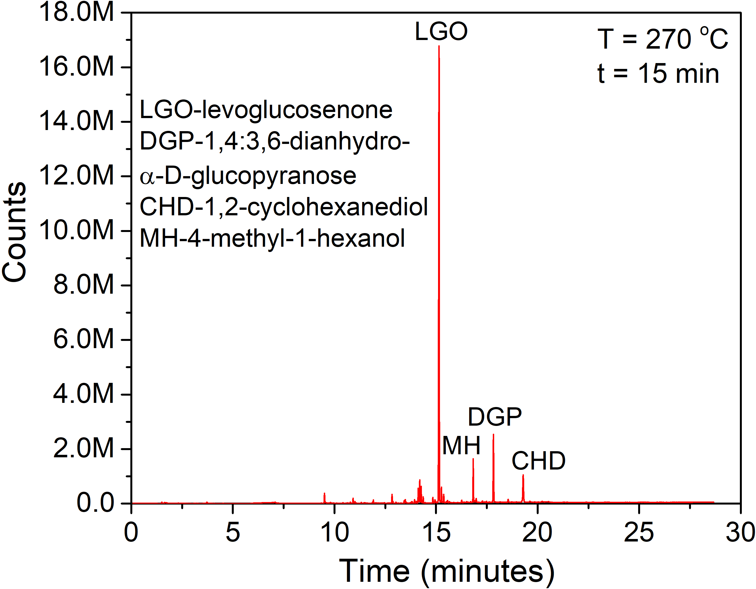
Fig. S1. GC-MS spectra of the liquid product mixture after DT of WCPR at 270 °C for 15 min.

(a) | (b)
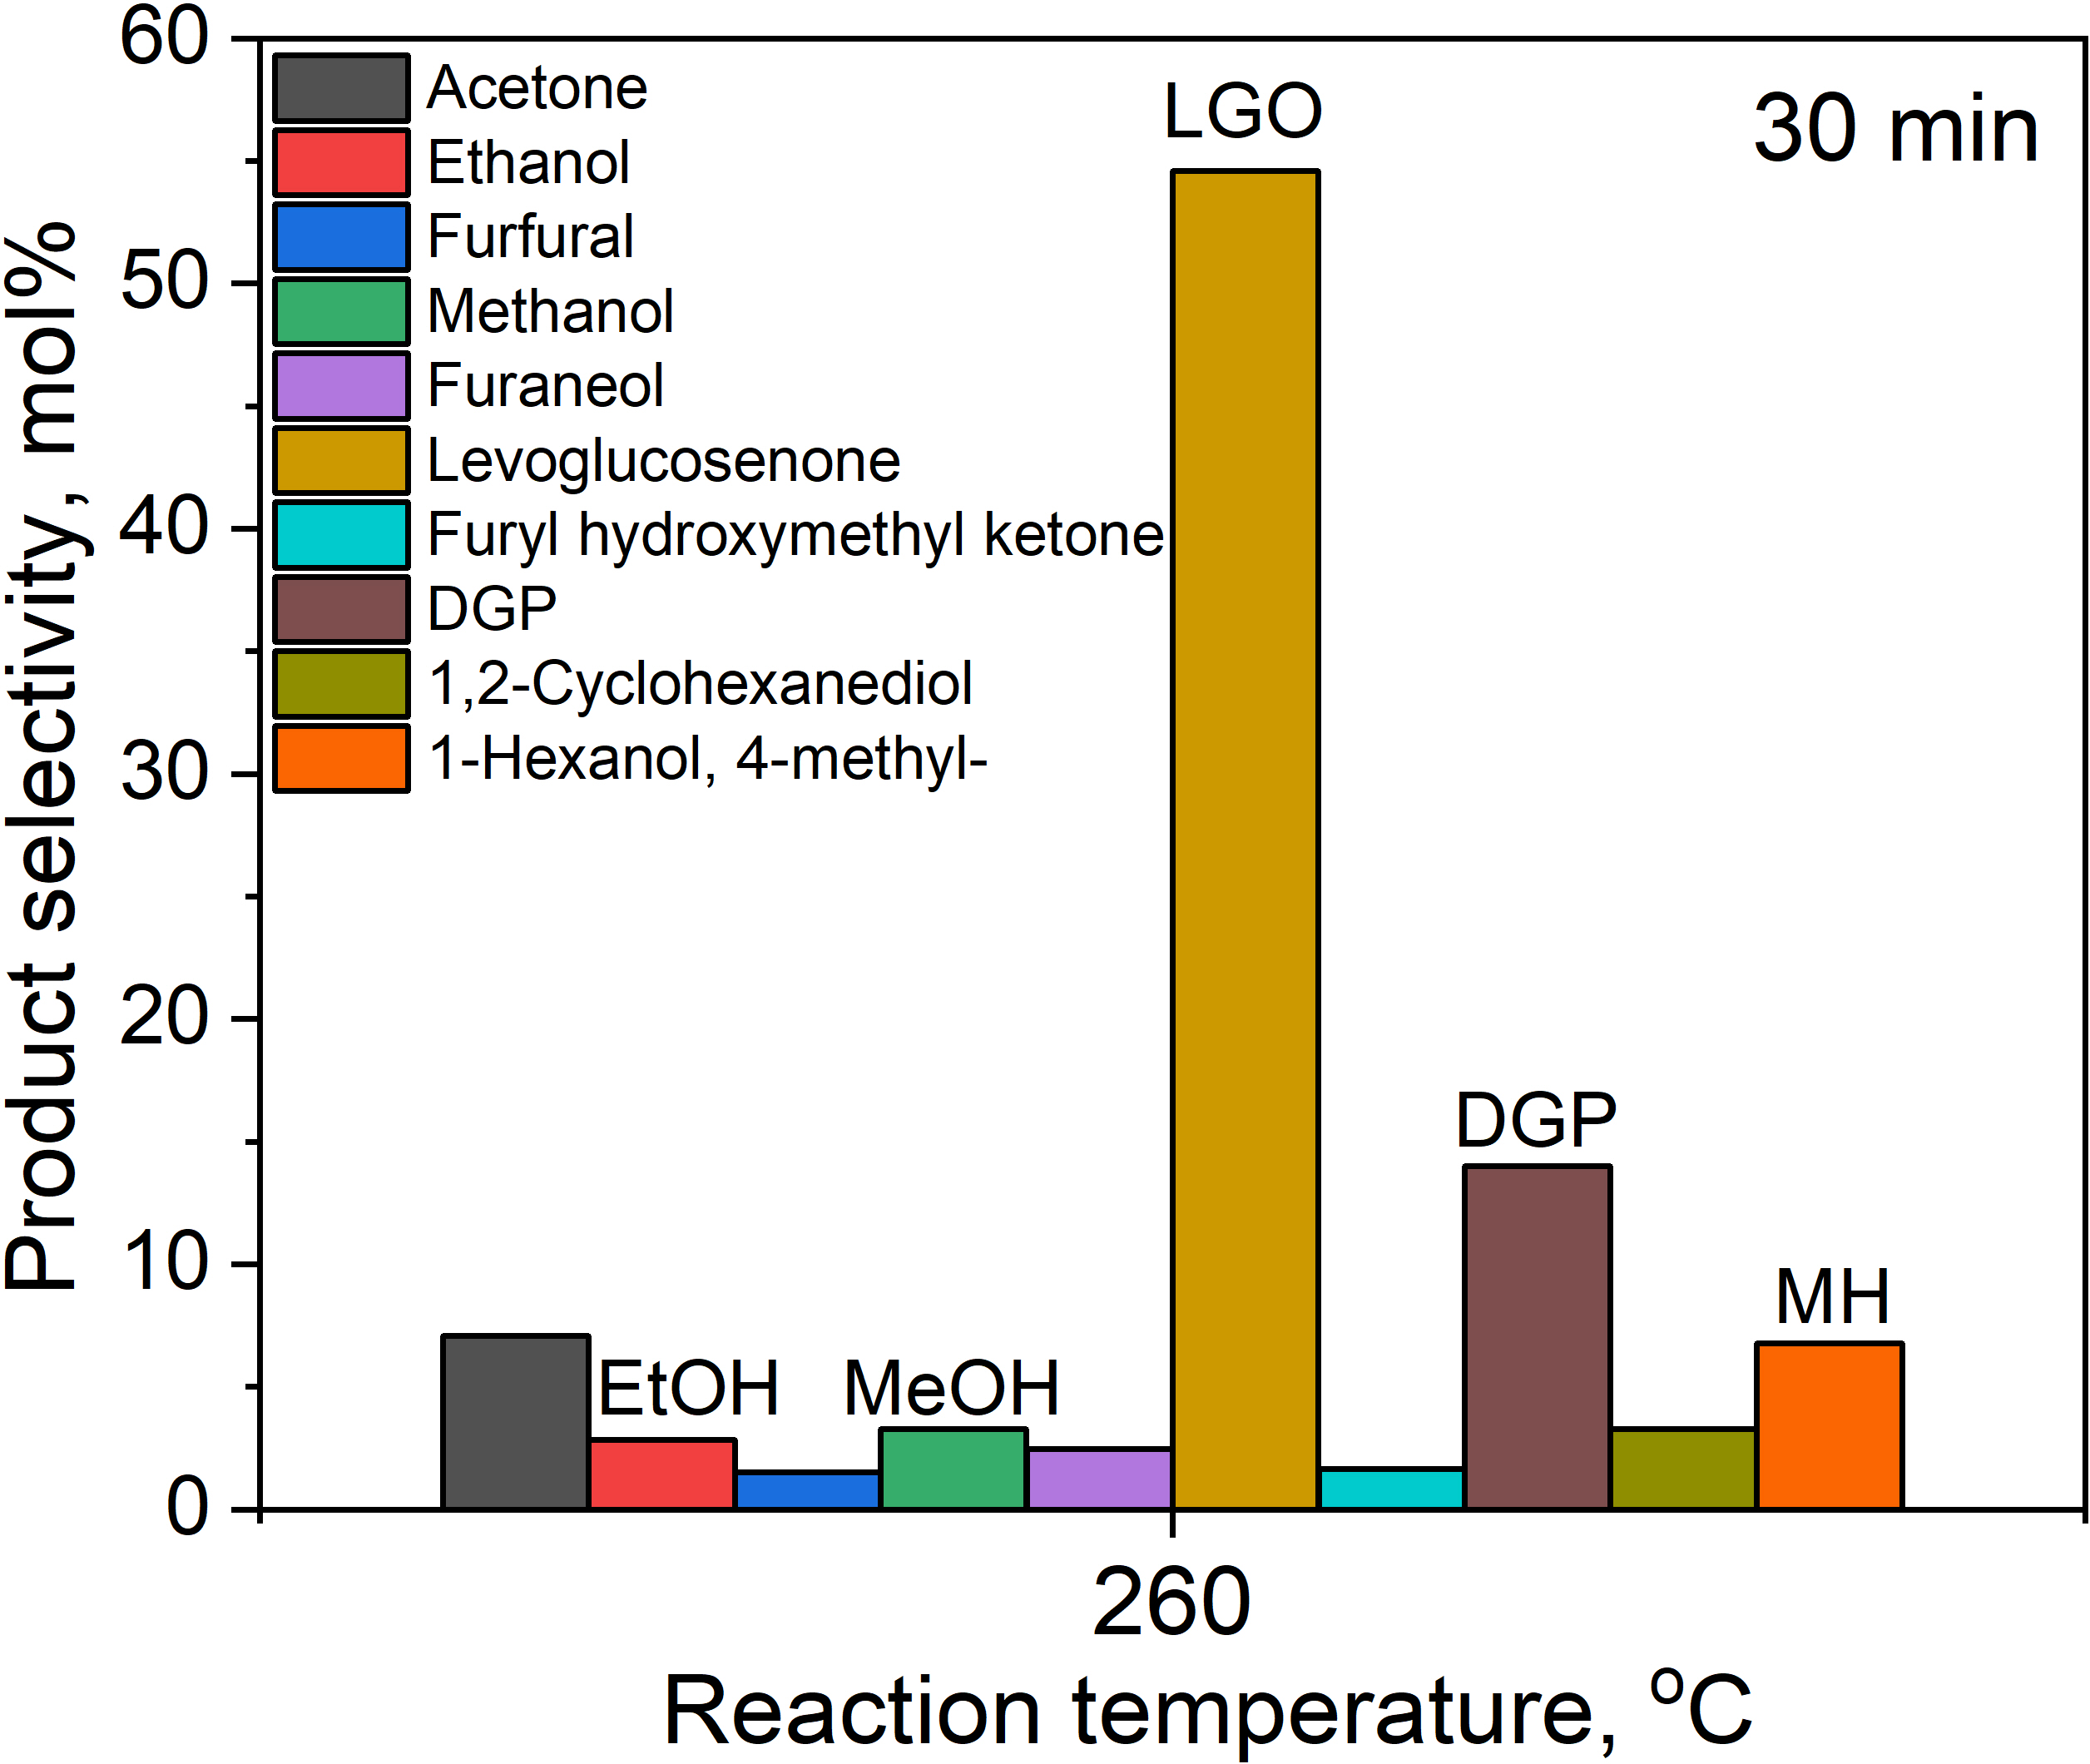 | 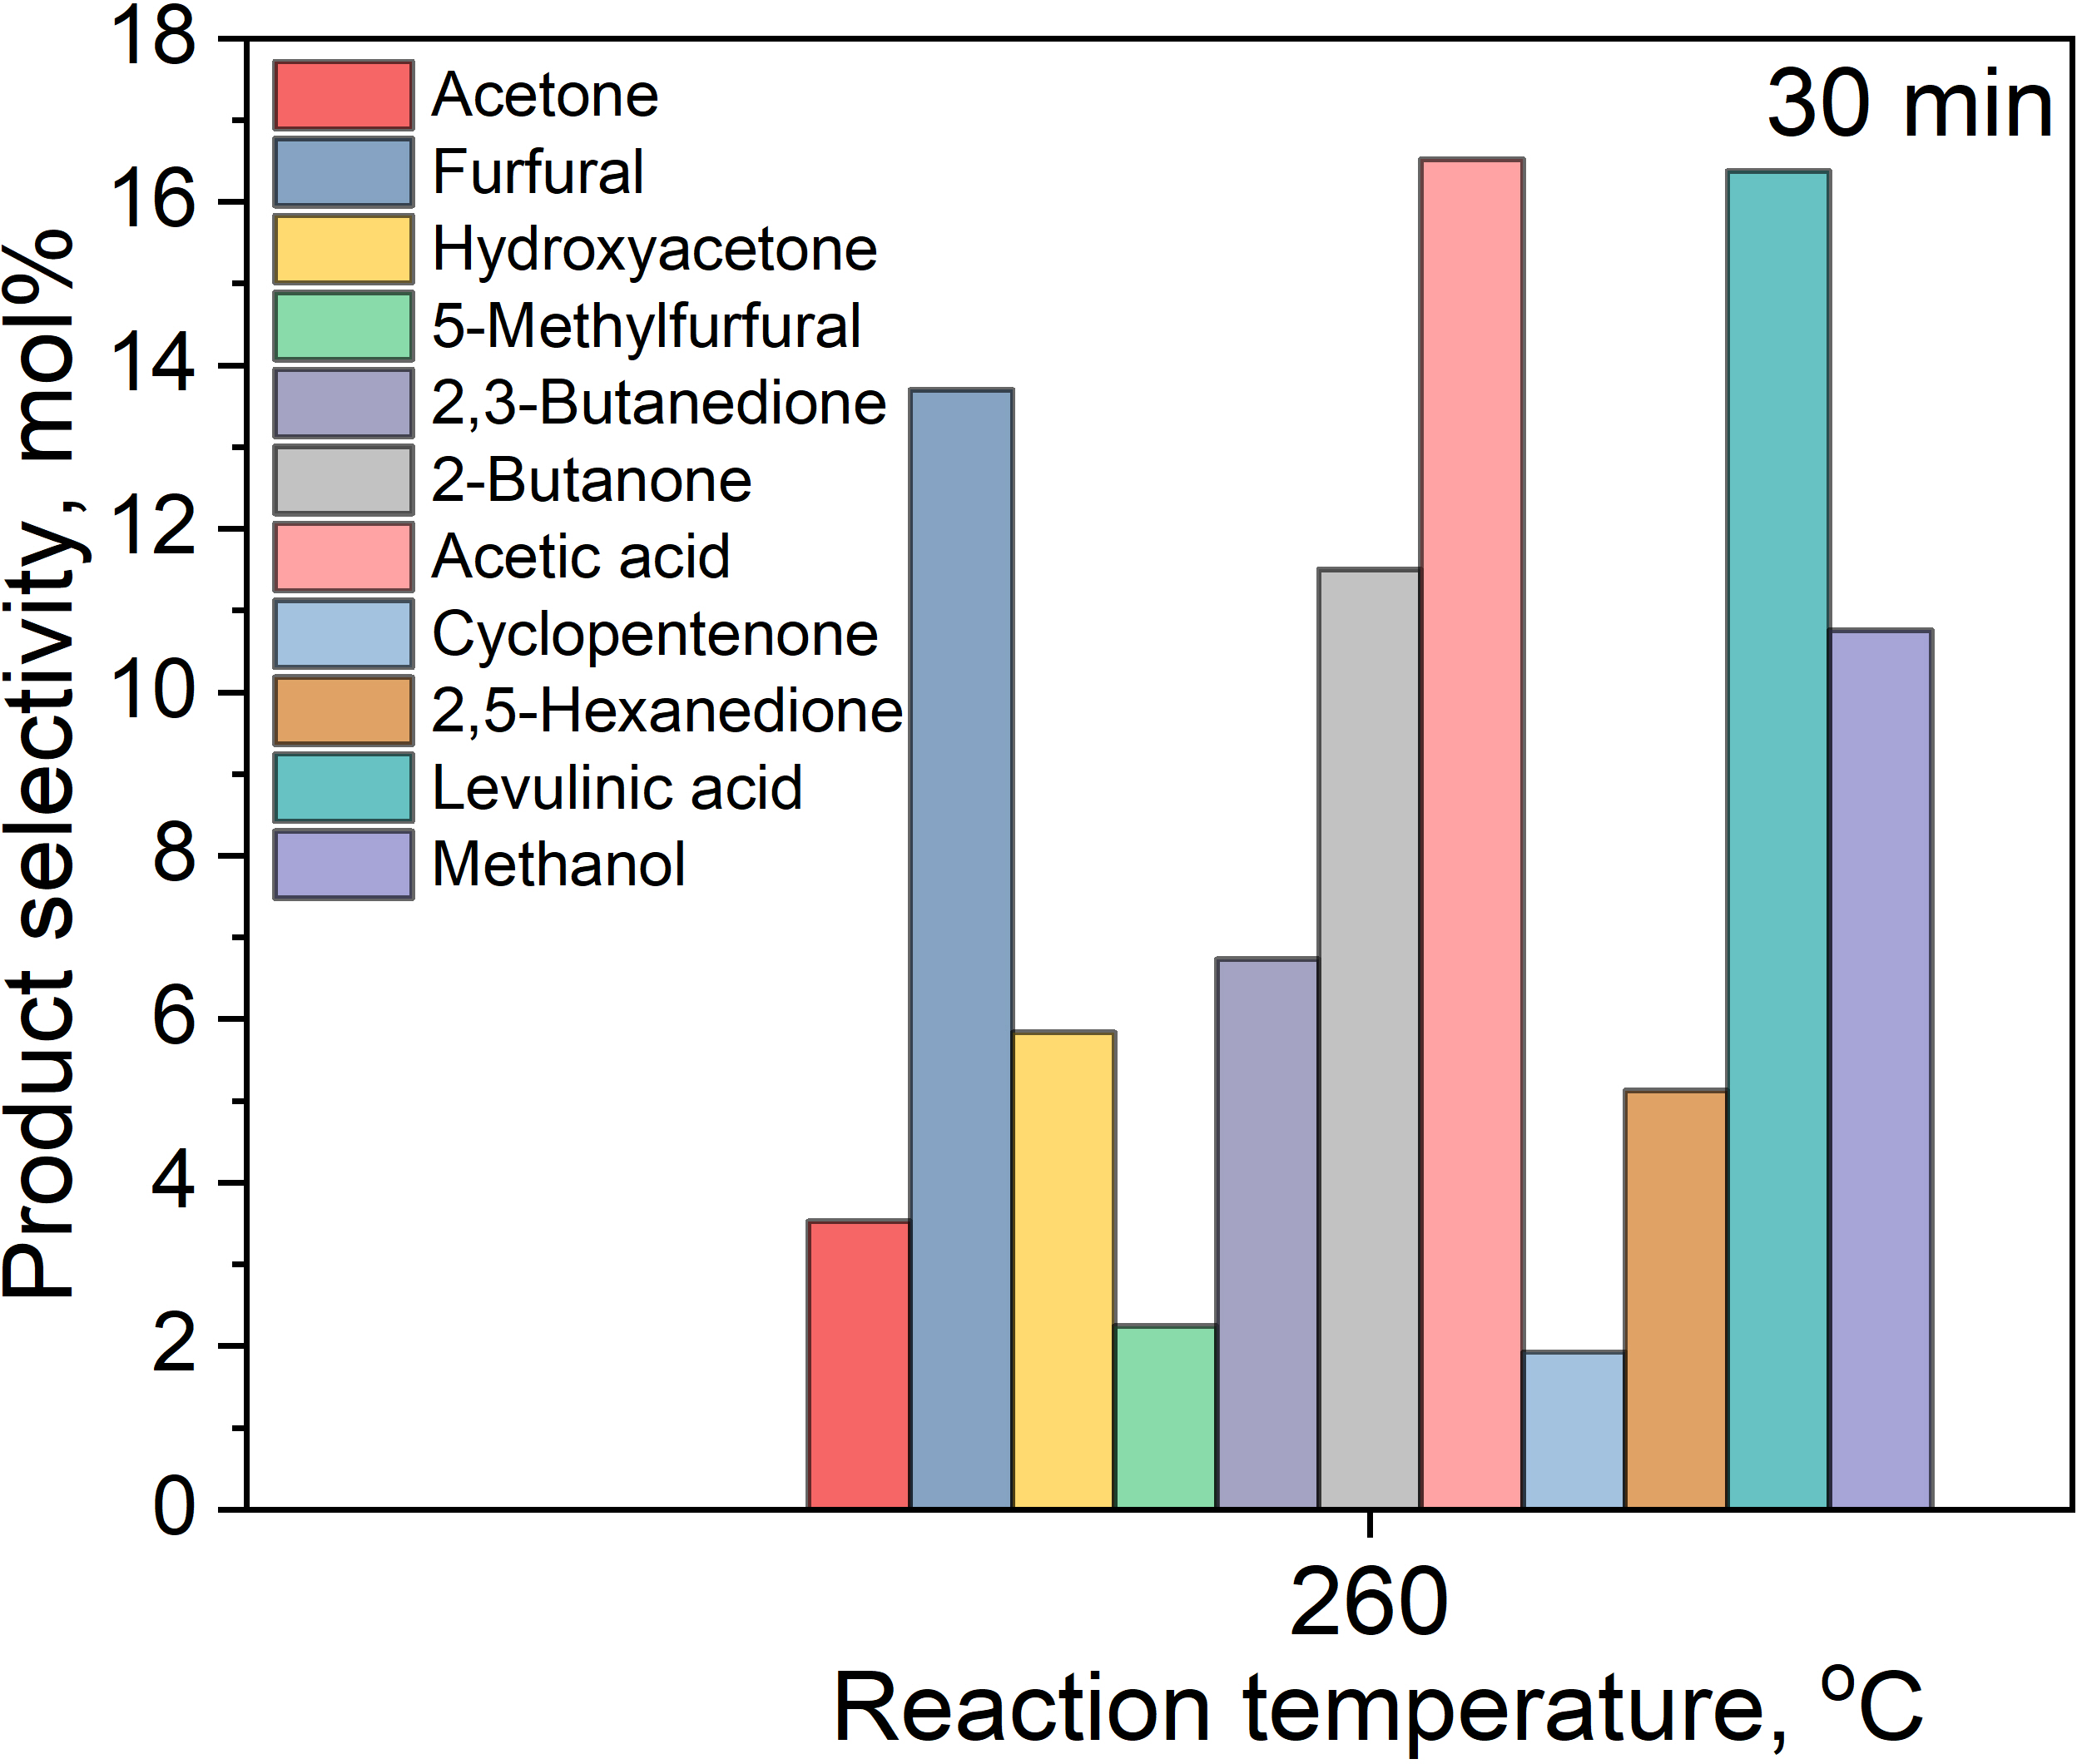
Fig. S2. Comparing DT – (a) and WT – (b) of WCPR. Reaction conditions for DT: 5.0 g of WCPR, N₂ flow of 200 mL/min, reaction temperature of 260 °C, and a reaction time of 30 min. Reaction conditions for WT: 3.0 g of WCPR, 30 mL of water, stirring speed at 900 rpm, reaction temperature of 260 °C, and a reaction time of 30 min.

Table S2. Proximate and elemental analysis, BET surface area, pore diameter (PD), crystalline index, and crystallite size of the DT of WCPR samples as compared to the WCPR.
Samples | T, °C | t, min | Proximate analysis  (wt%) |  |  |  | Elemental analysis (wt%) |  |  |  |  | BET surface area, m²/g | PD³, Å | Crystalline index, % | Crystallite size, nm
Samples | T, °C | t, min | Moisture | VM¹ | FC² | Ash | C | H | O | N | S
WCPR | − | − | 3.91 | 78.72 | 15.91 | 1.46 | 48.25 | 6.22 | 39.6 | 0.10 | 0.45 | 3.4 | 73 | 76.5 | 3.3
DT_WCPR_210 | 210 | 15 | 2.64 | 79.25 | 13.37 | 4.73 | 50.09 | 5.96 | 36.1 | 0.14 | 0.35 | 4.2 | 318 | 73.5 | 3.2
DT_WCPR_240 | 240 | 15 | 1.44 | 79.77 | 16.67 | 2.13 | 49.72 | 5.75 | 40.5 | 0.15 | 0.36 | 3.8 | 268 | 69.5 | 3.0
DT_WCPR_270 | 270 | 15 | 1.67 | 73.95 | 21.82 | 2.56 | 53.58 | 5.49 | 36.2 | 0.16 | 0.38 | 3.2 | 472 | 48.1 | 1.1
DT_WCPR_300 | 300 | 15 | 2.22 | 59.59 | 36.49 | 1.70 | 62.13 | 4.89 | 28.5 | 0.17 | 0.44 | 2.9 | 222 | 6.7 | 0.8
DT_WCPR_210 | 210 | 30 | 1.13 | 79.30 | 15.44 | 4.14 | 50.49 | 5.91 | 37.8 | 0.16 | 0.39 | 3.7 | 374 | 71.6 | 3.2
DT_WCPR_240 | 240 | 30 | 1.65 | 78.99 | 17.46 | 1.91 | 51.50 | 5.81 | 38.6 | 0.13 | 0.38 | 3.8 | 288 | 64.5 | 2.7
DT_WCPR_270 | 270 | 30 | 1.64 | 69.52 | 26.69 | 2.15 | 55.38 | 5.31 | 34.9 | 0.14 | 0.43 | 3.5 | 334 | 32.6 | 1.0
DT_WCPR_300 | 300 | 30 | 1.42 | 56.09 | 38.16 | 4.33 | 64.17 | 4.77 | 24.6 | 0.19 | 0.54 | 2.5 | 726 | 10.7 | 0.8
DT_WCPR_210 | 210 | 60 | 1.44 | 81.02 | 15.96 | 1.58 | 50.32 | 5.83 | 40.3 | 0.14 | 0.43 | 4.3 | 225 | 71.2 | 3.1
DT_WCPR_240 | 240 | 60 | 1.75 | 78.19 | 18.14 | 1.93 | 51.49 | 5.62 | 38.6 | 0.14 | 0.46 | 4.4 | 256 | 61.4 | 2.5
DT_WCPR_270 | 270 | 60 | 1.82 | 66.64 | 29.59 | 1.94 | 58.03 | 5.10 | 32.4 | 0.15 | 0.55 | 3.5 | 362 | 28.0 | 1.1
DT_WCPR_300 | 300 | 60 | 1.55 | 51.82 | 40.93 | 5.70 | 65.25 | 4.49 | 22.1 | 0.17 | 0.70 | 2.6 | 215 | 10.1 | 0.7
¹VM – volatile matter, ²FC – fixed carbon, ³PD – Average pore diameter measured from the desorption branch according to the BJH method.

Table S3. HHV, solid yield, carbon yield, hydrogen yield, energy yield, DC, DH, DO, ARE, CE, enhancement factor and atomic ratios of the DT of WCPR samples as compared to the WCPR.
Samples | T, °C | t, min | HHV,  MJ/kg | Solid yield, wt% | Carbon yield,  wt% | Hydrogen yield,  wt% | Energy yield, % | DC¹, % | DH², % | DO³, % | ARE⁴,  % | EF⁵ | Atomic ratio |  | CE⁶ | WL⁷
 |  |  |  |  |  |  |  |  |  |  |  |  | O/C | H/C | CE⁶ | WL⁷
WCPR | − | − | 19.2 | − | − | − | − | − | − | − | − | 1.00 | 0.6 | 1.5 | 1.00 | −
DT_WCPR_210 | 210 | 15 | 19.9 | 94.4 | 97.9 | 90.7 | 97.9 | 2.1 | 9.3 | 15.5 | 18.3 | 1.04 | 0.5 | 1.4 | 1.00 | 5.6
DT_WCPR_240 | 240 | 15 | 19.7 | 91.4 | 94.1 | 84.8 | 93.8 | 5.9 | 15.2 | 8.2 | 12.5 | 1.03 | 0.6 | 1.4 | 1.04 | 8.6
DT_WCPR_270 | 270 | 15 | 21.2 | 81.1 | 89.9 | 71.8 | 89.6 | 10.1 | 28.2 | 27.3 | 33.2 | 1.11 | 0.5 | 1.2 | 1.03 | 18.9
DT_WCPR_300 | 300 | 15 | 24.6 | 61.0 | 78.5 | 48.1 | 78.1 | 21.5 | 51.9 | 56.9 | 45.4 | 1.28 | 0.3 | 0.9 | 1.11 | 39.0
DT_WCPR_210 | 210 | 30 | 20.1 | 94.3 | 98.5 | 89.9 | 98.6 | 1.5 | 10.1 | 11.6 | 16.3 | 1.05 | 0.6 | 1.4 | 1.05 | 5.7
DT_WCPR_240 | 240 | 30 | 20.4 | 89.0 | 94.9 | 83.4 | 94.9 | 5.1 | 16.6 | 14.7 | 14.4 | 1.07 | 0.6 | 1.4 | 1.07 | 11.0
DT_WCPR_270 | 270 | 30 | 21.9 | 74.5 | 85.4 | 63.8 | 85.0 | 14.6 | 36.2 | 35.4 | 37.6 | 1.14 | 0.5 | 1.2 | 1.15 | 25.5
DT_WCPR_300 | 300 | 30 | 25.4 | 57.2 | 76.0 | 44.0 | 75.7 | 24.0 | 56.0 | 65.1 | 126.9 | 1.32 | 0.3 | 0.9 | 1.33 | 42.8
DT_WCPR_210 | 210 | 60 | 20.0 | 93.6 | 97.5 | 88.0 | 97.3 | 2.5 | 12.0 | 6.5 | 7.0 | 1.04 | 0.6 | 1.4 | 1.04 | 6.4
DT_WCPR_240 | 240 | 60 | 20.4 | 87.6 | 93.3 | 79.4 | 93.0 | 6.7 | 20.6 | 16.1 | 16.4 | 1.06 | 0.6 | 1.3 | 1.07 | 12.4
DT_WCPR_270 | 270 | 60 | 22.9 | 70.3 | 84.5 | 57.9 | 83.9 | 15.5 | 42.1 | 43.4 | 39.4 | 1.19 | 0.4 | 1.1 | 1.20 | 29.7
DT_WCPR_300 | 300 | 60 | 25.6 | 55.0 | 74.3 | 39.8 | 73.3 | 25.7 | 60.2 | 69.8 | 175.8 | 1.33 | 0.3 | 0.8 | 1.35 | 45.0
¹DC – decarbonization, ²DH – dehydrogenation, ³DO – deoxygenation, ⁴ARE – ash removal efficiency, ⁵EF – enhancement factor, ⁶CE – carbon enrichment, ⁷WL – weight loss.

(a) | (b)
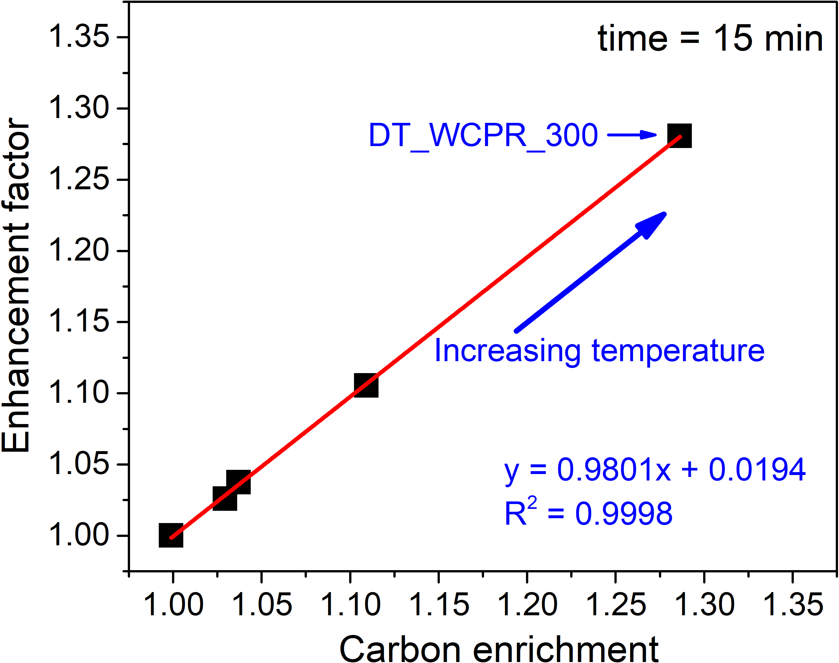 | 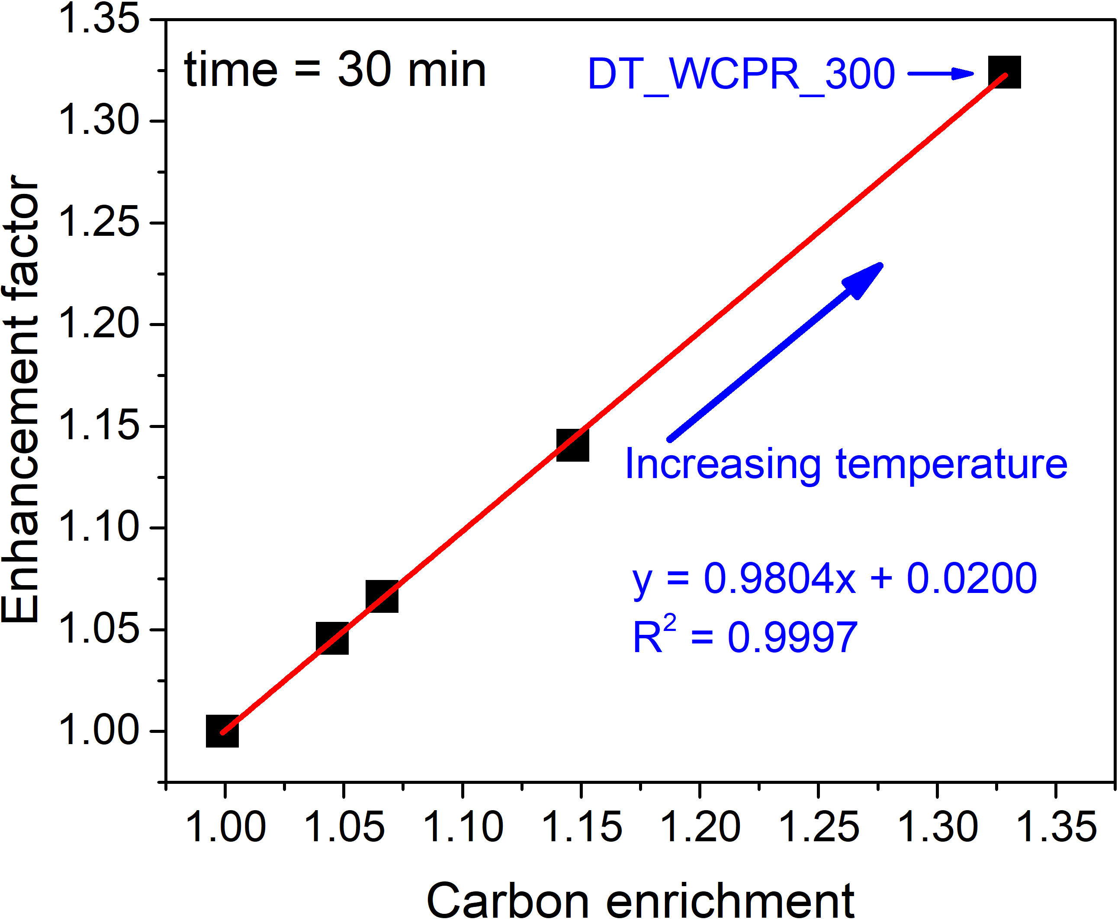
(c) | (d)
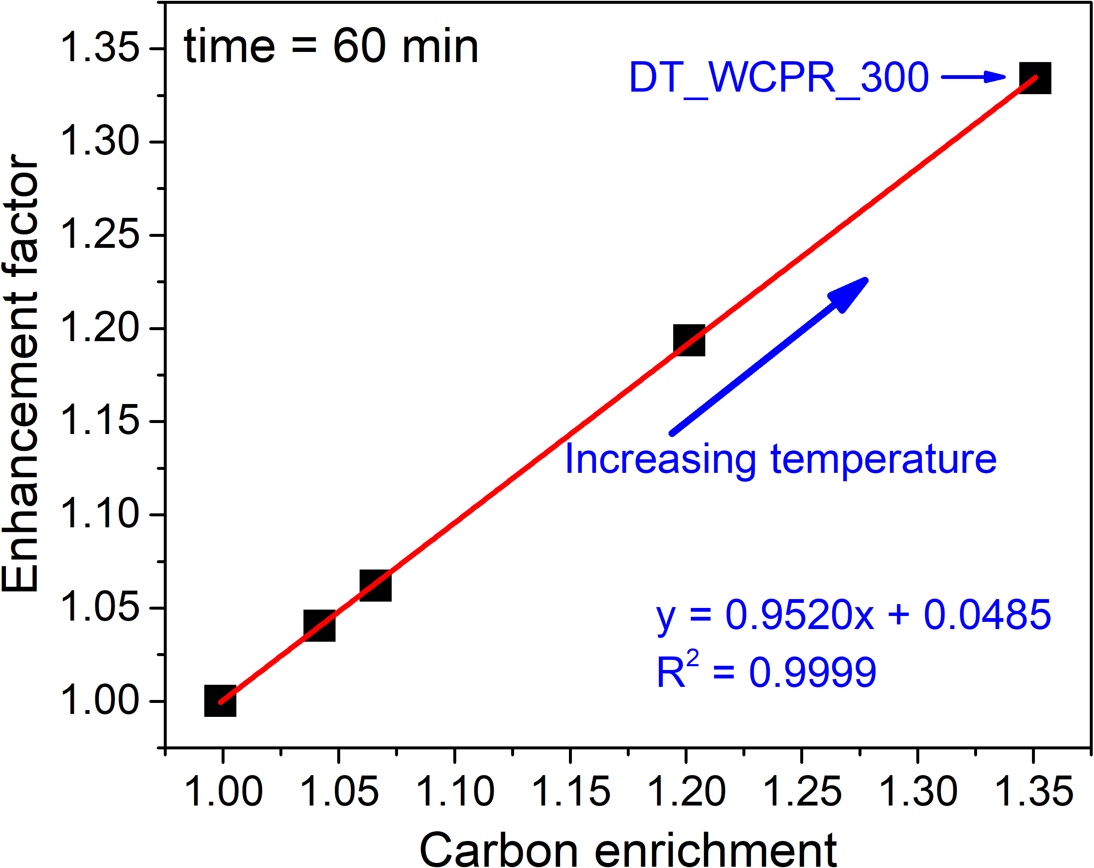 | 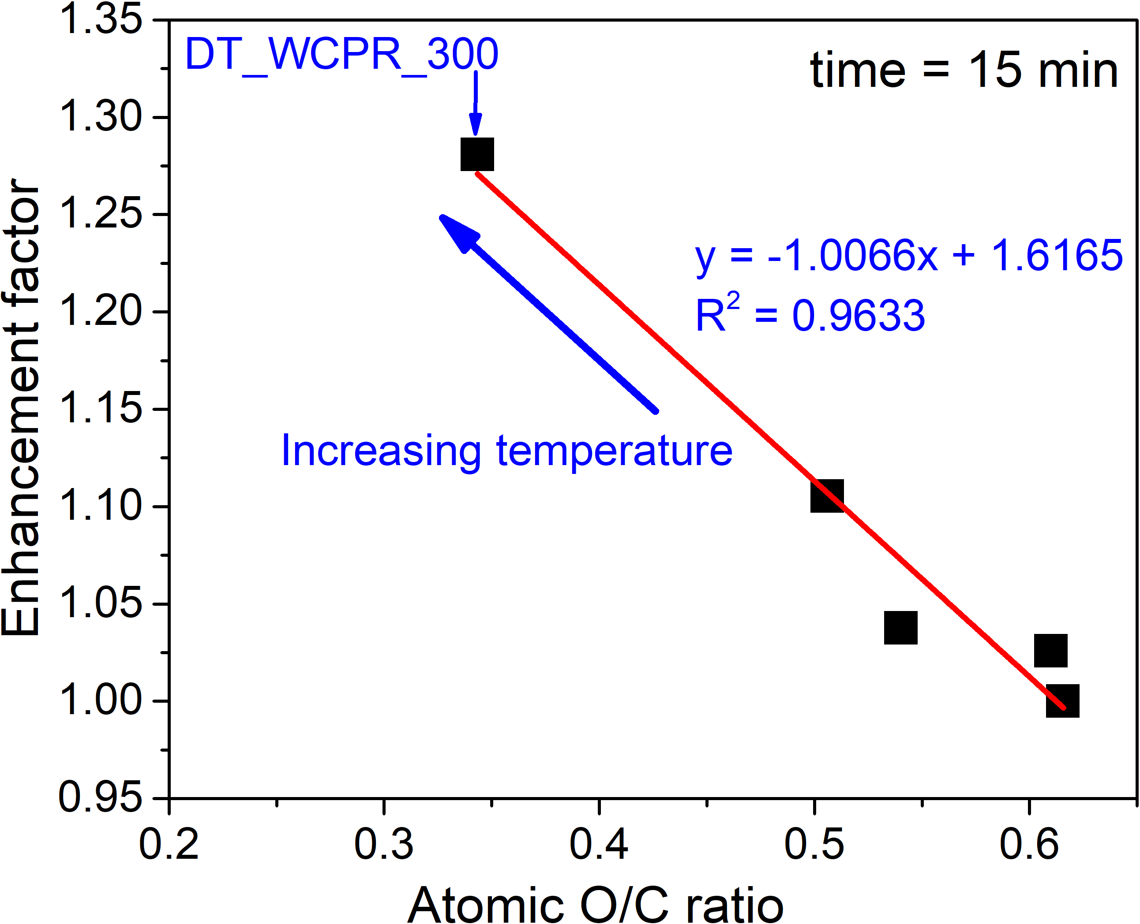
(e) | (f)
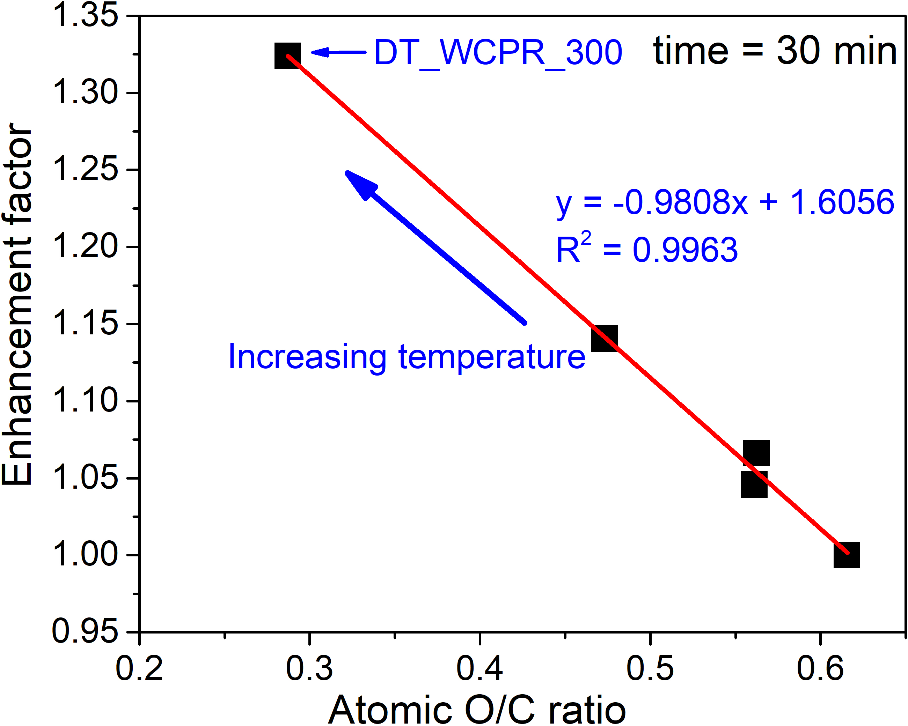 | 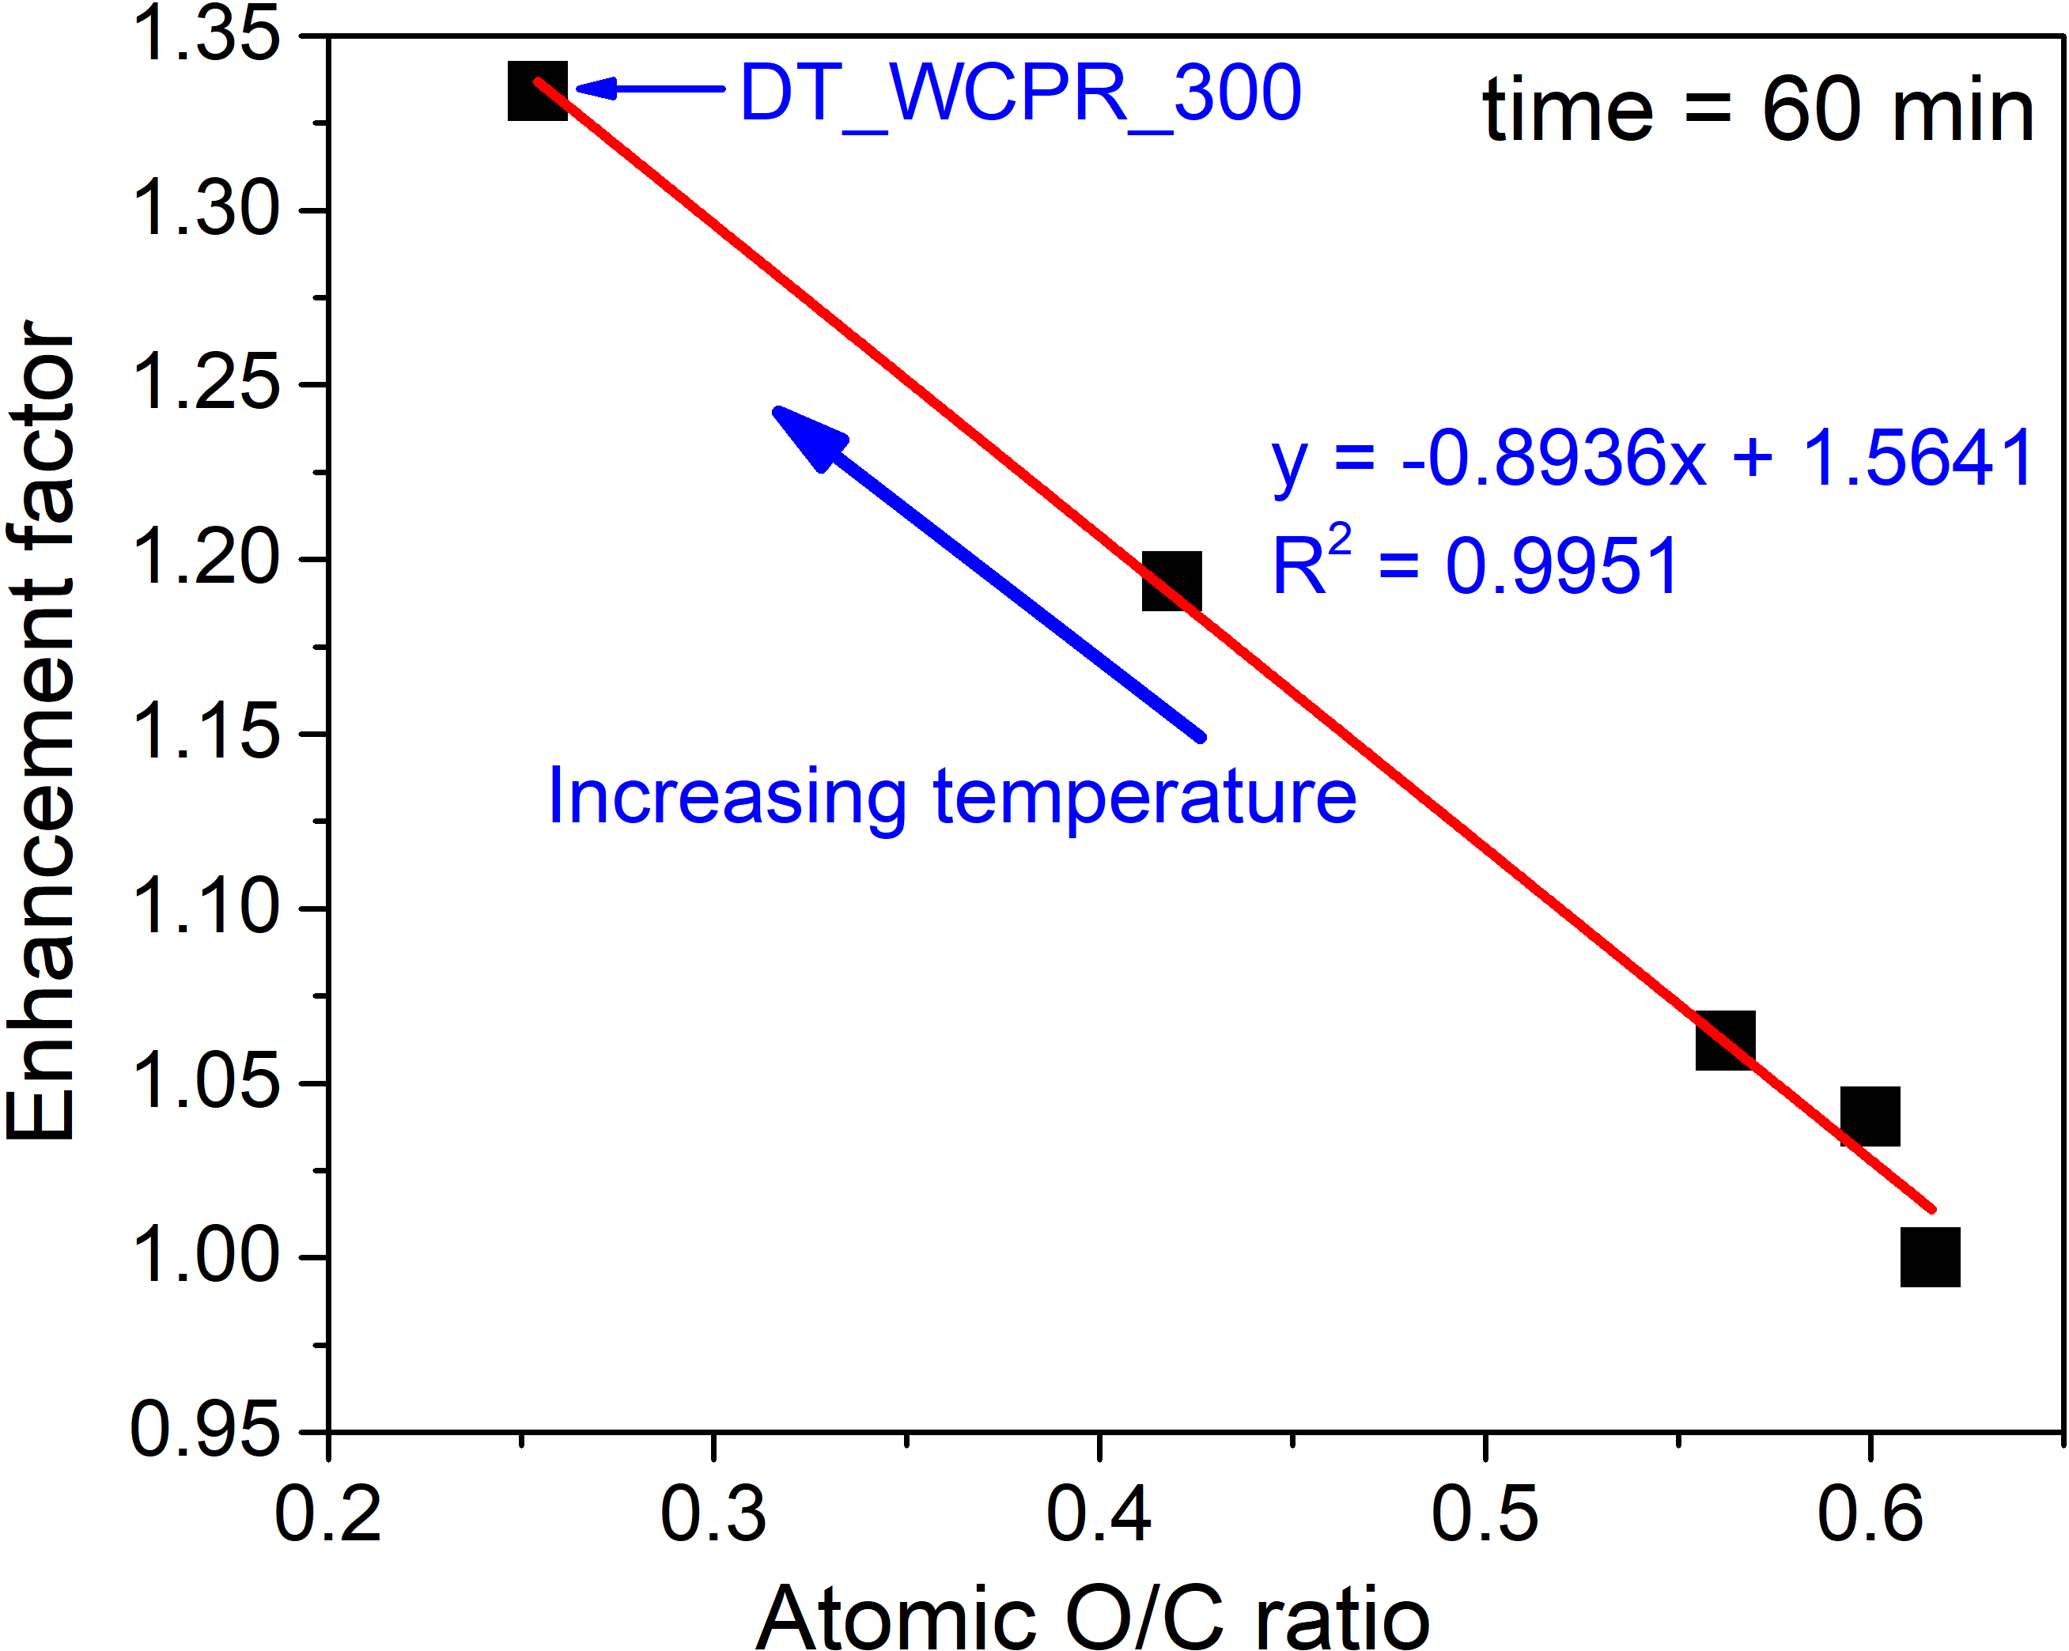
Fig. S3. Enhancement factor versus carbon enrichment (a–c) and O/C ratio (d–f) for different durations (15–60 min) of DT of WCPR.

References

[1] L. Segal, J.J. Creely, A.E. Martin, C.M. Conrad, An Empirical Method for Estimating the Degree of Crystallinity of Native Cellulose Using the X-Ray Diffractometer, Text. Res. J. 29 (1959) 786–794. https://doi.org/10.1177/004051755902901003.
[2] A. Thygesen, J. Oddershede, H. Lilholt, A.B. Thomsen, K. Ståhl, On the determination of crystallinity and cellulose content in plant fibres, Cellulose. 12 (2005) 563–576. https://doi.org/10.1007/s10570-005-9001-8.
[3] N. Johar, I. Ahmad, A. Dufresne, Extraction, preparation and characterization of cellulose fibres and nanocrystals from rice husk, Ind. Crops Prod. 37 (2012) 93–99. https://doi.org/10.1016/j.indcrop.2011.12.016.
[4] G. SriBala, R. Chennuru, S. Mahapatra, R. Vinu, Effect of alkaline ultrasonic pretreatment on crystalline morphology and enzymatic hydrolysis of cellulose, Cellulose. 23 (2016) 1725–1740. https://doi.org/10.1007/s10570-016-0893-2.
[5] A. Zheng, Z. Zhao, S. Chang, Z. Huang, K. Zhao, G. Wei, F. He, H. Li, Comparison of the effect of wet and dry torrefaction on chemical structure and pyrolysis behavior of corncobs, Bioresour. Technol. 176 (2015) 15–22. https://doi.org/10.1016/j.biortech.2014.10.157.
[6] R. García, C. Pizarro, A.G. Lavín, J.L. Bueno, Biomass proximate analysis using thermogravimetry, Bioresour. Technol. 139 (2013) 1–4. https://doi.org/10.1016/j.biortech.2013.03.197.
[7] X. Li, Z. Lu, J. Chen, X. Chen, Y. Jiang, J. Jian, S. Yao, Effect of oxidative torrefaction on high temperature combustion process of wood sphere, Fuel. 286 (2021) 119379. https://doi.org/10.1016/j.fuel.2020.119379.
[8] X. Niu, Y. Xu, L. Shen, Effect of torrefaction on the evolution of carbon and nitrogen during chemical looping gasification of rapeseed cake, Chem. Eng. J. 450 (2022) 138134. https://doi.org/10.1016/j.cej.2022.138134.
[9] D. Chen, A. Gao, K. Cen, J. Zhang, X. Cao, Z. Ma, Investigation of biomass torrefaction based on three major components: Hemicellulose, cellulose, and lignin, Energy Convers. Manag. 169 (2018) 228–237. https://doi.org/10.1016/j.enconman.2018.05.063.
[10] C. Zhang, S.H. Ho, W.H. Chen, Y. Xie, Z. Liu, J.S. Chang, Torrefaction performance and energy usage of biomass wastes and their correlations with torrefaction severity index, Appl. Energy. 220 (2018) 598–604. https://doi.org/10.1016/j.apenergy.2018.03.129.
[11] X. Wang, J. Wu, Y. Chen, A. Pattiya, H. Yang, H. Chen, Comparative study of wet and dry torrefaction of corn stalk and the effect on biomass pyrolysis polygeneration, Bioresour. Technol. 258 (2018) 88–97. https://doi.org/10.1016/j.biortech.2018.02.114.

∗Corresponding author: E-mail address: andrii.kostyniuk@ki.si (Andrii Kostyniuk)

