Appendix A. Supplementary material

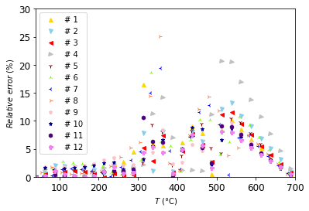
Figure A.1. Relative errors between kinetic models and measured data, the absolute value of the errors was considered in the calculation.

Table A.1. Statistical properties of the relative errors between kinetic models and measured data.
# | 1 | 2 | 3 | 4 | 5 | 6 | 7 | 8 | 9 | 10 | 11 | 12
Maximum (%) | 16.55 | 13.19 | 11.58 | 20.72 | 10.46 | 18.64 | 19.37 | 25.10 | 9.64 | 8.83 | 10.63 | 8.06
Mean (%) | 4.09 | 4.16 | 3.55 | 5.77 | 3.76 | 4.50 | 4.59 | 5.24 | 3.65 | 3.47 | 3.31 | 2.89

Table A.2. The average elemental composition of the samples determined using the SEM-EDS technique. The values include standard deviations.
 | Hemp-char |  |  | Hemp-fresh
 | Roots (11) | Leaves (12) | Stems (4) | Roots | Leaves | Stems
O/C wt. (/) | 0.10 ± 0.02 | 0.22 ± 0.08 | 0.18 ± 0.01 | 0.50 ± 0.05 | 0.34 ± 0.01 | 0.73 ± 0.01
O/C at. (/) | 0.07 ± 0.02 | 0.16 ± 0.06 | 0.14 ± 0.01 | 0.40 ± 0.04 | 0.26 ± 0.01 | 0.55 ± 0.01
C (wt.%) | 84 ± 3 | 76 ± 6 | 81 ± 2 | 63 ± 3 | 70 ± 1 | 57 ± 1
O (wt.%) | 8 ± 2 | 17 ± 5 | 15 ± 1 | 34 ± 3 | 24.0 ± 0.5 | 42.0 ± 0.3
K (wt.%) | 6 ± 1 | 5.9 ± 1 | 3.1 ± 0.6 | 1.2 ± 0.1 | 3.6 ± 1.0 | 0.5 ± 0.2
Ca (wt.%) | 1.0 ± 0.5 | 1.2 ± 0.8 | 0.9 ± 0.3 | 0.6 ± 0.3 | 1.2 ± 0.4 | 0.3 ± 0.1
Cl (wt.%) | 0.10 ± 0.03 | 0.20 ± 0.06 | 0.01 ± 0.01 | 0.1 ± 0.06 | 0.3 ± 0.1 | 0.10 ± 0.03
Cu (wt.%) | 0.10 ± 0.01 | 0.01 ± 0.01 | 0.10 ± 0.02 | 0.1 | 0.10 ± 0.03 | 0.01 ± 0.01
Fe (wt.%) | 0.10 ± 0.06 | 0.01 ± 0.01 | 0 | 0.1 | 0.01 ± 0.01 | 0
Mg (wt.%) | 0.10 ± 0.05 | 0.3 ± 0.2 | 0.10 ± 0.04 | 0.10 ± 0.06 | 0.3 ± 0.2 | 0.01 ± 0.01
Na (wt.%) | 0.1 ± 0.1 | 0.10 ± 0.04 | 0.10 ± 0.09 | 0.03 ± 0.03 | 0.01 ± 0.01 | 0.04 ± 0.04
P (wt.%) | 0.10 ± 0.02 | 0.10 ± 0.06 | 0.10 ± 0.03 | 0.10 ± 0.06 | 0.20 ± 0.08 | 0.01 ± 0.01
S (wt.%) | 0.10 ± 0.04 | 0.10 ± 0.05 | 0 | 0.10 ± 0.04 | 0.10 ± 0.03 | 0.01 ± 0.01
Si (wt.%) | 0.10 ± 0.07 | 0.01 ± 0.01 | 0 | 0.10 ± 0.08 | 0.01 ± 0.01 | 0.01 ± 0.01
Al (wt.%) | 0.04 ± 0.04 | 0.01 ± 0.01 | 0 | 0.10 ± 0.06 | 0.10 ± 0.03 | 0.01 ± 0.01

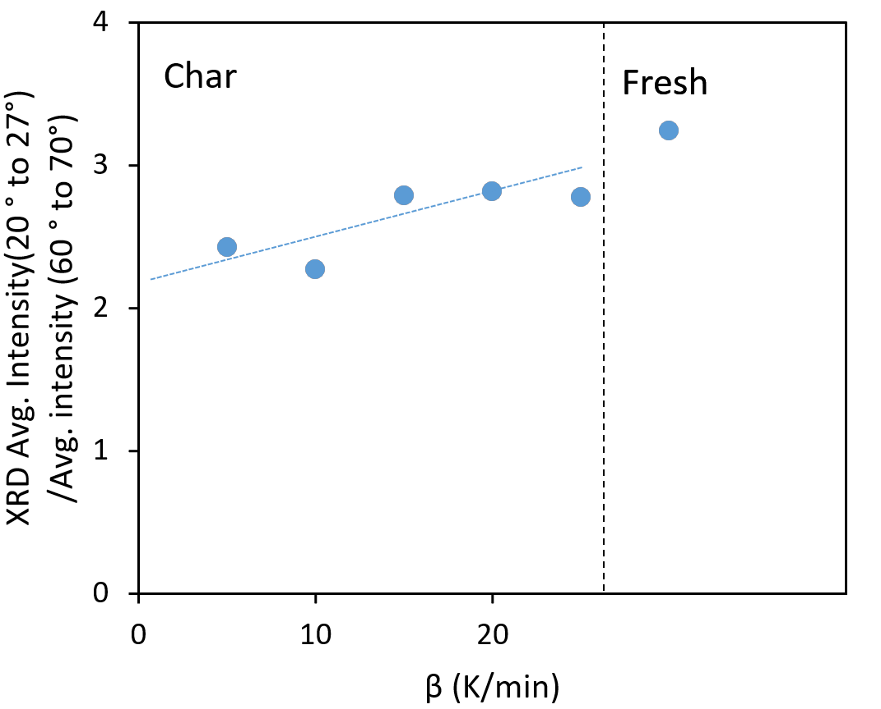
Fig. A.2. Comparison of the hemp stem chars (samples 4-8). The ratios at average intensity between 20°-27° (representing the turbostratic carbon) and the background signal (average between 60°-70°) show a weak decreasing trend of the signal intensity of the partially ordered carbon at lower heating rates (dotted line).

Fig. A.3. The XRD diffractogram of the repeated analysis, with a higher amount of sample 4 (stems at 5 K/min), shows an absence of signal at 26.5°.

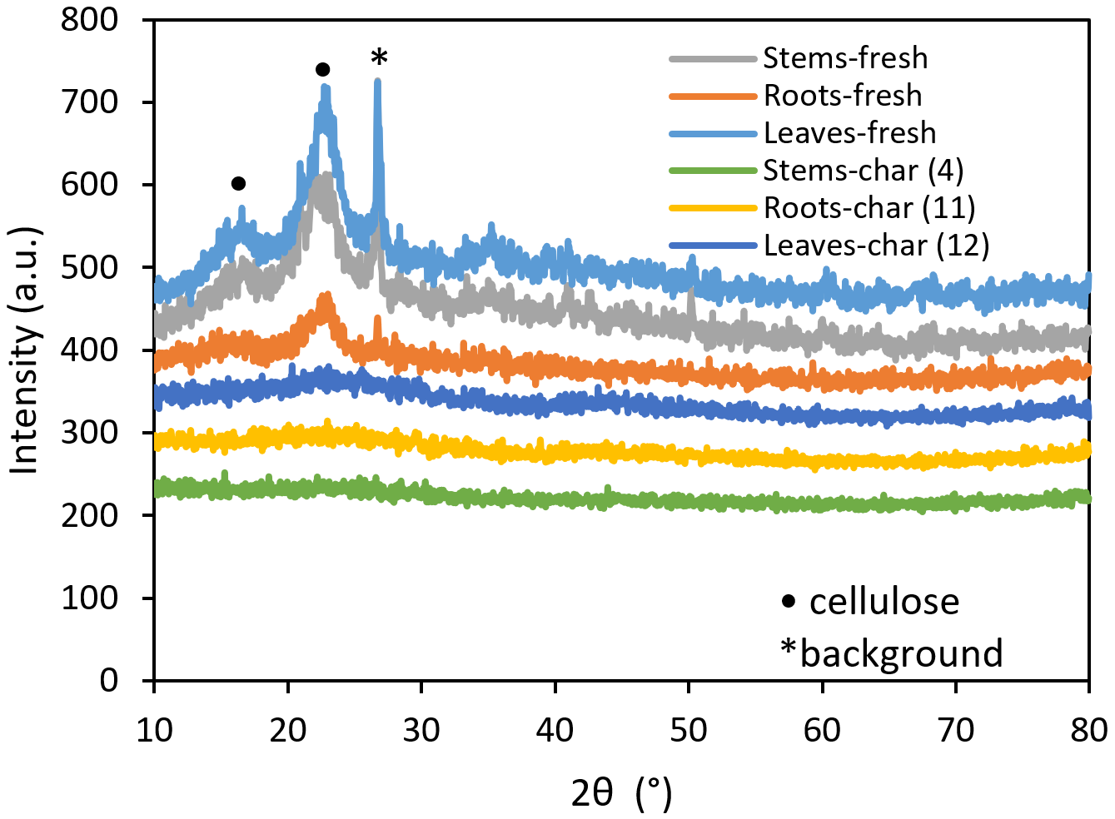
Fig. A.4. Comparison of X-ray powder diffractograms of fresh and pyrolyzed samples of stems, roots and leaves prepared at a heating rate of 5 K/min.

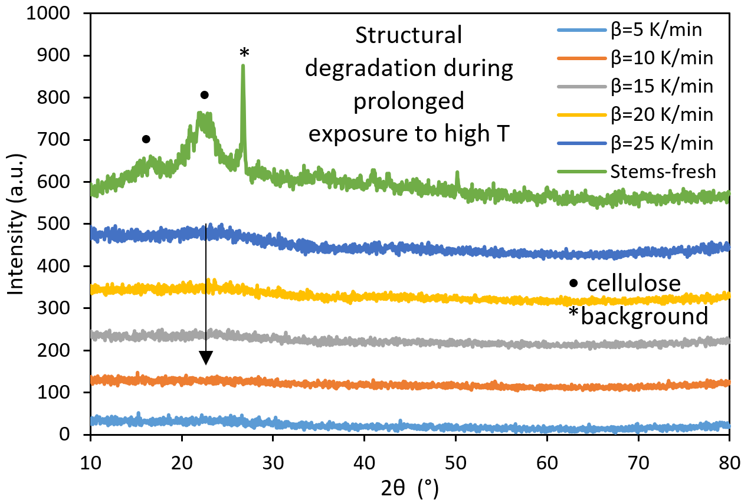
Fig. A.5. X-ray powder diffractograms of fresh and pyrolyzed hemp stems (samples 4-8), pyrolyzed at 5 K/min.

