Catalytic Wet Torrefaction of Biomass Waste into Bio-Ethanol, Levulinic Acid, and High Quality Solid Fuel

Andrii Kostyniukª∗, Blaž Likozar^{a,b,c,d}
ªDepartment of Catalysis and Chemical Reaction Engineering, National Institute of Chemistry, Hajdrihova 19, Ljubljana, 1001, Slovenia
^{b}Faculty of Polymer Technology, Slovenj Gradec 2380, Slovenia
^{c}Pulp and Paper Institute, Bogišićeva 8, Ljubljana 1000, Slovenia
^{d}Faculty of Chemistry and Chemical Technology, University of Ljubljana, Večna pot 113, Ljubljana 1000, Slovenia

Table S1
Composition of the wood cellulose pulp residue (WCPR).
Glucan (wt% dry) | Lignin AIL − ash | Lignin ASL | Ash | Total
62.26 | 30.90 | 0.14 | 1.4 | 94.7
Lignin AIL | Acid Insoluble Lignin
Lignin ASL | Acid Soluble Lignin

(a)
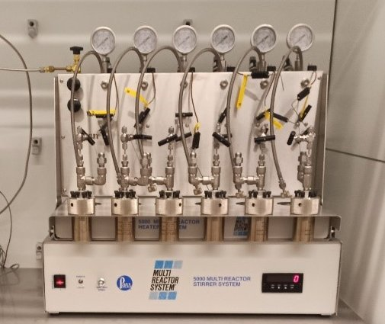
(b)
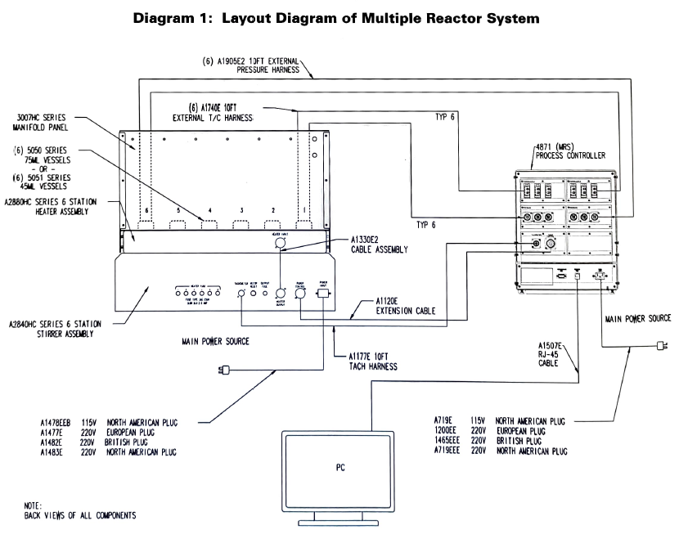
(c)
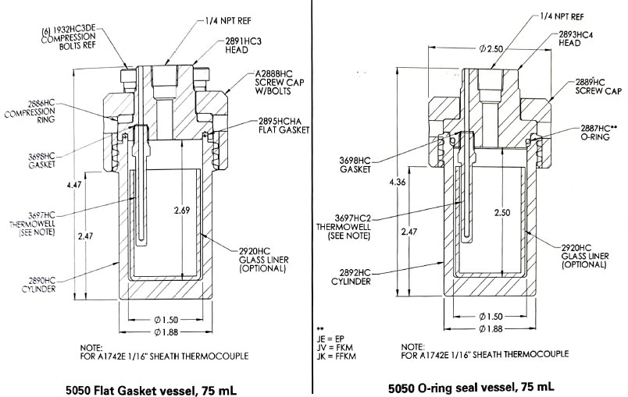
Fig. S1. Photograph of the stainless steel (Parr, 5000 Multiple Reactor System) batch reactors utilized for WT of WCPR – (a); layout diagram of multiple reactor system – (b); 5050/5051 vessel body diagram, PTFE and O-ring seals – (c).

Table S2
Chemical analysis and structural properties of the H-ZSM-5 zeolite catalyst.
Catalyst | SiO₂/Al₂O₃  ratio | S_{BET}ª  (m²/g) | S_{micro}ª  (m²/g) | S_{meso}ª  (m²/g) | V_{micro}^{b}  (cm³/g) | V_{total}^{b}  (cm³/g) | V_{meso}^{b}  (cm³/g) | PD^{c}  (nm) | Average crystallite size^{d}  (nm)
H-ZSM-5 | 30 | 348 | 230 | 118 | 0.12 | 0.25 | 0.13 | 6.4 | 50.3
ªBET method. ^{b}t-plot method. ^{c}PD − average pore diameter measured from the desorption branch according to the BJH method. ^{d}The crystallite size and relative crystallinity were calculated from the seven most intensive diffraction peaks of XRD spectra.

Table S3
Acid properties of the H-ZSM-5 zeolite catalyst.
Acid site density by NH₃-TPD (mmol_{NH3}/g_{cat}) |  |  |  | Diversity of acid sites by pyridine-DRIFTS (%)
Total | Weakª | Strong^{b} | Strong/Weak | BAS | LAS | BAS/LAS ratio
0.87 | 0.43 | 0.44 | 1.0 | 71.5 | 28.5 | 2.51
a − determined at average temperature T = 202.2 °C.
b − determined at average temperature T = 396.6 °C.
BAS − Brönsted acid sites.
LAS − Lewis acid sites.

Table S4. SEM-EDX analysis of the WCPR, WT_WCPR and the WT+ZSM-5 samples.
WCPR
Element | Scan 1 (wt%) | Scan 2 (wt%) | Scan 3 (wt%)
C | 57.97 | 58.57 | 57.97
O | 41.69 | 41.27 | 41.85
Si | 0.06 | ‒ | 0.06
Al | ‒ | ‒ | ‒
S | 0.14 | ‒ | ‒
Ca | 0.13 | ‒ | 0.13
WT_WCPR
C | 59.42 | 59.40 | 58.75
O | 40.58 | 40.60 | 41.25
Si | ‒ | ‒ | ‒
Al | ‒ | ‒ | ‒
S | ‒ | ‒ | ‒
Ca | ‒ | ‒ | ‒
WT+ZSM-5
C | 45.68 | 43.87 | 45.26
O | 42.70 | 43.95 | 42.01
Si | 10.65 | 11.18 | 11.68
Al | 0.86 | 0.88 | 0.91
S | ‒ | ‒ | ‒
Ca | 0.12 | 0.11 | 0.13

∗Corresponding authors: E-mail address: andrii.kostyniuk@ki.si (Andrii Kostyniuk)

