Non-Linear Functional Polymers Containing Selective/Cleavable Bonds: Synthesis and Their Biomedical Applications
Mahdi Rahimi¹, Monika Gałęziewska², Krzysztof Jerczyński², Sylwia Wróbel², Joanna Pietrasik²*
¹Centre de Recherche, Hôpital du Sacré-Cœur de Montréal du CIUSSS NIM, Faculté de Médecine, Université de Montréal, 5400 boul Gouin Ouest, Montreal, QC H4J 1C5, Canada
²Institute of Polymer and Dye Technology, Faculty of Chemistry, Lodz University of Technology, Stefanowskiego 16, 90-537 Lodz, Poland
- All authors contributed equally to this work.
*Corresponding author:
joanna.pietrasik@p.lodz.pl (Joanna Pietrasik)

Abstract
The growing interest in functional materials has resulted in the emergence of smart polymers, demonstrating practical performance in various applications especially for biomedical purposes. The properties of functional polymers are mainly determined by the presence of functional groups that differ from those in the main chains. While some polymers are naturally active and considered functional, others require modification for enhanced impact and functionality. Many functional polymers typically have a linear backbone, but very recently the attention has been shifted towards those with specific topologies and architecture, for example, bottlebrushes, stars, dendritic polymers, and gels. Over the past few years, there has been a rising emphasis on integrating selective bonds into complex polymer structures to enhance chain scission in single macromolecules. This review captures the most recent and promising approaches to the design of non-linear functional polymers containing selective/cleavable bonds and discusses the potential of these materials for biomedical applications.

Keywords: non-linear architecture; cleavable bonds; functional polymers; controlled polymerization

- Introduction
Science is witnessing rapid growth in the development of polymeric materials used in many biomedical fields such as medical implants, artificial organs, bone repair, diagnostic systems, and pharmaceuticals science especially drug delivery, gene delivery, and tissue engineering [1-3]. Functional polymers are a class of macromolecules with unique properties that depend enormously on the presence of chemical functional groups other than the main chain. For example, the functionalization of the bulk polymer allows the grafting of specific moieties or their conjugation which improves the material performance [4, 5]. Another advantage of functional polymers is the possibility to create self-assemblies or supramolecular structures. The formation or breakdown of self-assemblies in response to chemical or physical stimuli can lead to outstanding performance of such materials. On the other hand, single molecules of such polymers may demonstrate tailored stability under very specific conditions. In recent years, there has been a growing emphasis on incorporating selective bonds into polymer architectures to improve the chain scission within single macromolecules. Those are for example acetal, ester, disulfide, and azo bonds. Such materials are contrary to conventional polymers, which are typically characterized by their structural stability, as their molecular compositions consist of robust and permanent covalent bonds that are resistant to alteration.
Recent advances in polymerization techniques that started with the discovery of the living anionic polymerization technique, followed by living cationic polymerization, living ring-opening metathesis polymerization, and controlled radical polymerizations allow for the synthesis of polymers with precisely tuned parameters that affect the properties of the polymers, such as molecular weight, molecular weight distribution, functionality, and chains architecture. Non-linear polymers are a class of polymers that have a branched or cross-linked structure, as opposed to linear polymers. These types of polymers, classified as stars, bottlebrushes, dendritic polymers, or polymer gels have attracted considerable attention [6, 7] not only because their unique topologies provide several characteristics that are not accessible for linear functional polymers but also because they appear to be good candidates for a wide range of biomedical applications [8-11]. The scope of application becomes broader if one considers the presence of cleavable bonds within their structure. Importantly, the position of the selective bond within well-defined star/hyperbranched/bottlebrush polymers as well as crosslinked polymer networks can be well-controlled and precisely defined.
In this discussion, we summarized the recent studies that revolved around polymer architectures such as bottlebrushes, stars, dendritic polymers, and polymer gels, containing specific bonds within their structure, that can be cleaved under selected stimuli. Specifically, pH, redox environment, and light were selected as the most common factors used in biomedical applications. To organize our discussion, we categorized the sections based on the type of polymer architecture, which were further gathered into sections referring to selected stimuli. The discussed polymers were synthesized using a variety of techniques that involve both radical and ring-opening polymerizations. Therefore, a short introduction to the polymerization mechanisms was also included. Conclusions were added as a final section to highlight the main features of the functional polymers discussed.

- Approaches for Synthesis of Functional Polymers
One of the most significant contributions of polymer science over recent decades has been the continuous development of controlled polymerization techniques [12, 13]. Advances in polymers synthesis have allowed the tailoring of their properties and, in turn, developed a wide range of advanced functional materials [14]. The above-mentioned functional polymers can be obtained using various polymerization methods; however, their synthesis requires well-controlled polymer growth. The molecular parameters of polymers such as molecular weight, distribution, and morphology should be precisely defined. Hence reversible-deactivation radical polymerization (RDRP) is the most suitable strategy due to the effective and simultaneous growth of all polymeric chains [15]. Those include nitroxide-mediated polymerization (NMP), atom transfer radical polymerization (ATRP), and reversible addition-fragmentation chain transfer (RAFT) polymerization [16-18]. Beyond RDRP methods, ring-opening polymerization (ROP) and ring-opening metathesis polymerization (ROMP) have also been reported in the synthesis of functional polymers [19-21]. The mechanisms of mentioned techniques are presented in Figure 1. Most significantly, modern polymerization techniques are shaping the current landscape of nanomaterials and nanomedicine and have opened new areas in the design of macromolecular architectures to generate uniform polymer materials with tailor-made properties. Thus, it became possible to yield macromolecules with varied morphologies including stars, dendritic polymers, or bottlebrushes.
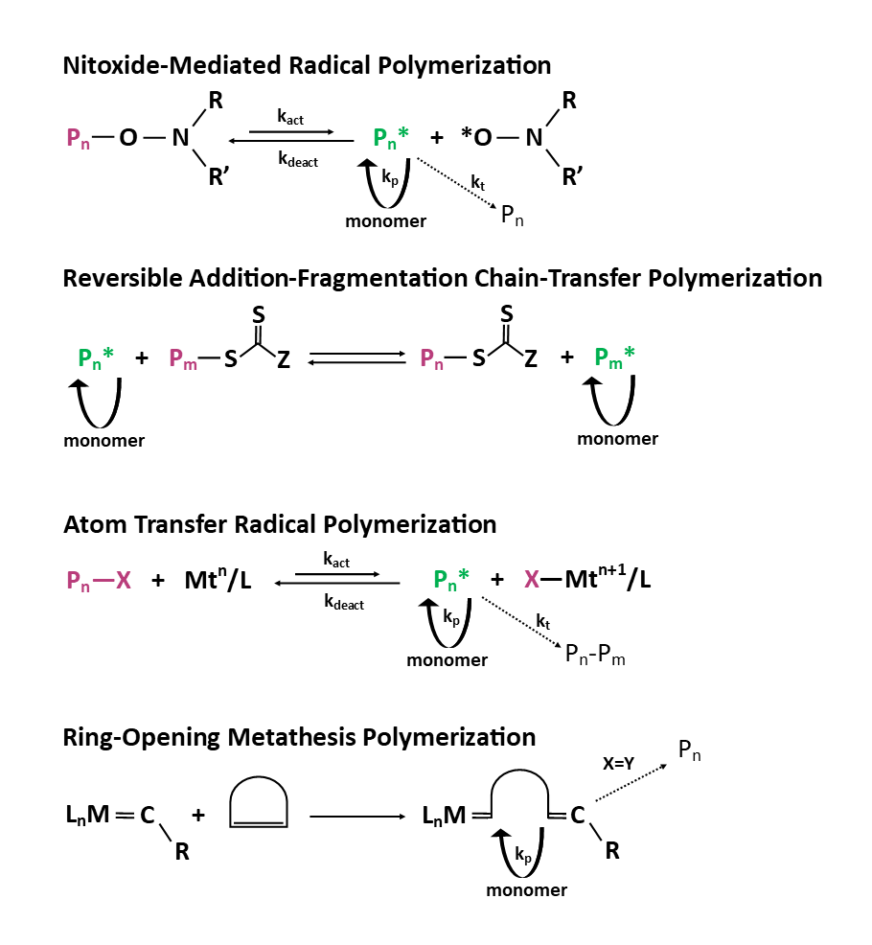
Figure 1. The main polymerization approaches to the synthesis of functional polymers.
  - Nitroxide-Mediated Polymerization (NMP)
Consistently with other RDRP techniques, NMP is based on the reversible activation and deactivation reactions of a stable free radical, which enables the controlled growth of a propagating polymer chain [16]. The propagating chain is reversibly deactivated by the stable radical, which makes NMP a pseudo-living polymerization. The stable free radical is produced from nitroxide, which yields a macroalkoxyamine as the dormant species [15]. The reversed reaction requires only the increase in temperature, which is an important advantage of NMP over other RDRP techniques, for which a catalyst or transfer agent is required [22]. On the other hand, NMP exhibits slow polymerization kinetics, which require significantly longer reaction times in comparison to other RDRP methods. Another challenge in NMP is the inherent difficulty with the polymerization of methacrylate monomers, caused by side reactions and slow recombination of propagating radicals with nitroxide. There are, however, some monomers for which the mechanism of NMP is in favor, such as styrene or 1,3-diene monomers. Additionally, NMP requires the synthesis of nitroxide and alkoxyamine for which few commercial options are available [23]. The use of NMP has been reported in the synthesis of functional polymers such as bottlebrushes and polymer brushes synthesized from the surface [22, 24].
  - Reversible Addition-Fragmentation Chain Transfer Polymerization (RAFT)
In the case of RAFT polymerization, the activation/deactivation cycles involve degenerate chain transfer. These reactions are termed “degenerate” because the process involves only an exchange of functionality, hence the sole distinction between the species in the equilibrium state is their degree of polymerization. For this process to occur, a chain transfer agent (CTA) is required. This CTA should be carefully adjusted to the system so that there is a high fraction of living chains and only minimal retardation occurs [25]. The effectiveness of the RAFT agent is determined by the properties of the radical leaving group and the activating group. Dithioesters, thiocarbonyls, and trithiocarbonates are often used as CTA [26]. The use of sulfur reagents is one of the limitations of RAFT. Another important issue is the limited range of molecular weights, which can be achieved, while keeping control over dispersity, due to the high probability of termination during long-chain growth reactions. RAFT can be applied to numerous monomer classes, however, to retain good control over molecular weight distribution, the CTA has to be carefully adjusted to the chosen monomer, which can be perceived as a limitation [27, 28]. RAFT has been applied to the synthesis of functional polymers with varied morphologies including polymer brushes synthesized from the surface, bottlebrushes, and stars [29-34].
  - Atom Transfer Radical Polymerization (ATRP)
ATRP requires primarily the reaction of a transition metal catalyst and an alkyl halide, followed by further propagation with monomer units. The reversibility of activation/deactivation is due to the reversible halogen atom transfer between dormant species and a transition metal complex in the lower oxidation state, which results in the production of a propagating active radical and transition metal complex in the higher oxidation state. The equilibrium in ATRP is pushed towards the dormant species, resulting in low concertation of radicals, which reduces radical-radical termination reactions [35]. The drawback of ATRP is the use of a catalyst and complex reaction process which includes many components- catalyst, initiator, ligand, as well as the sensitivity to air and moisture. However, novel ATRP methods can be conducted in aqueous media, under a limited amount of air, and with extremely small catalyst concentrations. Also, a wide range of monomers can be applied to ATRP, including some acidic monomers [36-38]. Moreover, ATRP appears to be the most used polymerization method in the synthesis of functional polymers, especially bottlebrush polymers and polymer brushes synthesized from the surface, as well as star polymers [39-44].
  - Ring-Opening Polymerization (ROP)
ROP can be considered as a chain growth polymerization, like ATRP and RAFT [45]. The difference between ROP and other chain growth methods is that this polymerization process is not achieved by the reactions of unsaturated bonds. The driving force of ROP is the release of ring strain energy of cyclic monomers, therefore ROP monomers are usually highly strained cyclic compounds such as cyclic esters, amides, epoxides, or hydrocarbons [46]. In the case of ROP, the equilibrium state plays a crucial role in polymerization kinetics. The monomer concentration and reaction temperature have a significant effect on the microstructure of the product [47]. The ring-opening process allows the incorporation of heteroatoms into the polymer main chain, which is a significant factor in the synthesis of polymers with cleavable or labile bonds. ROP has been applied for the synthesis of bottlebrushes, polymer brushes synthesized from the surface, branched polymers, and dendrimers [44, 48, 49].
  - Ring-Opening Metathesis Polymerization (ROMP)
Ring-opening metathesis polymerization is a type of ROP in which the double bond present in a cyclic monomer is retained in the main polymer chain after polymerization. The mechanism is based on metal-mediated olefin metathesis, which distinguishes ROMP from other typical chain growth polymerizations [49]. The limitation of ROMP is its sensitivity to monomer concentration, which should be relatively high for polymerization to occur efficiently. ROMP has been applied for the synthesis of bottlebrushes, polymer brushes synthesized from the surface and dendrimers [49-51].

- Non-Linear Functional Polymers Containing Cleavable Bonds
  - Bottlebrush Polymers
Bottlebrush polymers (BBPs) represent a class of macromolecules containing densely grafted side chains per repeating units of a linear backbone [52]. Bottlebrush polymers – also frequently referred to as molecular brushes, polymer brushes, cylindrical polymer brushes, or densely grafted polymers – are particularly exciting and can be synthesized through three popular strategies called “grafting from”, “grafting to” and “grafting through” methods (Figure 2) [53]. In fact, the bottlebrush architecture provides polymeric materials with unique properties in comparison to linear polymers: i) high concentration of polymeric side chains; ii) stretched polymer backbone because of the steric repulsion between side chains; and iii) decreased spatial density of chain [54]. The compact arrangement of side chains in bottlebrush polymers (distance much smaller than their unperturbed dimensions) leads to an entropically unfavorable extension of both the backbone and the side chains [55]. These features have provided exciting opportunities for the use of bottlebrush polymers in biomedical applications [30, 56].
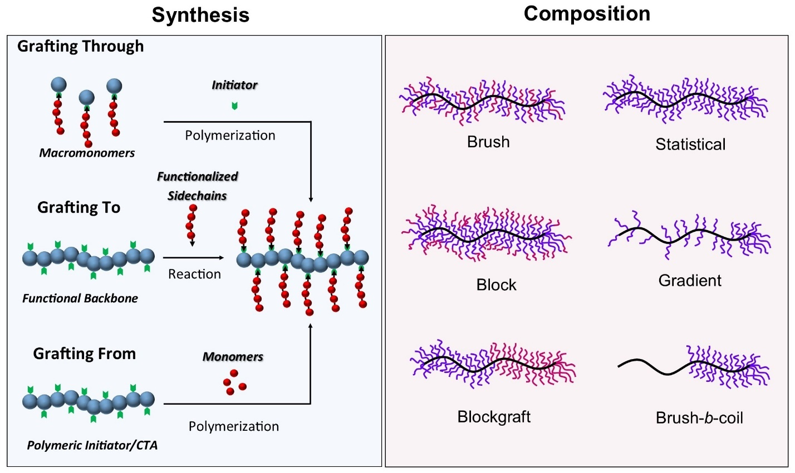
Figure 2. Approaches for the synthesis of bottlebrush polymers and their different compositions.
    - pH-Responsive Bottlebrush Polymers
pH-responsive polymers have been widely studied because pH is a convenient and effective stimulus in many applications [57]. For example, a modular approach was chosen to design a bottlebrush polymer with labile functionalities that ultimately cleave off grafted side chains under acidic conditions. Three CTAs with labile moieties including a ketoxime, solketal, and ethoxyethyl (EE) acetal groups which linked to a norbornene unit were used for polymerization of N,N-dimethylacrylamide as side chains. The labile bonds allowed ultimately for the positioning of the cleavage point into the brush. Moreover, the norbornene unit was subsequently addressed in a grafting-through approach via ROMP to form bottlebrush polymers with cleavable bonds. High degrees of detachment of the brush side chains occurred when the polymer was exposed to an acidic condition. The results showed that the bottlebrush polymers containing ketoxime and solketal demonstrated a slow degradation rate and required harsher reaction conditions in comparison to EE-acetal (more susceptible towards degradation via a milder acidic trigger) [57]. Recently, a novel phosphorylcholine-based bottlebrush polymer with pH-sensitive cleavable silanol bonds was fabricated as an anticancer drug carrier. The bottlebrush loaded with the drug showed a controlled drug release because the prepared drug-polymer complex could be easily dissociated and cleaved in response to pH changes with a higher release rate under cancerous tissue conditions compared to standard physiological conditions (Figure 3). The presence of bio-inspired poly(2-methacryloyloxyethyl phosphorylcholine) side chains in the bottlebrush polymer enables effective uptake of the polymer-drug complex by tumor cells. To check the controlled release of the side chains, the bottlebrush polymer was incubated under ascorbic acid solution 5% (wt) and the side chains cleavage happened with a 96% reduction in molecular weight of the bottlebrush over the first hour [58].
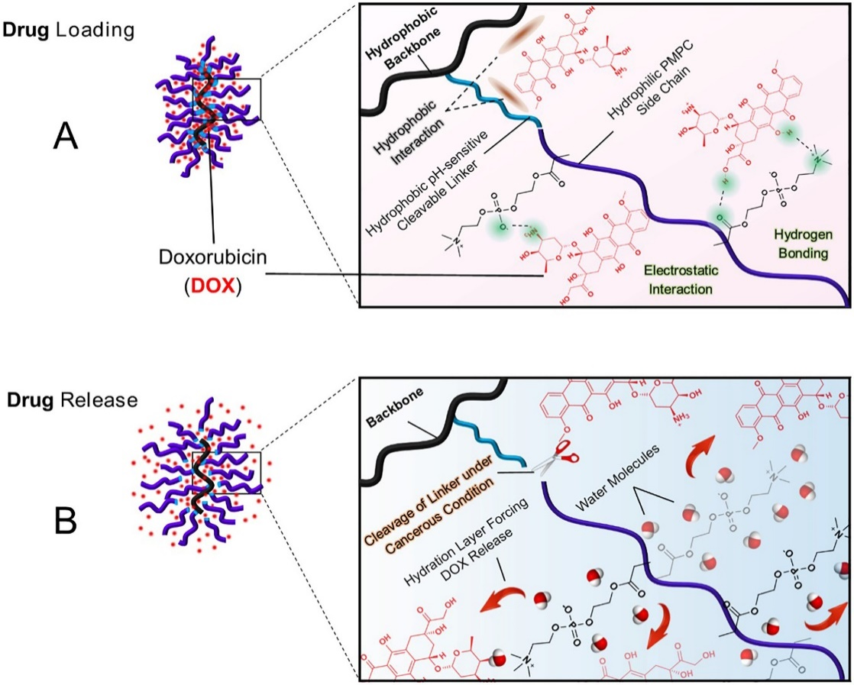
Figure 3. A phosphorylcholine-based bottlebrush polymer with pH-sensitive cleavable bonds for doxorubicin (DOX) delivery to the cancer cell line. (A) Drug loading and (B) drug release mechanism after side chains cleavage of the bottlebrush polymer under acidic conditions. Reprinted with permission from Ref. [58], copyright 2021, Elsevier Inc. All rights reserved.
    - Redox-Responsive Bottlebrush Polymers
One of the advantages of round brush-like molecules is providing a convenient framework for the preparation of cylindrically shaped nanomaterials. Several molecular templating approaches were reported for utilizing multicomponent bottlebrush copolymers to create structurally and functionally well-defined nanotubes [59]. For example, Rzayev group demonstrated numerous ways to achieve hollow organic nanotubes including their ability to disassemble [60, 61]. A new thiol-functionalized bottlebrush copolymer was successfully synthesized and transformed into degradable organic nanotubes (Figure 4). In this regard, the degradable organic nanotubes were prepared via single-molecule templating of core−shell bottlebrush copolymers. It was composed of two blocks including an etchable and degradable inner block based on polylactide and a functional cross-linkable outer block based on poly(styrene-co-maleic anhydride) [62]. The nucleophilic addition of cysteamine to anhydride groups in the polymeric backbone generates pendant mercapto groups along the outer block of chains. Later, the oxidization of mercapto functional groups within the shell layer can create degradable cross-linking disulfide units. By removing the polyester inner core through hydrolysis, hollow organic nanotubes were created, bound together by disulfide groups. Complete disintegration of nanotube structures into small fragments occurred when disulfide linkers were cleaved using 1,4-dithiothreitol (DTT) [62]. Although these nanotubes have not been used in delivery applications yet, they were shown to be capable of transporting dendrimers in their internal channel [63]. Furthermore, they were tested for in vitro performance like their internalization pathways dependent upon their surface chemistry alterations. The nanoparticles were internalized into HeLa cells through micropinocytosis in which by altering the surface's hydrophilic-hydrophobic balance, the group could control cell-to-nanoparticle interactions. [64].
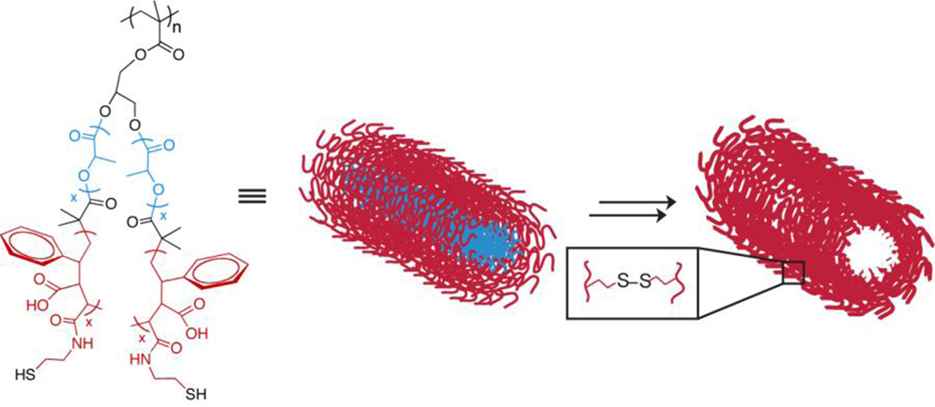
Figure 4. Synthetic pathway to multicomponent bottlebrush copolymers and fabrication of degradable organic nanotubes by molecular templating of core-shell bottlebrush copolymers with a potential for future delivery of water-soluble cargoes. Reprinted with permission from [62]. Copyright 2012 American Chemical Society.
    - Light-Responsive Bottlebrush Polymers
Designing a photo-responsive cleavable polymer is a common strategy to create light-degradable carriers for several biomedical applications [65, 66]. Likewise, for redox-responsive bottlebrush polymers, the Rzayev group also reported the synthesis of organic nanotubes from photo-cross-linkable-core–shell bottlebrush copolymer precursors by using “grafting from” approach via RAFT and ROP. The precursor polymers consisted of a poly(glycidyl methacrylate) backbone, an inner degradable polylactide (PLA) block, and an outer block containing photoactive coumarin functionalities, poly(styrene-ran-(7-(2-methacryolyoxyethoxy)-4-methylcoumarin)). [67]. Visible light-induced reversible photo-dimerization and cleavage occurred in the presence of coumarins, without requiring metal catalysts or additional additives. Consequently, the bottlebrush polymers showed excellent photo-responsive properties, including fast photo-response and effective photo-reversibility. Hollow cylindrical nanoparticles were formed through the hydrolytic removal of PLA blocks, and their shape and dimensions were maintained by coumarin photo-dimer cross-links. This new technique allowed for the creation of cylindrical nanocapsules without using any metal, using bottlebrush molecular templating, and can be applied in various ways [67]. Several linear polymeric materials with other photo-cleavable bonds were also reported. O-nitrobenzyl (ONB) derivatives are one of the common groups implemented at the middle site of the chain via controlled polymerizations, coupling reactions, and their combinations [68]. By exposure to UV light, the ONB groups can be broken down via photoisomerization [69]. In the case of bottlebrush polymers, a photo-cleavable bond can be introduced not only within the polymeric backbones or side chains but also between the side chain and backbone chains. A series of UV-cleavable bottlebrush polymers with o-nitrobenzyl-linked at the side chains of the polymer was synthesized by using the “grafting-onto” strategy. Poly(3-azido-2-hydroxypropyl methacrylate) was chosen as the backbone and ONB propargyl-capped polystyrene (PS-alkynyl) was grafted as the side chains on the backbone via copper-catalyzed azide alkyne cycloaddition (CuAAC) (“click” reaction). The side chains were detached and underwent elimination and decarboxylation reactions to form carbon dioxide and an azaquinone methide intermediate. The products were further reacted with water to form the final 4-aminobenzyl alcohol derivatives. Acrylate substituted poly(carbamates) as side chains were synthesized for further development of the model functional bottlebrush polymers, these chains' self-immolation disintegration continuously produced fluorescent signals. Furthermore, it is possible to easily adjust the overall rate of disintegration of bottlebrush polymers by modifying the side chain poly(carbamate) substituent group. Overall, that study explored innovative bottlebrush polymers with UV-cleavable side chains due to their ultrahigh molecular weight and worm-like molecular architecture, providing insights into controlled disassembly and potential applications in materials science [70, 71].

  - Star Polymers
Star polymers are structures in which polymer chains called arms are attached to the multifunctional core. These macromolecules can be synthesized using three different approaches analogous to the methods used for molecular brushes, “core first”, “arm first” and “coupling-onto” (Figure 5) [72]. Star polymers have much lower viscosity in solutions in comparison to linear polymers with the same molecular weight. On the other hand, they possess numerous functional groups in repeating units in the arms or at their ends, like molecular brushes. Macromolecules with star architecture can be divided considering the chemical composition of arms into regular (arms as homopolymers, block or random copolymers) and miktoarm (asymmetry in molecular weight, functional groups, and arrangement of arms) (Figure 5) [73, 74].
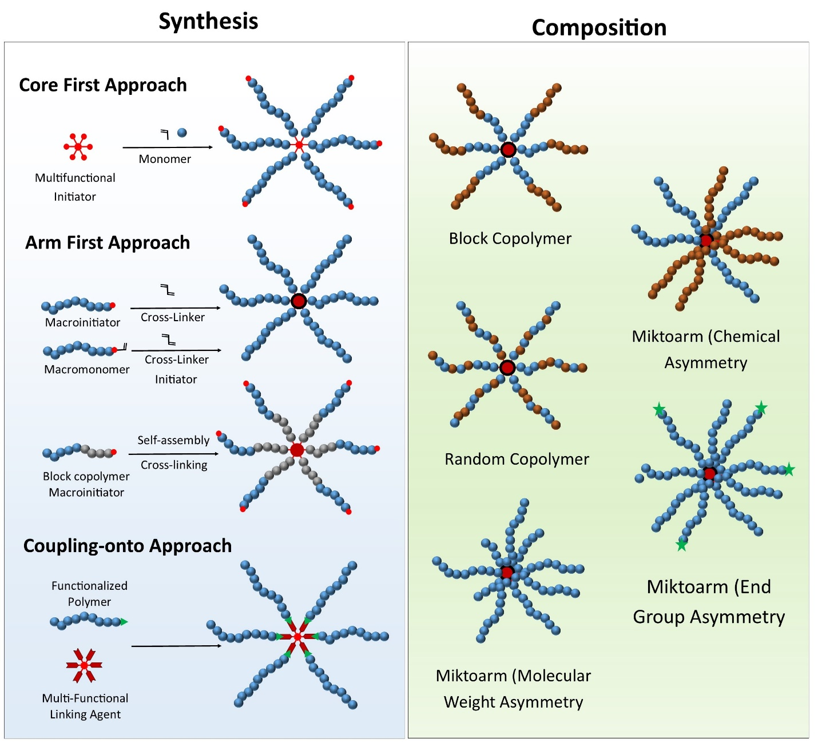
Figure 5. Synthesis approaches of star-shape polymers and their different types of compositions.
One of the first attempts to synthesize star polymers with cleavable bonds was reported in 2008 by Huang and Zhang [75]. A mixed-arm star polymer was synthesized utilizing both ATRP and RAFT approaches with a hyperbranched polyglycerol core with polystyrene (PS) and poly(acrylic acid) (PAA) arms. The arms were connected via ester bonds which could be hydrolyzed under specific conditions [76]. Later, other approaches for the synthesis of star polymers containing disulfide bonds were reported. In one of them, both “core-first” and “arm-first” approaches were chosen to synthesize a star polymer. In the “core-first” method, a three-armed initiator with disulfide linkage, hyperbranched polyglycerol modified with 2-bromoisobutyryl bromide within its structure was prepared and later the PS or poly(N-isopropylacrylamide) (PNIPAM) arms were obtained via RAFT. On the other hand, the “arm-first” approach was performed to form a star polymer via covalent coupling of the pre-synthesized arms to the initiator using a disulfide linkage. The cleavage study of both star polymers was done under the same conditions using DTT and glutathione (GSH) [77]. In the other report, another type of trifunctional RAFT CTA, 3-(hydroxylethyl disulfide) ethyl, 2-ethyltrithiocarbonate isopropionate (HDEEI), connected to the core of the star, 1,3,5-benzenetricarbonyl trichloride, via disulfide linkages was used and two polymeric arms with polystyrene or poly(poly(ethylene glycol) acrylate) (PEG-A, MW 454) were polymerized via RAFT. Then, disulfide linkages were introduced at the ends of the arms which enabled further modification with cholesterol and β-cyclodextrin (β-CD). The presence of a selective bond between arms and core but also between arms and cholesterol led to double cleavage using DTT [78]. Another example refers to the six-armed star polymers which were synthesized with a hexacarboxylic acid functionalized RAFT CTA, 3-(hydroxylethyl disulfide) ethyl, 3-benzyltrithiocarbonate propionate (HDEBP) with disulfide linkage between the core and arms, incorporated in the structure. Then, PS or PEG-A arms, and their block copolymers (PS-b-PEG-A) were prepared via RAFT. In the final step, DTT and GSH were used to investigate the detachment of the arms from the core [79]. It was found that the cleavage using DTT is much faster than GSH, however, usage of GSH imitates physiological conditions which is essential from the point of view of potential biomedical applications.
In further studies, Chen et al. [80] described the first method of synthesis of star polymers with four polystyrene arms and core containing both ester and disulfide bonds. Bis(2-hydroxyethyl) disulfide was esterified with 2,2-bis(2-bromoisobutyroyloxymethyl)propionic acid to obtain the initiator and then PS arms were grafted from four initial sites via ATRP. Disulfide linkage was in the middle of the core, thus using tri-n-butylphosphine (Bu₃P) or DTT the star polymer was degraded into halves (two linear PS). Next, ester bonds in the following structures were hydrolyzed using a potassium hydroxide solution creating shorter individual PS chains. One-step cleavage by direct hydrolysis of the star polymer was also demonstrated [80]. More complex star structures with cores containing ester and disulfide bonds in each initial site were also reported by Thang and Rosselgong et al. [32] using RAFT polymerization, a series of star polymers were prepared with four arms made of poly(methyl methacrylate) (PMMA), poly(N,N-dimethylacrylamide) (PDMA), polystyrene or block copolymer of poly(methyl methacrylate) and poly(poly(ethylene glycol) methyl ether methacrylate) (POEGMA, MW 500) (PMMA-b-POEGMA), respectively. Selective bonds in the core were cleaved under different conditions, for example, PMMA and PS homopolymer arms were detached via cleavage of disulfide bond using Bu₃P. For PMMA-b-POEGMA block copolymer arms, three reductive agents: Bu₃P, DTT, and tris(2-carboxyethyl)phosphine were applied. In the case of PDMA arms, ester bonds were cleaved in the acidic environment or in the presence of an esterase enzyme [32]. It was highlighted that the usage of cleavable linkages is potentially promising for biomedical applications like drug or gene delivery. They constitute a decent background for further research and open new possibilities to produce degradable star polymers also with other types of selective bonds. The most common cleavable bonds in star polymers are disulfide, ester, acetal, and azo linkages. They can be divided into pH- (acetal, ester), redox- (disulfide), and photo-cleavable (azo) and will be described in the following sections.
    - pH-Cleavable Star Polymers
Themistou et al. [81] synthesized star polymers with acetal linkages in the cores using an “arm-first” approach. POEGMA, poly(2-(dimethylamino)ethyl methacrylate) (PDMAEMA), and POEGMA-stat-PDMAEMA linear polymers were obtained via RAFT and then, cross-linking was done into stars using bis((2-methacryloyloxy)ethoxymethyl) ether (MOEME) with cleavable acetal linkages. The chemical composition of the arms was designed to provide different charge densities by combining the cationic properties of PDMAEMA with neutral POEGMA. The resulting star polymers could interact with DNA, and the yield of binding was improved by increasing the content of PDMAEMA in the star structure. However, polycations showed significant cytotoxicity, so the presence of POEGMA was essential to provide high cell viability. The authors found that the ratio of POEGMA to PDMAEMA should be further optimized to provide a higher level of DNA transfection. Acetal bonds in the cores enabled cleavage under an acidic environment (cell endosomal condition), leading to the degradation of stars to linear polymers. The prepared star polymers were introduced as promising gene carriers since their complexes with DNA showed low cytotoxicity, and good gene transfection and were effectively degraded in endosomal pH [81].
Synthesis of degradable star polymers with three arms made of poly(ethylene glycol) monomethyl ether (mPEG, MW 2 000) and poly(ε-caprolactone) (PCL) block copolymers (mPEG-b-PCL) was described by He et al. [82]. First, PCL with triple bond at the chain end was prepared by ring-opening polymerization and followed by CuAAC “click” reaction with mPEG-a-N₃ to obtain a diblock copolymer. Then, the prepared diblock copolymers were attached to the triprop-2-ynyl benzene-1,3,5-tricarboxylate (TPBTC) core via another “click” reaction to form (mPEG-a-PCL-a-) ₃ star polymers. The synthesis involved varying degrees of polymerization for PCL stars, with a constant DP for mPEG. Finally, the star polymers with acid-labile acetal linkages between the blocks in the copolymer and between the arms and core were obtained. It was found that prepared star polymers with amphiphilic arms self-assembled into micelles. The spherical micelles were formed at low concentrations and visualized by TEM, while rod-like objects were obtained at high concentrations. It was observed that higher DP of PCL block caused decreasing in critical aggregation concentration. Prepared micelles were stable in neutral pH but degraded in acidic pH due to the cleavage of acetal bonds. Micelles were used as DOX carriers, and it was found that more DOX was loaded into the hydrophobic core if PCL had a higher DP. Empty micelles had low cytotoxicity against L929 and HeLa cells. On the contrary, complexes with the drug inhibited the proliferation of HeLa cells due to the efficient delivery and release of DOX in the nuclei of HeLa cells. Release of DOX was investigated at 37 °C in buffer solutions with different pH (pH 5.0, 6.0, and 7.4). Prepared complexes were promising carriers for anticancer drugs [82].
An example of the usage of cleavable carbonate bonds in the core of the star was reported by Feng et al. [83]. They prepared a series of star polymers with poly(ethylene oxide) (PEO) and poly(propylene oxide) (PPO) arms using anionic ring-opening polymerization (AROP). In the “core-first” approach they copolymerized vinyl cyclohexene dioxide (VCD) with CO₂ to obtain carbonate core (PVCDC) and then polymerized PEO and PPO-b-PEO arms. In the “arm-first” method miktoarm star polymers with PPO and PEO arms were prepared. Carbonate linkages in the core were hydrolyzed in KOH however, they could degrade in both basic and acidic conditions with a potential application in drug delivery [83]. Another strategy for the synthesis of brush-arm star polymers (BASPs) with boronic ester labile bonds was described by Costa et al. [84]. Using “grafting through” they prepared brush-arms made of PEG which were then cross-linked into star polymers by boronic ester-based bis-norbornene derivative. The core of the stars was cleaved by hydrogen peroxide solution, while the stars were stable neutral and acidic pH, 7.4 and 5.5, respectively. Hydrogen peroxide is an example of reactive oxygen species (ROS) which excess lead to many diseases but on the other hand, they could be used for targeting delivery or imaging. Based on the presented synthetic procedure they prepared a second type of star polymers for magnetic resonance imaging (MRI). Spirocyclohexyl nitroxide “chex” was introduced into arms as a stable spin probe. Star polymers had high MRI contrast, while after degradation by H₂O₂ brush-arms had lower contrast (Figure 6) [84].
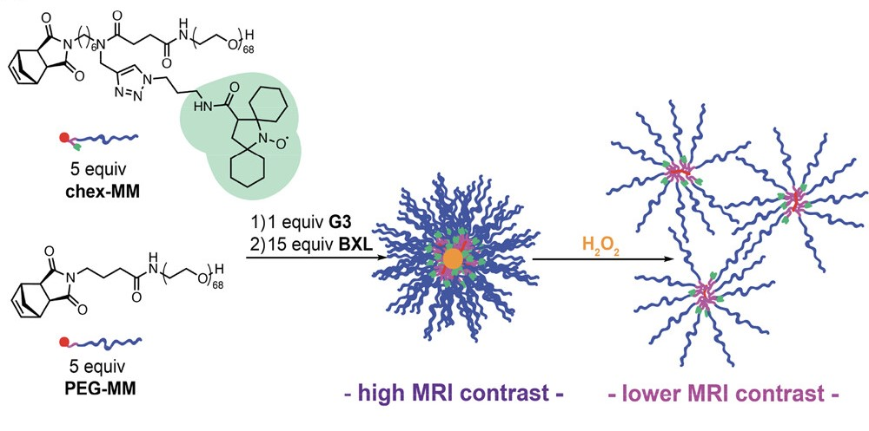
Figure 6. Redox-cleavable star polymers with high MRI contrast and low MRI contrast under peroxide. Reprinted with permission from [84]. Copyright 2012 American Chemical Society.
    - Redox-Cleavable Star Polymers
A redox-responsive star polymer with cleavable bonds for gene delivery was reported by Liu et al. [85]. In this regard, PDMAEMA was obtained via ATRP and extended with poly(N,N-bis(acryloyl)cystamine) (PBAC) to form the arms and core of the star, respectively. The formed structures were able to condense plasmid DNA (pDNA) with higher complexation efficiency in comparison to linear PDMAEMA due to the higher density of positive charges. The cross-linked core of the star contained disulfide bonds that could be cleaved using DTT and GSH thus it should also degrade in the intracellular environment and promote releasing of pDNA. The resulting complexes showed lower cytotoxicity than polyethylenimine (PEI25K, MW 25 000), also in vitro gene transfection efficiency results were promising. Another highlighted advantage of star polymers was the protection of DNA against DNase degradation [85].
Cyclodextrins (β-CD) have been also used as cores of the star polymers for pDNA delivery [86]. Xu et al. presented the synthesis of a β-CD core modified with 21 ATRP initiator molecules linked to the core by disulfide bonds. Cationic ethanolamine-functionalized poly(glycidyl methacrylate) (PGEA) arms were obtained via ATRP of PGMA and by ring-opening of epoxide groups, respectively. Then, star polymers were tested and found to be efficient carriers of pDNA, that could release active substance and be degraded in redox conditions by the cleavage of disulfide linkages using DTT. Cytotoxicity of synthesized star polymers depended on PGEA molecular weight, and it was lower than for PEI25K/pDNA complex. Moreover, the molecular weight of PGEA affected gene transfection. Efficient endosomal escape of pDNA was provided by the high buffer capacity of polycations like PGEA (or PDMAEMA) [87]. Li et al. [88] described the usage of γ-cyclodextrin (γ-CD) as a star core for oligoethylenimine (OEI, MW 600) arms. Then, folic acid (FA) was linked to the arm ends by disulfide bonds, and various ratios of FA to γ-CD-OEI (0.8, 1.3, 1.7) were employed. Cationic polymers in the arms formed complexes with pDNA, while folic acid interacted with folate receptors on the cellular membrane of cancer cells and enabled controlled delivery. The cleavage of disulfide linkages was tested using DTT, however GSH in the cells was expected to play the same role and lead to the degradation of the complexes. As gene transfection occurred, and folate receptor could be regenerated onto cellular membranes to increase gene expression. Prepared complexes showed low cytotoxicity (lower than for PEI25K), high selectivity due to usage of FA, and high efficiency of gene expression (6 times higher than PEI25K). Results obtained for γ-CD-OEI-SS-FA were compared with γ-CD-OEI-FA and confirmed the validity of the introduction of disulfide bond into star structure [88].
Miktoarm star polymers were reported as anticancer drug carriers by Yang et al. [89]. First, RAFT CTA was modified with 7-ethyl-10-hydroxycamptothecin (SN-38) which is an anticancer moiety for the treatment of colon cancer. Then, three different polymers, POEGMA (MW 475), PDMAEMA, and poly(n-butyl methacrylate) (PBMA) were synthesized via RAFT and connected using disulfide dimethacrylate cross-linker DSDMA. Each polymer in the star polymer structure exhibited different properties. Hydrophilic POEGMA increased the water solubility of SN-38 in comparison to the free drug, which is a relevant challenge in its medical applications [90]. The cationic section of PDMAEMA after quaternization potentially could be used for the complexation with small interfering RNA (siRNA). The release of the drug and degradation of the stars to linear polymers were tested by the cleavage of disulfide bonds by Bu₃P [89]. Analogous miktoarm star polymers were synthesized by Feng et al. [31] First, RAFT CTA was modified with arginyl glycyl aspartic acid (RGD) and used for the polymerization of PDMAEMA, PBMA, and POEGMA. Prepared arms were cross-linked by disulfide dimethacrylate (DSDMA) to form stars consisting of a biodegradable core and three different types of arms with RGD peptide on the ends. Obtained structures showed very low cytotoxicity in various concentrations. Under reductive conditions, in the presence of GSH, Bu₃P or DTT arms were successfully cleaved to form linear polymers. Described star polymers have potential applications as drug or gene carriers in cancer treatment. The presence of the RGD peptide should additionally increase the selectivity of the complex [31].
Another possible application of materials based on star polymers is bone regeneration. Jones et al. [91, 92] described hybrid sol-gel materials based on star polymers made of cores with and without cleavable disulfide bonds and poly(methyl methacrylate-co-3-(trimethoxysilyl)propyl methacrylate) (P(MMA-co-TMSPMA) arms. Stars were synthesized via “arm-first” approach thus polymer chains were cross-linked using a disulfide dimethacrylate cross-linker (DSDMA). Inorganic-organic hybrids P(MMA-co-TMSPMA)-SiO₂ were obtained after a sol-gel reaction with tetraethyl orthosilicate (TEOS). Synthesized materials showed better mechanical properties than bioactive glass (typically used for bone regeneration), they passed cytotoxicity tests, and MC3T3-E1 preosteoblast cells were successfully attached to their surface which made them suitable for bone regeneration. Moreover, comparison to star polymers without degradable cores proved similar mechanical properties and cell attachment characteristics. Selective disulfide bonds in the cores of individual stars and hybrid materials were cleaved using GSH to obtain linear polymers. Molecular weight determined after cleavage was low enough for the filtration of macromolecules by the kidneys [91, 92].
    - Photothermal-Cleavable Star Polymers
Star polymers were also modified by azo bonds that are cleavable under photothermal conditions. To do so, Sumerlin et al. [93] synthesized block copolymers of poly(ethylene glycol) monomethyl ether (PEG, MW 5 000) and poly((N-2-hydroxypropyl) methacrylamide) (PHPMA) via RAFT. Hydroxyl groups of PHPMA were then esterified with carboxylic groups in the structure of 4,4’-azobis(4-cyanovaleric acid) to form star polymers containing azo linkages. Their stability was tested using Nile red dye and it was found that stars were stable at room temperature, while degradation occurred at 90 °C. Due to that near-infrared (NIR) light was selected as an external stimulus that could indirectly induce degradation of the azo bond. An important advantage of the usage of NIR is that it penetrates tissues deeper than e.g. UV and causes fewer side effects [94]. Therefore, obtained star polymers were studied as active substance carriers using indocyanine green (ICG) as a photosensitizer that generates site-specific heating upon NIR radiation and induces azo bond cleavage. Both ICG and furan-modified fluorescein (FF) were loaded into the core of the stars to check the releasing process. Azo linkage cleavage and efficient FF release were observed only with ICG incorporated in the core and under NIR radiation. Investigated star polymers had potential applications for drug delivery with well-controlled external stimuli generated release [93].

  - Dendritic Polymers
Two main subclasses of dendritic polymers are hyperbranched polymers (HBPs) with randomly branched molecules and dendrimers with regular branched and uniform structures (the linear, branched, and cross-linking polymers). HBP are three-dimensional and spherical, which makes them stand out among the existing polymers because of their appealing characteristics including highly branching topological structures, sufficient spatial voids, several terminal functional groups, and easy synthetic processes. HBPs can be divided into two main categories: compact HBPs and segmented HBPs. The occurrence of one or more repeating units between two branching points is typical for compact HBPs. Such HBPs have a compact branching topology and peripheral functional groups. In contrast, segmented HBPs possess weakly branched architecture, and their long linear segments are dispersed between two branching points. Segmented HBPs’ reactive groups may be located inside or on the periphery of the structure. There are four main synthetic routes toward compact HBPs synthesis: single-monomer methodology (SMM), double-monomer methodology (DMM), couple-monomer methodology (CMM), and multi-component methodology (MCM), whereas segmented HBPs can be synthesized through polymerization of AB₂ type macromonomer or copolymerization of A₂+B₃ type (macro)monomers [95]. SMM and DMM approaches are presented in Figure 7A. Biocompatible or biodegradable hyperbranched structures can be achieved through step-growth polycondensation (SGP), self-condensing vinyl polymerization (SCVP), self-condensing ring-opening polymerization (SCROP), and similar techniques.

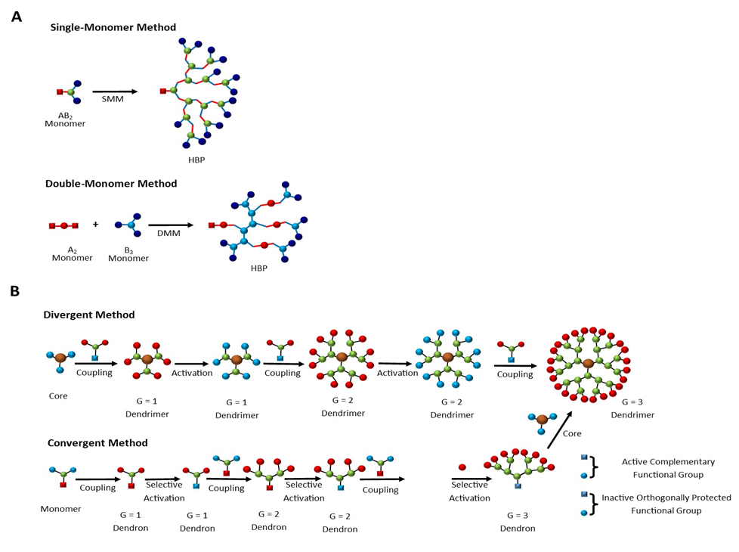
Figure 7. Selected synthetic routes for the synthesis of dendritic polymers. (A) Single-monomer methodology (SMM) and double-monomer methodology (DMM) for the synthesis of hyperbranched polymers. (B) Divergent and convergent methods for the synthesis of dendrimers (B).

The characteristics of biocompatible or biodegradable HBPs can be customized for specific purposes using terminal modification, backbone modification, or hybrid modification. A broad range of fields have seen the exploration of HBPs' applications due to their exceptional physical and chemical properties with unique advantages in biological and biomedical systems. All of the following features are of great significance for designing and producing HBPs biomaterials: (1) The technique of preparing HBPs often just requires straightforward one-pot reactions rather than complex synthesis and purification steps. This simplifies the manufacturing process and lowers production costs. (2) The abundance of HBP end groups provides the sites for the conjugation of functional moieties and can also be used to customize the compounds' characteristics like increasing their adaptability in biological conditions. (3) HBPs possess excellent biocompatibility and biodegradability, as well as the capacity to include a variety of guest molecules via covalent or noncovalent methods [96].
Dendrimers, which are synthetic polymers with several exposed anionic, neutral, or cationic terminal functions on their surface and branched repeating units that emerge from a focal point, are another subclass of dendritic polymers. The terminal functional groups lead to hydrophilic or hydrophobic nature of the polymer. Due to the nanometric size of with radially symmetric, mono-dispersed, and homogenous properties, dendrimers have been used in nanomedicine research [97, 98]. Aside from their apparent utility as drug delivery or gene carrier systems, research has revealed that certain dendrimers have therapeutic applications of their own, primarily because of their antifungal [99], and antibacterial [100, 101], and cytotoxic properties [102, 103]. Dendrimers lie on the border between polymer and molecular chemistry. They are related to the field of molecular chemistry due to their step-by-step planned synthesis, and they are related to the field of polymers because of their repeating monomer structure. Dendrimers are generally prepared using either a divergent method or a convergent one (Figure 7B). In the different methods, the dendrimer grows outward from a multifunctional core molecule. The core molecule reacts with monomer molecules containing one reactive and two dormant groups, giving the first-generation dendrimer. Then, the new periphery of the molecule is activated for reactions with more monomers.
    - pH-Cleavable Dendritic Polymers
According to the type of pH-sensitive bond, dendrimeric polymers can contain ester, acetal/ketal, and hydrazone bonds. Dendrimeric polymers, having different functions, are stable in physiological conditions for a long enough time to reach the target tissue/cell, and then due to the presence of labile bonds can be biodegraded into smaller fragments or monomer units to be excreted from the body by metabolic pathway. Fragmentation alleviates toxicity issues because it minimizes the accumulation of dendrimeric polymers in tissues/cells and results in more efficient elimination [104].
Degradability of dendrimeric polymers containing pH-sensitive ester bonds can be used in MRI [105]. Paramagnetic gadolinium chelate conjugated with polyester dendrimer with β-cyclodextrin core, synthesized by the sequential clicking reaction of cysteamine and 2-[(methacryloyl)oxy]ethyl acrylate, was tested as an MRI contrast agent. Hydrolysis of ester bonds was performed in phosphate-buffered saline with a pH of 7.4. After 20 h, 30% of the ester bonds of the prepared dendrimer contrast agent, were hydrolyzed. It was shown that the addition of an esterase, which is present in substantial amounts in the cytoplasm, accelerated hydrolysis notably. Under the same conditions, only 50% of ester bonds remained after 6 h of hydrolysis. Described studies revealed that biodegradable conjugated dendrimers can be fragmented and excreted from the body. The degradability of ester bonds led to minimal tissue retention of toxic Gd in mice. Moreover, Gd-chelate dendrimer showed significant blood pool and kidney contrast enhancement, higher than small molecules of Gd chelate [105].
Surface PEGylated polyester dendrimers were used to prepare nanocarriers for pressurized metered-dose inhalers [106]. The effect of dendrimer generation and surface chemistry on dendrimer interactions with a model of the pulmonary epithelium, as well as the transport of dendrimer to and through the lungs, were investigated. PEGylation facilitated the formulation of dendrimer in a portable oral-inhalation device, which had a positive impact on the uptake and transport across the polarized epithelium and allowed regulation of the degradation of the dendrimer. Degradation of synthesized dendrimers was performed in phosphate (pH= 7.4) or citrate buffer (pH= 4.5) to ensure extracellular or lysosomal conditions, respectively. Ester bonds were stable under acidic conditions over 30 days of degradation studies. At pH 7.4 PEGylated dendrimer was stable for 5 days. After 25 days, all the PEG chains were shed and on the 30th day, the dendrimer structure was under degradation, while non-PEGylated dendrimer lost only one monomer unit over 30 days [106].
Biodegradable polyester dendrimer containing protocatechuic acid (3,4-dihydroxybenzoic acid; PCA) as a building block is a potential anticancer drug and carrier for drug release [107]. PCA dendrimers could be loaded with DOX due to π–π stacking interaction between the dendrimers’ and DOX’s benzene rings. Interestingly, they exhibited pH and redox-dual responsive drug release. Full degradation of PCA polyester took 3 hours when treated with DTT in the presence of triethylamine (TEA). The release of DOX was studied at pH 5.0 and 7.4. After 48 h, about 95% and 38% of doxorubicin was released at pH 5.0 and 7.4, respectively. Enhanced drug release at pH 5.0 might be attributed to hydrolysis of phenol ester at pH 5.0. Furthermore, it could be the result of reduced π–π stacking interaction between the dendrimer and DOX caused by partial ionization of DOX at a lower pH. DOX release was also investigated in the presence of GSH. The presence of GSH caused faster DOX release that could be attributed to GSH-triggered thiolysis of phenol ester. Acid-promoted drug release is auspicious for anticancer drug delivery systems since it may diminish the nonspecific drug release during blood circulation (pH 7.4). GSH-dependent drug release PCA dendrimer system enhanced the delivery of drug to the target cells because it released the drug faster in the reducing environment inside the cells than in the blood [107].
Another degradable polyester dendrimer, based on 2,2- bis(hydroxymethyl)propionic acid (bis-MPA) monomer, was also tested as a potential drug carrier. PEGylation of the dendrimer leads to the preparation of water-soluble dendrimer with encapsulated DOX [108]. Similar to the above-described studies [107], the faster release of DOX at pH 5.0 than at pH 7.4 was explained by the faster degradation of the polyester structure in acidic conditions [108].
Khoee et al. [109] described the preparation of pH-susceptible dendrons based on linear poly(ε-caprolactone), dendritic polyamine-ester, and linear poly(ethylene glycol). The amphiphilic dendrons could self-assemble and form micelles in water. Therefore, the authors prepared magnetite particles coated with these amphiphilic block copolymers intended for the effective entrapment of hydrophobic drugs for targeted therapy. Hydrolysis of dendrons was studied at pH 5.8 and 7.4 at 37 °C. Cleavage of ester bonds led to the formation of water-soluble oligomers [109]. They also demonstrated that the presence of PEG slowed down the degradation of the core which is consistent with studies reported by Heyder et al. [108]. The authors also examined the dependence of the degradation rate of dendrimers on dendrimer generation. The rate of hydrolytic degradation of 3rd generation dendrimer was higher than that of 2nd generation dendrimer, while the 2nd generation dendrimer was higher than that of 1st generation dendrimer [108].
Dendritic polymers containing pH-labile acetal/ketal groups are another important class of dendritic polymers in biomedical applications. Huang et al. [110] described facile synthesis of acid-labile polyacetal dendrimers, by alternating reaction of an asymmetry acetal monomer and cysteamine via azo-Michael addition and thiol-ene “click” reaction, with POSS core. Synthesized dendrimers were functionalized by PEG or zwitterions and self-assembled into charge-reversible and pH-responsive degradable micelles or nanofibers. The presence of acetal groups enabled pH-responsive degradation of dendrimers in phosphate buffer at pH 5.0, which makes polyacetal dendrimers promising anticancer drug delivery systems. Similarly to polyester dendrimers [109], the hydrolysis rate of polyacetal dendrimer was dependent on dendrimer generation. It decreased with increasing generation. Moreover, dendrimers exhibited a pH-triggered charge reverse behavior [110].
The same research group [111] synthesized polyacetal dendrimers with a β-CD core and adamantane-terminated zwitterionic poly(sulfobetaine), that could self-assemble into charge-reversible and pH-sensitive biodegradable micelles or vesicles. Host-gest recognition of polyacetal dendrimers with β-CD core and adamantane-terminated polymers formed amphiphilic linear-dendritic block copolymers. Zwitterionic linear segments provided charge-reversal ability and excellent resistivity to protein absorption. DOX was encapsulated into the micelles and vesicles. Because of acid-labile acetal bonds present in the dendritic segments, nanoparticles could release DOX at pH 5.0 while they were stable at pH 7.4. DOX-loaded nanoparticles are promising nanocarriers of anticancer drugs because they also exhibit remarkable cytotoxicity against cancer cells [111].
Tonhauser et al. [49] utilized acetal-containing epoxide inimer for the synthesis of a degradable hyperbranched polyether backbone. The authors copolymerized a new monomer, 1-glycidyloxy)ethyl ethylene glycol ether, in anionic ROP with ethylene oxide or glycidol. Obtained hyperbranched polyether polyols revealed a strong pH dependence on their half-time. Toxicity tests were not performed but the authors claimed that obtained structures can be used in pharmaceutical applications [112].
Shenoi et al. [113] reported the synthesis of hyperbranched polyglycerols based on a degradable core structure. Acid-sensitive core was prepared by anionic ring-opening multi-branching polymerization of glycidol with the use of initiator-bearing dimethyl and cyclohexyl ketal groups, containing varying numbers of hydroxyl and ketal groups. Studies have shown that polymers were stable at neutral pH, however, their degradation rate could be controlled at acidic pH and depended on the number of hydroxyl and ketal groups in the initiator structure. Hyperbranched polymers with the core bearing cyclohexyl ketal groups exhibited slower degradation than those containing dimethyl ketal groups. The biocompatibility of hyperbranched polymers and products of their degradation was tested by blood coagulation, complement activation, platelet activation, and cell viability assays. Excellent biocompatibility, together with a controlled degradation profile proved hyperbranched polyglycerols are suitable for drug delivery and bioconjugation applications [112].
Shenoi et al. studied not only the degradation of dendritic polymers with structurally different ketal linkages in the core [113] but also in the backbone [114]. They synthesized dendritic poly(ketal hydroxyethers), containing cyclic and acyclic ketal bonds, by anionic ring-opening multi-branching polymerization of α-epoxy-ω-hydroxyl-functionalized AB2-type ketal monomers. The polymer degradation was dependent on the pH and molecular structure of the ketal linkages. Structure dependent-degradability of synthesized dendritic polymers in an aqueous acidic solution was controlled by the torsional strain of the substituted ketal groups, whereas the degradation of polymers with acyclic ketal groups was additionally dependent on the hydrophobicity of the polymer. Determined hydrolysis half-lives of poly(ketal hydroxyethers) ranged from a few minutes to a few hundred days and could be tuned by altering ketal group structures. Control of the degradation could be achieved not only in an aqueous solution, but it was also tested in cells by delivery of a fluorescent marker to the cytosol. Moreover, degradation products were nontoxic and neutral, and they could be easily excreted from the cells. Studied poly(ketal hydroxyethers) exhibited high cell viability and blood compatibility that makes them promising candidates for drug delivery devices [114].
Amphiphilic dendritic polymers containing two types of pH-sensitive bonds, acetal and hydrazone bonds in their backbone were also reported [115]. It consisted of hydrophobic hyperbranched polyacetal core and hydrophilic poly(ethylene glycol) chains linked to the core by hydrazone bonds. A prepared hyperbranched polymer formed 35 nm micelles and was tested as a drug (DOX) carrier.
Hyperbranched polymers with pH-sensitive acylhydrazone bonds were also studied for biomedical applications, as drug carriers. Zhu et al. [116] prepared backbone cleavable hyperbranched polyacylhydrazone (HPAH) by polycondensation of 2,3-butanedione and 1-(2-aminoethyl) piperazine tri-propionylhydrazine. The hyperbranched polymer was conjugated with DOX via acylhydrazine terminal groups. Due to its amphiphilicity, obtained conjugate self-assembled into micelles. They were stable at physiological conditions (pH = 7.4), while after cellular uptake, in an acidic lysosome environment (pH = 5-6), degraded into oligomers and monomers releasing DOX. Described polyacylhydrazone exhibited low cytotoxicity which makes it a potential drug delivery vesicle. Zhu et al. [117] also studied PEG-modified HPAH as a tumor-targeted drug delivery system. The combination of HPAH aimed to increase biocompatibility and decrease recognition and phagocytosis by the reticuloendothelial system. HPAH-PEG micelles had a diameter of about 190 nm and demonstrated pH-controlled release of hydrophobic chemotherapy drugs - DOX (nuclear DNA-targeting drug) and docetaxel, DTX (cytoplasmic tubulin-targeting drug). Moreover, HPAH-PEG with loaded DTX exhibited better anti-tumor efficacy and lower toxicity in vivo in comparison to free DTX.
    - Redox-Cleavable Dendritic Polymers
Hyperbranched polymers with redox-responsive disulfide bonds can be utilized for gene therapy. Peng et al. [118] reported the synthesis of galactose-based cationic hyperbranched polymers composed of 2-lactobionamidoethylmethacrylamide and 2-aminoethylmethacrylamide, and cross-linker N,N′-bis(methacryloyl)cystamine. Described polymers formed polyplexes with siRNA and then released payload in GSH solution, owing to the presence of disulfide linkages in cross-linkers. Redox-responsive S-S bonds facilitate the targeted release of siRNA in a tumor environment, where the concentration of GSH is elevated in comparison to disease-free tissue. Studies showed that described polymers could silence protein tyrosine kinase receptors, like epidermal growth factor receptor (EGFR), in about 85%, in the presence of serum protein. EGFR controls signaling networks responsible for cellular processes taking part in tumor carcinogenesis [119]. Furthermore, galactose-based hyperbranched polymers exhibited high cellular uptake and very low cytotoxicity (95% cell viability) in normal cell lines [118].
Redox-sensitive amphiphilic Janus dendrimers were also utilized in siRNA delivery. Du et al. [120] synthesized Janus dendrimer with a cationic hydrophilic head containing three amino groups and a hydrophobic tail possessing two fatty chains with disulfide bonds. Described Janus dendrimer self-assembled into a bilayered spherical vesicle-type structure called a dendrimersome. As-prepared redox-sensitive dendrimersome could bind siRNA via electrostatic interactions. After internalization into tumor cells, a high level of intracellular GSH caused the release of siRNA and improved gene silencing. Moreover, dendrimersome with loaded siRNA exhibited excellent biocompatibility, which together with effective downregulation of gene expression, makes redox-sensitive amphiphilic Janus dendrimer suitable for cancer therapy as an siRNA delivery carrier.
Zhuang et al. [121] designed and synthesized backbone redox-responsive hyperbranched poly(2-((2-(acryloyloxy)ethyl)disulfanyl)ethyl 4-cyano-4-(((propylthio)carbonothioyl)-thio)-
pentanoate-co-poly(ethylene glycol) methacrylate) (HPAEG) using RAFT polymerization and self-condensing vinyl polymerization. Due to the presence of surface vinyl groups, HPAEG was functionalized with DNA aptamer AS1411, forming tumor-targeting drug delivery carriers (HPAEG-AS1411). AS1411 binds specifically with nucleolin receptors that are overexpressed in cancer cells. The amphiphilic structure of HPAEG-AS1411 could self-assemble into nanoparticles and encapsulate the DOX anticancer drug. Formed nanoparticles were then internalized into cancer cells. HPAEG-AS1411 was uptaken via endocytosis and DOX was released rapidly in the cytoplasm as a result of cleavage of disulfide bonds by GSH. DNA aptamer-modified HPAEG has potential application as a targeted drug delivery system in cancer therapy because when loaded with DOX, it exhibited a high tumor cellular proliferation inhibition rate and low cytotoxicity to normal cells.
Zhang et al. [122] described redox-multi cleavable dendritic comb-like and toothbrush-like copolymers obtained via self-condensing vinyl polymerization, sequence-controlled copolymerization, and the RAFT process. Dendritic comb-like copolymers with alternating PEG and PCL grafts were synthesized via RAFT copolymerization of a disulfide-linked polymerizable RAFT agent and styrene and maleimide macromonomers, while dendritic toothbrush-like copolymers were obtained via a subsequent chain extension polymerization of styrene, tert-butyl acrylate, methyl methacrylate, and N-isopropylacrylamide. In vitro drug release studies revealed that copolymer self-assembled aggregates could rapidly release DOX in 10 mM DTT solution due to the cleavage of disulfide linkages in branching points of the copolymer.
    - Photo-Cleavable Dendritic Polymers
Another group of hyperbranched polymers utilized in biomedical applications is dendritic polymers with photo-cleavable linkages such as o-nitrobenzyl and labile coumarin group. Li et al. [123] prepared a library of photo-cleavable amphiphilic Janus dendrimers. Hydrophilic and hydrophobic dendrons were connected via labile o-nitrobenzyl group that allowed for photocleavage, disassembly, and reassembly into nanometer size unilamellar-like (≤2 visible lamellae) vesicles or micron size onion-like and multilamellar dendrimersomes. Upon 405 nm laser illumination, big dendrimersomes disassembled and reassembled into smaller vesicles. Moreover, when dendrimersomes were loaded with cargo they released 70-85% of it within 15 s. Doxorubicin and enzyme (E. coli dihydrofolate reductase) were tested. Presented amphiphilic dendrimers can interface with cells and they can be used in the modulation of cells in response to light stimuli for synthetic biology.
Nazemi et al. [124] also prepared polyester dendrimers with photodegradable backbone using bis(hydroxymethyl)propionic acid as a monomer. It underwent complete photolytic degradation in visible and near-infrared light due to the presence of o-nitrobenzyl moieties. The authors did not study synthesized dendrimers for biomedical applications, but they claimed that these hyperbranched polymers are suitable for such usage.
Dendritic polymers containing coumarin groups can be utilized in drug [125] and gene delivery [126]. Pashaei-Sarnaghi et al. [127] prepared 7-(carboxymethoxy)-4-methylcoumarin anchored fourth-generation polyamidoamine (PAMAM) dendrimers. The authors synthesized dendrimers containing different amounts of coumarin moieties. Due to the presence of coumarin groups, dendrimers could be cross-linked and broken down under UV light at wavelengths of 365 and 254 nm, respectively. Nanometer-sized spherical structures were formed before and after cross-linking and were utilized as nanocarriers of DOX. Studies showed that the release of DOX from photo-cross-linked structures was lower than from the samples before cross-linking, because of the photodimerization of coumarin moieties that decreased the ability of DOX to be released from the structure. As expected, the photocleavage of cross-linked coumarins under UV light at 254 nm resulted in increased DOX release. Wang et al. [126] synthesized first-generation PAMAM dendrimers modified with coumarin moieties and showed that these types of dendrimers could be utilized not only in light-responsive drug delivery but also as an efficient gene delivery system at the same time. Amphiphilic dendrimers assembled in aqueous solution via hydrophobic interactions. They exhibited light-responsive delivery of 5-fluorouracil (anticancer drug) and therapeutic gene encoding tumor necrosis factor-related apoptosis-inducing ligand. Moreover, they demonstrated very low toxicity to the transfected cells.

  - Polymeric Gels
Polymeric gels are versatile semi-solid materials, comprising cross-linked polymer networks with cavities, in which various molecules such as solvent or drug molecules can be trapped [128]. They have tunable composition and controlled size, which enables the modification of water or solvent content and adjustment of properties such as biocompatibility. The ability to retain molecules inside the network allows the incorporation of drugs, proteins, or DNA, which makes polymeric gels attractive for biomedical applications [129]. Polymeric gels can be synthesized via two approaches: from monomers or from polymers. During synthesis from monomers, the gel network structure is formed during the synthesis of polymeric chains either via polymerization or polycondensation. In the case of free radical polymerization, two monomers should be applied, a vinyl monomer with one carbon-carbon double bond and a multifunctional monomer with at least two nonconjugated carbon-carbon double bonds. However, in the case of polycondensation, a monomer with two functional groups is used as a constructive linear polymer, and three or more functional monomers are used as cross-linkers [130]. In the second approach, synthesizing polymeric gels from polymers, the network is obtained by cross-linking of already synthesized polymer chains. Cross-linking can be done in several ways, depending on the chemical structure of the polymeric chains and it can also be divided into chemical or physical cross-linking [131]. The most common approaches for the synthesis of polymeric gels are presented in Figure 8. For polymers containing carbon-carbon double bonds, cross-linking can be done using sulfur, photo cross-linking, or multifunctional monomers [132, 133]. For example, to synthesize gel from polyacrylamide (PAAm), two monomers are used: acrylamide and N, N′­methylenebisacrylamide [134, 135]. For polymers containing functional groups, cross-linking can be achieved through the reaction of those functional groups with multifunctional cross-linkers, such as esterification reaction or amide bond formation [136, 137]. Physical methods are more desired in biomedical applications, because of the absence of chemical cross-linker, moreover, physical cross-linking is reversible when conditions such as pH or temperature are altered. Physical cross-linking can occur through the following interactions: electrostatic, hydrophobic, van der Walls forces, polymer interchain interactions, or hydrogen bonds [135, 138, 139].
Figure 8. Methods of synthesis of polymeric gels.
    - pH-Cleavable Gels
The pH-responsive behavior in biomedical applications of hydrogels plays a significant role in drug release and targeted drug delivery, as tumor tissues and inflammatory sites exhibit lower pH in comparison to healthy tissues [140-143]. Several injectable hydrogels with pH-cleavable bonds for biomedical applications have been reported recently. Li et al. developed a pH-responsive hydrogel-based natural polymer loaded with insulin as a bioactive dressing for enhancing diabetic wound healing [144]. Healing of foot ulcers in diabetic people is especially difficult, because of the acidic and hyperglycemic microenvironment [145]. A hydrogel was synthesized from n-carboxyethyl chitosan (N-chitosan), hyaluronic acid-aldehyde (HA-ALD), and adipic acid dihydrazide (ADH) with acyl hydrazone, a pH-sensitive reversible dynamic bond. Insulin was incorporated into the hydrogel in the form of insulin glargine and the drug-release and wound-healing properties were examined. The hydrogels were soaked in PBS containing lysosome (104 units/mL) with pH values varied from 6.5 to 7.4 at 37 °C and showed a higher degradation under acidic conditions than in physiological conditions, which was attributed to the lability of acyl hydrazone bonds in an acidic environment. The wound healing properties were also examined on rats with induced diabetes, with a 5 mm wound on their feet. The studies confirmed that insulin-loaded hydrogel shortened the inflammation phase, enhanced granulation tissue formation, accelerated re-epithelialization and neovascularization, and promoted collagen deposition, thus significantly accelerating healing. Moreover, the released insulin maintained the original bioactivity [146].
Zhao et al. also reported the synthesis of pH-responsive hybrid hydrogel for bone tissue engineering using carboxymethyl chitosan (CMCh) nanoparticles and amorphous calcium phosphate (ACP) hydrogel [108]. The particles were blended into the hydrogel via the incorporation of δ-lactone (GDL) into a basic dispersion of freeze-dried nanoparticles. The surface charges of CMCh-ACP hybrids were pH-dependent, which caused electrostatic self-assembly. After the addition of GDL to particle dispersion at pH 11.0, large aggregates were detected and with a gradual decrease of pH down to 7.5, self-assembly was triggered. Right after the addition of GDL, particles shrunk aggregates grew gradually in time, precipitated after 30 minutes, and a two-phase system was formed. The hybrid gel remained stable at pH 7.5 for 36 h and remained injectable. The CMCh-ACP hydrogel exhibited excellent biocompatibility and effectively supported MSC proliferation and cell adhesion. The gel was found to be osteoinductive and able to induce osteogenic regulators and bone markers in vitro [147]. Rogina et al. developed a pH-responsive hydrogel based on chitosan-hydroxyapatite with potential application as a cell carrier [148]. Sodium bicarbonate was used as the gelling agent, which allowed non-cytotoxic rapid gelation within 4 minutes. The gel was synthesized via in situ formation of the hydroxyapatite phase by wet precipitation reaction from calcium and phosphate starting materials. The in situ process resulted in a stable composite suspension and a homogenous final product. Moreover, this process resulted in a pH higher than the initial chitosan solution, which ensured cell viability during encapsulation. The pH-dependent behavior was mainly rheological and due to the hydration of chitosan [148].
In another study, Chen et al. synthesized a pH and temperature dual-responsive liposome gel with potential application as a vaginal delivery system [149]. This material was designed as a liposome gel that would selectively degrade in locally acidic vaginal conditions. The liposome was prepared from methoxy polyethylene glycol 2000-hydrazone-cholesteryl hemisuccinate (mPEG2000-Hz-CHEMS), cholesterol, and soybean phosphatidylcholine and subsequent loading with arctigenin. The hydrogel was then prepared from P188 and P407 poloxamers and the pH-sensitive liposomes. Gelation temperature was dependent on the ratio of P407:P188 and for composition of 1:1, gelation occurred at 37.6 ± 1.8 °C. It was found that the addition of pH-responsive liposomes did not affect the gelation significantly. The gelation temperature around human body temperature indicated that the gel could be used for a vaginal drug delivery system which could be formed at room temperature and would create a gel in situ after vaginal administration. The pH sensitivity tests showed that the liposome gels stored at pH 5.0 completely eroded after 5 days, whereas in pH 7.4, and 9.0 complete erosion took 5 weeks. The in vitro drug release studies were performed in different pH buffers over 2 days at 37 °C. At pH 5.0 the material showed constant drug release, which was completed within 3 days. The cytotoxicity tests showed that arctigenin-loaded liposome gel was less toxic than pure arctigenin [149].
    - Redox-Cleavable Gels
The incorporation of disulfide bonds is a common strategy in obtaining physiologically degradable, redox-responsive hydrogels. Zha et al. synthesized a dual acid- and thiol-cleavable multifunctional hydrogel for codelivery of both antimicrobial and anticancer drugs [150]. The hydrogel was synthesized via radical polymerization of oligo(ethylene glycol) methyl ether acrylate (OEGMA), camptothecin prodrug monomer (CPTM), and poly(ethylenimine) (PEI) derivatives (-COOH/-vinyl), which acted as acid-responsive cross-linkers. The covalent dynamic Schiff base cross-linking bonds dissociated upon exposure to acidic microenvironment. Synthesized hydrogels were loaded with curcumin, which was capable of on-demand release from the polymeric network. The pH-cleavable behavior was studied by keeping the hydrogel at pH=5.0 at 37 °C for 6 days, after which the gel dissolved and created aggregates with an average diameter of 160 nm. The CPTM’s response to thiols occured due to the presence of disulfide linkage, which was essential as tumor tissues have significantly higher GSH levels. The pH and thiol-responsive behavior resulted in targeted drug release, with 40% CPT released after 2 h incubation, followed by a sustained release. To study the stability of the incorporated drug, the hydrogel was kept in acid aqueous solution in the absence of thiol, and it was found that only a small amount of CPT was released, proving that the synthesized hydrogel could serve as an optimal platform for protecting anti-cancer drugs and maintaining a sustained slow drug release [150].
The synthesis of redox-cleavable aqueous poly(N-vinyl caprolactam) (PVCL) microgels with a cross-linked based on cyclodextrin (CD) and ferrocene (Fc) derivatives for potential drug delivery applications was reported by Jung et al [151]. PVCL is highly resistant to hydrolysis, undergoes phase transition in the physiological temperature range, and is highly biocompatible. The reported material could be degraded using chemical oxidants such as ferric chloride (FeCl₃) or hydrogen peroxide (H₂O₂) or via oxidation during bulk electrolysis. The sensitivity to hydrogen peroxide plays an important factor in cell signal transduction as a cell-signaling molecule. This redox-cleavable behavior was enabled using a supramolecular host-guest complex of monofunctional β-cyclodextrin methacrylate and vinyl ferrocene (VFc). Oxidation of ferrocene to the corresponding cation changed the hydrophobicity and the cation was expelled from the cavity of cyclodextrin, leading to the degradation of the hydrogel, which was a reversible process. In this study, drug loading and release studies were also conducted with a DOX loading efficiency of 60%. Interestingly the resulting microgel only showed 8% DOX release without the presence of an oxidant like peroxide, whereas 50% release was observed in the presence of hydrogen peroxide within 1 h (Figure 9) [151].
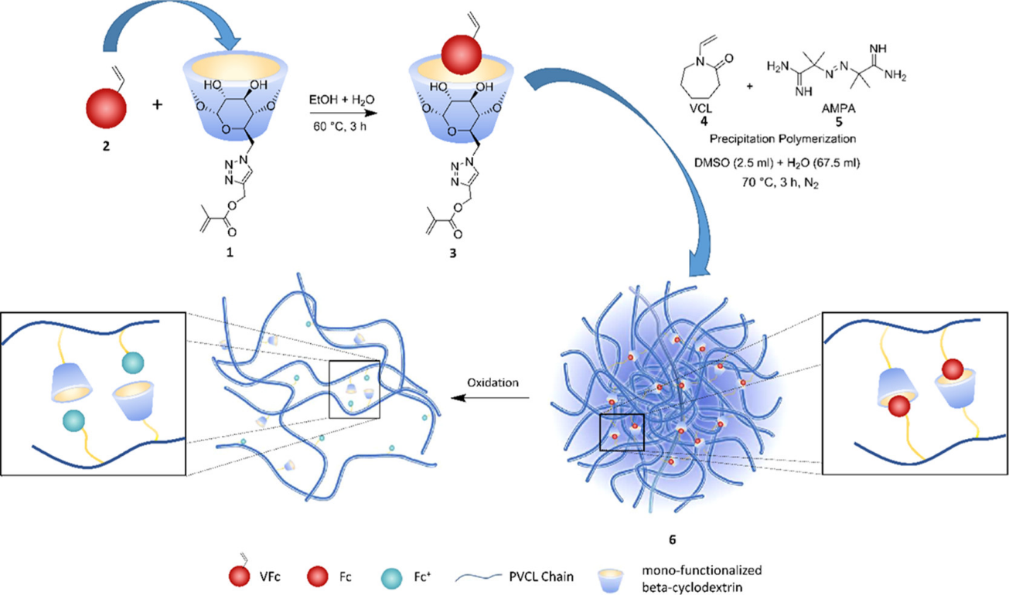
Figure 9. Schematic illustration of redox-responsive cleavable microgel with the integrated cross-linker and its cleavage and breakdown under oxidative conditions. Reprinted with permission from [151]. Copyright 2012 American Chemical Society.
Another example refers to the synthesis of multifunctional hydrogels with extremely fast self-healing and degradation properties owing to the incorporation of disulfide bonds into the polymer backbone that was reported by Tran et al. [152]. The hydrogel was synthesized by oxidative copolymerization of 2,3-dimercapto-1-propanol and meso-2.3-dimercaptosuccinic acid, yielding numerous reversible physical cross-links of hydrogen bonds and ionic interactions. The material exhibited impressive mechanical properties such as high tensile strength and loading-unloading capability. The self-healing was studied by cutting the sample and bringing the pieces into contact, followed by immediate mounting in the tensile strength test machine. The tensile strength, Young’s modulus, and work of extension were 95%, 106%, and 95% respectively of the values for the original, pristine hydrogel. This quick self-healing was explained based on the rupture of disulfide bonds which generated free radicals upon cutting of the bond and could quickly reform or exchange with other disulfides. Reported hydrogels were examined in terms of cytotoxicity and cell culture tests to present them as a potential material for biomedical applications. Cytotoxicity was investigated by in vitro cell tests, which showed high cell viability of around 100%. Moreover, after 30 h of incubation, numerous grown cells were identified, hence the hydrogel was claimed non-cytotoxic [152]. Bi et al. also reported another dual redox and photo-responsive self-healing hydrogel of thiolated galactoglucomannan (GGMSH) and 2,2,6,6-tetramethylpiperidine-1-oxyl (TEMPO)-oxidized cellulose nanofibrils (T-CNF) for protein release applications [153]. Reported hydrogels underwent a UV-triggered or redox-triggered thiol-disulfide exchange, enabling the self-healing process. TEMPO oxidation of cellulose nanofibrils determined the surface chemistry of the fibrils. T-CNFs are cytocompatible and increased the mechanical performance of the hydrogel, owing to their hydrogen bonding, hydrophobic interactions, and electrostatic repulsions. The GGMSH introduced thiol groups to the hydrogel enabling the photo responsiveness under UV-radiation, through a thiol-disulfide exchange reaction, which was expected to help with the controlled release of biological substances. The resulting hydrogel was also loaded with bovine serum albumin (BSA) and it was found that the introduction of BSA increased the rehydration ratio and swelling capacity. The BSA release was studied with the addition of glutathione to trigger the redox-responsive behavior, which showed 70% release of the protein after 6h. The hydrogel incubated only in PBS solution released 80% of BSA after the same time. The research group explained that the increased swelling, caused by the addition of BSA has greatly altered the mesh size of the hydrogel and the non-covalently bonded BSA was immediately released during swelling, which suppressed the redox-responsive behavior to glutathione. The cytotoxicity and cell proliferation tests were performed, proving that the hydrogel is non-cytotoxic, however, it suppressed cell proliferation which was attributed to the presence of free radicals [153].
    - Photo-Cleavable Gels
Klinger and Landfester reported the synthesis of dual stimuli-responsive microgels based on photo-cleavable cross-linkers: 4-(4-(1-hydroxyethyl)-2-methoxy-5- nitrophenoxy)butan-1-ol (HEMNPB) and 4-(4-(1-hydroxyethyl)-2-methoxy-5-nitrophenoxy)butanoic acid (HEMNPBA) [154]. The microgels were prepared by inverse mini-emulsion copolymerization of 2-hydroxyethyl methacrylate (HEMA) with methacrylic acid (MAA) and two kinds of photodegradable cross-linkers. The microgel exhibited pH-dependent swelling resulting from the protonation/deprotonation of MAA groups in the polymer network. The second stimuli-responsive behavior was photo-degradation enabled by the use of photo-labile o-nitrobenzyl cross-linkers, causing particle disintegration upon UV irradiation. The combination of these two behaviors was designed to exhibit two different degradation profiles. The disintegration of the particles by irradiation was expected to yield a one-step degradation, whereas the application of UV light on swollen particles was expected to promote a two-step swelling/degradation profile. The swelling was investigated by DLS measurements, and the photo-degradation was studied concerning degradation rates and changes in the degree of swelling, which were found to depend on pH, light intensity, and irradiation wavelength. The dual stimuli-responsiveness was proven to enable efficient loading and release of myoglobin protein. A slow diffusion-controlled, pH-induced release was combined with fast on-demand release caused by irradiation-induced degradation [154].

- Conclusions
Functional non-linear polymers bearing cleavable bonds have great potential in biomedical applications due to the combination of unique structures with selective bonds degrading upon stimuli. The introduction of selective bonds can lead to detachment of polymer chains and subsequent decrease in molecular weight, which can promote the release of active substances and facilitate the removal of polymer chains from the human body. Herein three types of stimuli-responsive behaviors of polymeric chains were described: pH-cleavage, redox-cleavage, and photo-cleavage. The focus on the aforementioned types of stimuli is caused by the demand of the biomedical industry for materials responding to the change of conditions in the human body, like lower pH or higher concentration of GSH in cancer cells. Although scientific reports described in this review are focused mostly on drug delivery and gene therapy, each of the described functional polymer types (bottlebrushes, stars, dendritic polymers, and gels) exhibit unique properties, which provide the potential for structure-specific applications.
The advantage of bottlebrushes over other molecular structures is that the cleavable linkages can be introduced not only within the polymer backbone but also on the side chains. Hence, such polymers can exhibit excellent drug-loading capacity, because of the densely packed side chains. Another opportunity for drug transportation caused by the densely grafted chains is the effective entrapment via physical interactions between the drug molecule and polymer molecule. Moreover, bottlebrushes with cleavable bonds can be applied as a framework for the synthesis of hollow polymeric particles, capable of loading and releasing significant amounts of active substances.
The use of star polymers containing acetal, ester, disulfide, and azo bonds provides new possibilities for more efficient and problem-specific applications. Therefore, these materials become more promising in varied biomedical applications, mostly in gene delivery, and drug delivery but also in imaging and bone regeneration described herein. The pH-sensitive stars exhibited high MRI activity, however after cleavage, the arms exhibited lower MRI activity, which could be useful in screening how the pH changes in the cancer region.
Dendritic polymers with complex branched structures and degradable cores or/and backbone are utilized in biomedical applications. Degradability of hyperbranched polymers and dendrimers containing pH-sensitive linkages can be used for example in drug delivery systems, in the production of MRI contrast agents and nanocarriers for portable oral inhalation devices. Dendrimers with pH-cleavable bonds can also be applied as anticancer drugs, whereas redox- and photo-cleavable dendritic polymers are mainly utilized in drug and gene delivery systems. Cleavable dendritic polymers with new compositions are being developed leading to obtaining a large library of very diverse structures for biomedical applications. There are reports on pH- and redox-dual-responsive dendrimers for controlled drug release. A combination of different stimuli responsiveness can reduce side effects and therefore improve drug efficacy by specific delivery of drug to the target tumor tissues.
In terms of polymeric gels, the incorporation of pH-cleavable linkages provides injectable materials for bone tissue engineering and drug delivery, which cross-link after administration to the human body and promote a sustained active substance release. Microgels with redox-cleavable bonds can potentially be applied as cell-signaling molecules combined with targeted drug delivery. What is more, polymeric gels with two different stimuli-responsive bonds (e.g. irradiation and pH) can exhibit two different drug-release profiles, depending on the applied stimuli, which is interesting as one material could be applied for rapid release and slow sustained release. This indicates that polymer gels with multi-stimuli-responsiveness should be the focus of research on their biomedical applications.
Future work should mostly focus on the design and synthesis of functional polymers with dual and multiple stimuli-responsive bonds, as well as more detailed studies examining the potential of these materials in biomedical applications, among others, their effectiveness in the delivery of active substances, transport, and metabolism in the body and biocompatibility. Experiments should be expanded to include ex vivo studies using for example tumor cell lines or tissue models or/and in vivo studies. To sum up, significant progress has been achieved in research on functional non-linear polymers with cleavable bonds for biomedical applications, however, there is still a long way to go before these materials reach the clinical trial process. More effort needs to be made to further explore these types of materials so that they can play a more significant role in real-life biomedical applications.

Acknowledgment
The financial support from the National Science Centre, Poland is gratefully acknowledged (Grant UMO-2020/39/I/ST5/02108). For the purpose of Open Access, the authors have applied a CC-BY public copyright license to any Author Accepted Manuscript (AAM) version arising from this submission.

Conflict of Interest
The authors declare that they have no known competing financial interests or personal relationships that could have appeared to influence the work reported in this paper.

References
1. Tang, Z., et al., Polymeric nanostructured materials for biomedical applications. Progress in Polymer Science, 2016. 60: p. 86-128.
2. Song, R., et al., Current development of biodegradable polymeric materials for biomedical applications. Drug design, development and therapy, 2018: p. 3117-3145.
3. Sung, Y.K. and S.W. Kim, Recent advances in polymeric drug delivery systems. Biomaterials Research, 2020. 24(1): p. 1-12.
4. Hosseini, M.-S., et al., Chapter 1 - Functional polymers: an introduction in the context of biomedical engineering, in Advanced Functional Polymers for Biomedical Applications, M. Mozafari and N.P. Singh Chauhan, Editors. 2019, Elsevier. p. 1-20.
5. Makvandi, P., et al., Functionalization of polymers and nanomaterials for water treatment, food packaging, textile and biomedical applications: a review. Environmental Chemistry Letters, 2021. 19(1): p. 583-611.
6. Wang, Y. and S.M. Grayson, Approaches for the preparation of non-linear amphiphilic polymers and their applications to drug delivery. Advanced Drug Delivery Reviews, 2012. 64(9): p. 852-865.
7. Hadjichristidis, N., et al., Linear and non-linear triblock terpolymers. Synthesis, self-assembly in selective solvents and in bulk. Progress in Polymer Science, 2005. 30(7): p. 725-782.
8. Wu, W., W. Wang, and J. Li, Star polymers: Advances in biomedical applications. Progress in Polymer Science, 2015. 46: p. 55-85.
9. Rahimi, M., et al., Multi-branched ionic liquid-chitosan as a smart and biocompatible nano-vehicle for combination chemotherapy with stealth and targeted properties. Carbohydrate Polymers, 2018. 196: p. 299-312.
10. Saadati, A., M. Hasanzadeh, and F. Seidi, Biomedical application of hyperbranched polymers: Recent Advances and challenges. TrAC Trends in Analytical Chemistry, 2021. 142: p. 116308.
11. Pedziwiatr-Werbicka, E., et al., Dendrimers and hyperbranched structures for biomedical applications. European Polymer Journal, 2019. 119: p. 61-73.
12. Braunecker, W.A. and K. Matyjaszewski, Controlled/living radical polymerization: Features, developments, and perspectives. Progress in Polymer Science, 2007. 32(1): p. 93-146.
13. Wang, K., et al., Advanced functional polymer materials. Materials Chemistry Frontiers, 2020. 4(7): p. 1803-1915.
14. Sutthasupa, S., M. Shiotsuki, and F. Sanda, Recent advances in ring-opening metathesis polymerization, and application to synthesis of functional materials. Polymer Journal, 2010. 42(12): p. 905-915.
15. Corrigan, N., et al., Reversible-deactivation radical polymerization (Controlled/living radical polymerization): From discovery to materials design and applications. Progress in Polymer Science, 2020. 111: p. 101311.
16. Nicolas, J., et al., Nitroxide-mediated polymerization. Progress in Polymer Science, 2013. 38(1): p. 63-235.
17. Matyjaszewski, K. and J. Xia, Atom transfer radical polymerization. Chemical reviews, 2001. 101(9): p. 2921-2990.
18. Chiefari, J., et al., Living free-radical polymerization by reversible addition-fragmentation chain transfer: the RAFT process. Macromolecules, 1998. 31(16): p. 5559.
19. Penczek, S., J. Pretula, and S. Slomkowski, Ring-opening polymerization. Chemistry Teacher International, 2021. 3(2): p. 33-57.
20. Nuyken, O. and S.D. Pask, Ring-opening polymerization—an introductory review. Polymers, 2013. 5(2): p. 361-403.
21. Lu, P., et al., Metal-free ring-opening metathesis polymerization: from concept to creation. Accounts of Chemical Research, 2020. 53(10): p. 2325-2335.
22. Lamontagne, H.R. and B.H. Lessard, Nitroxide-mediated polymerization: a versatile tool for the engineering of next generation materials. ACS Applied Polymer Materials, 2020. 2(12): p. 5327-5344.
23. Grubbs, R.B., Nitroxide-mediated radical polymerization: limitations and versatility. Polymer Reviews, 2011. 51(2): p. 104-137.
24. Heinrich, C.D. and M. Thelakkat, Poly-(3-hexylthiophene) bottlebrush copolymers with tailored side-chain lengths and high charge carrier mobilities. Journal of Materials Chemistry C, 2016. 4(23): p. 5370-5378.
25. Moad, G., E. Rizzardo, and S.H. Thang, RAFT polymerization and some of its applications. Chemistry–An Asian Journal, 2013. 8(8): p. 1634-1644.
26. Destarac, M., On the critical role of RAFT agent design in reversible addition-fragmentation chain transfer (RAFT) polymerization. Polymer reviews, 2011. 51(2): p. 163-187.
27. Hill, M.R., R.N. Carmean, and B.S. Sumerlin, Expanding the scope of RAFT polymerization: recent advances and new horizons. Macromolecules, 2015. 48(16): p. 5459-5469.
28. Perrier, S., 50th Anniversary Perspective: RAFT Polymerization—A User Guide. Macromolecules, 2017. 50(19): p. 7433-7447.
29. Ng, G., et al., Benchtop Preparation of Polymer Brushes by SI-PET-RAFT: The Effect of the Polymer Composition and Structure on Inhibition of a Pseudomonas Biofilm. ACS Applied Materials & Interfaces, 2020. 12(49): p. 55243-55254.
30. Charmi, G., et al., Bottlebrush polymer with dual functionality for osteoarthritis treatment: curcumin delivery and lubrication properties. Polymer Chemistry, 2023. 14(33): p. 3827-3833.
31. Chen, C., et al., Synthesis of multifunctional miktoarm star polymers via an RGD peptide-based RAFT agent. Polymer Chemistry, 2019. 10(2): p. 228-234.
32. Rosselgong, J., et al., Core Degradable Star RAFT Polymers: Synthesis, Polymerization, and Degradation Studies. Macromolecules, 2013. 46(23): p. 9181-9188.
33. Wang, M.-Q., et al., Bottlebrush Polymers Based on RAFT and the “C1” Polymerization Method: Controlled Synthesis and Application in Anticancer Drug Delivery. ACS Macro Letters, 2022. 11(2): p. 179-185.
34. Tanaka, J., et al., Orthogonal Cationic and Radical RAFT Polymerizations to Prepare Bottlebrush Polymers. Angewandte Chemie International Edition, 2020. 59(18): p. 7203-7208.
35. Tang, W., N.V. Tsarevsky, and K. Matyjaszewski, Determination of Equilibrium Constants for Atom Transfer Radical Polymerization. Journal of the American Chemical Society, 2006. 128(5): p. 1598-1604.
36. Lorandi, F., et al., Atom Transfer Radical Polymerization of Acrylic and Methacrylic Acids: Preparation of Acidic Polymers with Various Architectures. ACS Macro Letters, 2020. 9(5): p. 693-699.
37. Mazzotti, G., et al., Straightforward synthesis of well-defined poly(vinyl acetate) and its block copolymers by atom transfer radical polymerization. European Polymer Journal, 2016. 77: p. 75-87.
38. Matyjaszewski, K., Atom Transfer Radical Polymerization (ATRP): Current Status and Future Perspectives. Macromolecules, 2012. 45(10): p. 4015-4039.
39. Galeziewska, M., et al., Polyacrylamide brushes with varied morphologies as a tool for control of the intermolecular interactions within EPDM/MVQ blends. Polymer, 2021. 215: p. 123387.
40. Zygo, M., et al. Effect of Structure of Polymers Grafted from Graphene Oxide on the Compatibility of Particles with a Silicone-Based Environment and the Stimuli-Responsive Capabilities of Their Composites. Nanomaterials, 2020. 10, DOI: 10.3390/nano10030591.
41. Raj, W., et al. Renewable Fabric Surface-Initiated ATRP Polymerizations: Towards Mixed Polymer Brushes. Nanomaterials, 2020. 10, DOI: 10.3390/nano10030536.
42. Galeziewska, M., et al., One-Pot Strategy for the Preparation of Electrically Conductive Composites Using Simultaneous Reduction and Grafting of Graphene Oxide via Atom Transfer Radical Polymerization. Macromolecules, 2021. 54(21): p. 10177-10188.
43. Ilcikova, M., et al., Influence of PMMA brushes grafted from GO on rheological properties of PMMA/SAN immiscible blend in shear and elongation flow. Polymer, 2023. 279: p. 126015.
44. Vasilaki, E., et al., Non-cross-linked hollow polymer nanocapsules of controlled size and shell thickness. Colloids and Surfaces A: Physicochemical and Engineering Aspects, 2023. 661: p. 130928.
45. Cama, G., et al., 3 - Synthetic biodegradable medical polyesters: Poly-ε-caprolactone, in Science and Principles of Biodegradable and Bioresorbable Medical Polymers, X. Zhang, Editor. 2017, Woodhead Publishing. p. 79-105.
46. Nuyken, O. and S.D. Pask Ring-Opening Polymerization—An Introductory Review. Polymers, 2013. 5, 361-403 DOI: 10.3390/polym5020361.
47. Duda, A. and A. Kowalski, Thermodynamics and Kinetics of Ring-Opening Polymerization, in Handbook of Ring‐Opening Polymerization. 2009. p. 1-51.
48. Müller-Hülstede, J., et al., Surface-initiated ring-opening polymerization of ɛ-caprolactone as a feasible approach to modify flax yarn. Composites Part A: Applied Science and Manufacturing, 2022. 152: p. 106714.
49. Tonhauser, C., et al., Branched Acid-Degradable, Biocompatible Polyether Copolymers via Anionic Ring-Opening Polymerization Using an Epoxide Inimer. ACS Macro Letters, 2012. 1(9): p. 1094-1097.
50. Pribyl, J., et al., Polyethylene Grafted Silica Nanoparticles Prepared via Surface-Initiated ROMP. ACS Macro Letters, 2019. 8(3): p. 228-232.
51. Jiang, G., et al., Surface-Initiated Ring-Opening Metathesis Polymerization (SI-ROMP): Synthesis and Electropolymerization of Terthiophene-Functionalized Olefin Peripheral Dendrons. Macromolecules, 2010. 43(24): p. 10262-10274.
52. Li, Z., et al., Bottlebrush polymers: From controlled synthesis, self-assembly, properties to applications. Progress in Polymer Science, 2021. 116: p. 101387.
53. Xie, G., et al., Molecular Bottlebrushes as Novel Materials. Biomacromolecules, 2019. 20(1): p. 27-54.
54. Radzinski, S.C., J.C. Foster, and J.B. Matson, Synthesis of bottlebrush polymers via transfer-to and grafting-through approaches using a RAFT chain transfer agent with a ROMP-active Z-group. Polymer Chemistry, 2015. 6(31): p. 5643-5652.
55. Banquy, X., et al., Bioinspired Bottle-Brush Polymer Exhibits Low Friction and Amontons-like Behavior. Journal of the American Chemical Society, 2014. 136(17): p. 6199-6202.
56. Rahimi, M., et al., Recent developments in natural and synthetic polymeric drug delivery systems used for the treatment of osteoarthritis. Acta Biomaterialia, 2021. 123: p. 31-50.
57. Nese, A., et al., pH-Responsive Fluorescent Molecular Bottlebrushes Prepared by Atom Transfer Radical Polymerization. Macromolecules, 2011. 44(15): p. 5905-5910.
58. Raj, W., et al., Molecular bottlebrush with pH-responsive cleavable bonds as a unimolecular vehicle for anticancer drug delivery. Materials Science and Engineering: C, 2021. 130: p. 112439.
59. Rzayev, J., Molecular Bottlebrushes: New Opportunities in Nanomaterials Fabrication. ACS Macro Letters, 2012. 1(9): p. 1146-1149.
60. Huang, K. and J. Rzayev, Well-Defined Organic Nanotubes from Multicomponent Bottlebrush Copolymers. Journal of the American Chemical Society, 2009. 131(19): p. 6880-6885.
61. Huang, K., D.P. Canterbury, and J. Rzayev, Synthesis of Segmented Polylactide Molecular Brushes and Their Transformation to Open-End Nanotubes. Macromolecules, 2010. 43(16): p. 6632-6638.
62. Huang, K., M. Johnson, and J. Rzayev, Synthesis of Degradable Organic Nanotubes by Bottlebrush Molecular Templating. ACS Macro Letters, 2012. 1(7): p. 892-895.
63. Huang, K. and J. Rzayev, Charge and Size Selective Molecular Transport by Amphiphilic Organic Nanotubes. Journal of the American Chemical Society, 2011. 133(42): p. 16726-16729.
64. Huang, K., A. Jacobs, and J. Rzayev, De Novo Synthesis and Cellular Uptake of Organic Nanocapsules with Tunable Surface Chemistry. Biomacromolecules, 2011. 12(6): p. 2327-2334.
65. Sana, B., A. Finne-Wistrand, and D. Pappalardo, Recent development in near infrared light-responsive polymeric materials for smart drug-delivery systems. Materials Today Chemistry, 2022. 25: p. 100963.
66. Romano, A., et al., Recent trends in applying ortho-nitrobenzyl esters for the design of photo-responsive polymer networks. Materials, 2020. 13(12): p. 2777.
67. Onbulak, S. and J. Rzayev, Cylindrical nanocapsules from photo-cross-linkable core–shell bottlebrush copolymers. Polymer Chemistry, 2015. 6(5): p. 764-771.
68. Liu, T., et al., Photo-responsive Polymers based on ο-Nitrobenzyl Derivatives: From Structural Design to Applications. Progress in Polymer Science, 2023: p. 101741.
69. Liu, T., et al., Photo-responsive polymers based on ο-Nitrobenzyl derivatives: from structural design to applications. Progress in Polymer Science, 2023. 146: p. 101741.
70. Wu, Y., et al., Bottlebrush polymers with self-immolative side chains. Polymer Chemistry, 2018. 9(14): p. 1799-1806.
71. Zhu, W., et al., A UV-Cleavable Bottlebrush Polymer with o-Nitrobenzyl-Linked Side Chains. Macromolecular Rapid Communications, 2017. 38(11): p. 1700007.
72. Ren, J.M., et al., Star Polymers. Chemical Reviews, 2016. 116(12): p. 6743-6836.
73. Higashihara, T., M. Hayashi, and A. Hirao, Synthesis of well-defined star-branched polymers by stepwise iterative methodology using living anionic polymerization. Progress in Polymer Science, 2011. 36(3): p. 323-375.
74. Snijkers, F., et al., Effects of Core Microstructure on Structure and Dynamics of Star Polymer Melts: From Polymeric to Colloidal Response. Macromolecules, 2014. 47(15): p. 5347-5356.
75. Liu, C., Y. Zhang, and J. Huang, Well-Defined Star Polymers with Mixed-Arms by Sequential Polymerization of Atom Transfer Radical Polymerization and Reverse Addition−Fragmentation Chain Transfer on a Hyperbranched Polyglycerol Core. Macromolecules, 2008. 41(2): p. 325-331.
76. Liu, C., Y. Zhang, and J. Huang, Well-Defined Star Polymers with Mixed-Arms by Sequential Polymerization of Atom Transfer Radical Polymerization and Reverse Addition− Fragmentation Chain Transfer on a Hyperbranched Polyglycerol Core. Macromolecules, 2008. 41(2): p. 325-331.
77. Liu, J., et al., An approach to biodegradable star polymeric architectures using disulfide coupling. Chemical Communications, 2008(48): p. 6582-6584.
78. Setijadi, E., et al., Biodegradable Star Polymers Functionalized With β-Cyclodextrin Inclusion Complexes. Biomacromolecules, 2009. 10(9): p. 2699-2707.
79. Liu, J., et al., RAFT controlled synthesis of six-armed biodegradable star polymeric architectures via a ‘core-first’ methodology. Polymer, 2009. 50(19): p. 4455-4463.
80. Jiang, X., Y. Chen, and F. Xi, Stepwise Cleavable Star Polymers and Polymeric Gels Thereof. Macromolecules, 2010. 43(17): p. 7056-7061.
81. Gibson, T.J., et al., Star polymers with acid-labile diacetal-based cores synthesized by aqueous RAFT polymerization for intracellular DNA delivery. Polymer Chemistry, 2020. 11(2): p. 344-357.
82. Hu, J., et al., Precise modular synthesis and a structure–property study of acid-cleavable star-block copolymers for pH-triggered drug delivery. Polymer Chemistry, 2015. 6(9): p. 1553-1566.
83. Augustine, D., et al., Hydrophilic stars, amphiphilic star block copolymers, and miktoarm stars with degradable polycarbonate cores. Macromolecules, 2020. 53(3): p. 895-904.
84. Costa, L.C., et al., Hydrogen Peroxide-Triggered Disassembly of Boronic Ester-Cross-Linked Brush-Arm Star Polymers. ACS macro letters, 2023. 12(8): p. 1179-1184.
85. Dai, F., et al., Redox-cleavable star cationic PDMAEMA by arm-first approach of ATRP as a nonviral vector for gene delivery. Biomaterials, 2010. 31(3): p. 559-569.
86. Hu, Y., et al., New Star-Shaped Carriers Composed of β-Cyclodextrin Cores and Disulfide-Linked Poly(glycidyl methacrylate) Derivative Arms with Plentiful Flanking Secondary Amine and Hydroxyl Groups for Highly Efficient Gene Delivery. ACS Applied Materials & Interfaces, 2013. 5(3): p. 703-712.
87. Hu, Y., et al., New star-shaped carriers composed of β-cyclodextrin cores and disulfide-linked poly (glycidyl methacrylate) derivative arms with plentiful flanking secondary amine and hydroxyl groups for highly efficient gene delivery. ACS applied materials & interfaces, 2013. 5(3): p. 703-712.
88. Zhao, F., et al., Folic Acid Modified Cationic γ-Cyclodextrin-oligoethylenimine Star Polymer with Bioreducible Disulfide Linker for Efficient Targeted Gene Delivery. Biomacromolecules, 2013. 14(2): p. 476-484.
89. Wei, X., et al., Synthesis of cleavable multi-functional mikto-arm star polymer by RAFT polymerization: example of an anti-cancer drug 7-ethyl-10-hydroxycamptothecin (SN-38) as functional moiety. Science China Chemistry, 2014. 57(7): p. 995-1001.
90. Wei, X., et al., Synthesis of cleavable multi-functional mikto-arm star polymer by RAFT polymerization: example of an anti-cancer drug 7-ethyl-10-hydroxycamptothecin (SN-38) as functional moiety. Science China Chemistry, 2014. 57: p. 995-1001.
91. Chung, J.J., et al., Biodegradable inorganic-organic hybrids of methacrylate star polymers for bone regeneration. Acta biomaterialia, 2017. 54: p. 411-418.
92. Chung, J.J., et al., Tailoring Mechanical Properties of Sol–Gel Hybrids for Bone Regeneration through Polymer Structure. Chemistry of Materials, 2016. 28(17): p. 6127-6135.
93. Dai, Y., et al., Near-IR-induced dissociation of thermally-sensitive star polymers. Chemical Science, 2017. 8(3): p. 1815-1821.
94. Faris, F., et al., Non-invasive in vivo near-infrared optical measurement of the penetration depth in the neonatal head. Clinical Physics and Physiological Measurement, 1991. 12(4): p. 353.
95. Zheng, Y., et al., Hyperbranched polymers: advances from synthesis to applications. Chemical Society Reviews, 2015. 44(12): p. 4091-4130.
96. Wang, D., et al., Bioapplications of hyperbranched polymers. Chemical Society Reviews, 2015. 44(12): p. 4023-4071.
97. Dias, A.P., et al., Dendrimers in the context of nanomedicine. International Journal of Pharmaceutics, 2020. 573: p. 118814.
98. Nikzamir, M., et al., Applications of Dendrimers in Nanomedicine and Drug Delivery: A Review. Journal of Inorganic and Organometallic Polymers and Materials, 2021. 31(6): p. 2246-2261.
99. Mlynarczyk, D.T., et al., Dendrimers against fungi – A state of the art review. Journal of Controlled Release, 2021. 330: p. 599-617.
100. Galanakou, C., D. Dhumal, and L. Peng, Amphiphilic dendrimers against antibiotic resistance: light at the end of the tunnel? Biomaterials Science, 2023. 11(10): p. 3379-3393.
101. Alfei, S. and A.M. Schito From Nanobiotechnology, Positively Charged Biomimetic Dendrimers as Novel Antibacterial Agents: A Review. Nanomaterials, 2020. 10, DOI: 10.3390/nano10102022.
102. Janaszewska, A., et al. Cytotoxicity of Dendrimers. Biomolecules, 2019. 9, DOI: 10.3390/biom9080330.
103. Asadullah Khan, M., et al., Synthesis, dynamics and applications (cytotoxicity and biocompatibility) of dendrimers: A mini-review. European Polymer Journal, 2022. 181: p. 111708.
104. Jin, H., et al., Biocompatible or biodegradable hyperbranched polymers: from self-assembly to cytomimetic applications. Chemical Society Reviews, 2012. 41(18): p. 5986-5997.
105. Ye, M., et al., Facile synthesis and in vivo evaluation of biodegradable dendritic MRI contrast agents. Journal of Materials Chemistry, 2012. 22(29): p. 14369-14377.
106. Heyder, R.S., et al., Cellular internalization and transport of biodegradable polyester dendrimers on a model of the pulmonary epithelium and their formulation in pressurized metered-dose inhalers. International journal of pharmaceutics, 2017. 520(1-2): p. 181-194.
107. Xi, X., et al., Dendrimers with the protocatechuic acid building block for anticancer drug delivery. Journal of Materials Chemistry B, 2016. 4(31): p. 5236-5245.
108. Ma, X., et al., Facile synthesis of polyester dendrimers as drug delivery carriers. Macromolecules, 2013. 46(1): p. 37-42.
109. Khoee, S. and K. Hemati, Synthesis of magnetite/polyamino-ester dendrimer based on PCL/PEG amphiphilic copolymers via convergent approach for targeted diagnosis and therapy. Polymer, 2013. 54(21): p. 5574-5585.
110. Huang, D., et al., Facile synthesis and self-assembly behaviour of pH-responsive degradable polyacetal dendrimers. Polymer Chemistry, 2016. 7(40): p. 6154-6158.
111. Huang, D., et al., Charge-reversible and pH-responsive biodegradable micelles and vesicles from linear-dendritic supramolecular amphiphiles for anticancer drug delivery. Polymer Chemistry, 2017. 8(43): p. 6675-6687.
112. Tonhauser, C., et al., Branched acid-degradable, biocompatible polyether copolymers via anionic ring-opening polymerization using an epoxide inimer. ACS Macro Letters, 2012. 1(9): p. 1094-1097.
113. Shenoi, R.A., B.F.L. Lai, and J.N. Kizhakkedathu, Synthesis, Characterization, and Biocompatibility of Biodegradable Hyperbranched Polyglycerols from Acid-Cleavable Ketal Group Functionalized Initiators. Biomacromolecules, 2012. 13(10): p. 3018-3030.
114. Shenoi, R.A., et al., Branched Multifunctional Polyether Polyketals: Variation of Ketal Group Structure Enables Unprecedented Control over Polymer Degradation in Solution and within Cells. Journal of the American Chemical Society, 2012. 134(36): p. 14945-14957.
115. Chen, R. and L. Wang, Synthesis of an amphiphilic hyperbranched polymer as a novel pH-sensitive drug carrier. Rsc Advances, 2015. 5(26): p. 20155-20159.
116. Zhu, L., et al., Construction and application of pH-triggered cleavable hyperbranched polyacylhydrazone for drug delivery. Polymer Chemistry, 2011. 2(8): p. 1761-1768.
117. Yu, J., et al., The potential of pH-responsive PEG-hyperbranched polyacylhydrazone micelles for cancer therapy. Biomaterials, 2014. 35(9): p. 3132-3144.
118. Peng, Y.-Y., et al., Tumor microenvironment-regulated redox responsive cationic galactose-based hyperbranched polymers for siRNA delivery. Bioconjugate Chemistry, 2018. 30(2): p. 405-412.
119. Normanno, N., et al., Epidermal growth factor receptor (EGFR) signaling in cancer. Gene, 2006. 366(1): p. 2-16.
120. Du, X.-J., Z.-Y. Wang, and Y.-C. Wang, Redox-sensitive dendrimersomes assembled from amphiphilic Janus dendrimers for siRNA delivery. Biomaterials science, 2018. 6(8): p. 2122-2129.
121. Zhuang, Y., et al., Aptamer-functionalized and backbone redox-responsive hyperbranched polymer for targeted drug delivery in cancer therapy. Biomacromolecules, 2016. 17(6): p. 2050-2062.
122. Zhang, M., et al., Synthesis and properties of multicleavable amphiphilic dendritic comblike and toothbrushlike copolymers comprising alternating PEG and PCL grafts. Macromolecules, 2013. 46(4): p. 1325-1336.
123. Li, S., et al., Direct visualization of vesicle disassembly and reassembly using photocleavable dendrimers elucidates cargo release mechanisms. Acs Nano, 2020. 14(6): p. 7398-7411.
124. Nazemi, A., T.B. Schon, and E.R. Gillies, Synthesis and degradation of backbone photodegradable polyester dendrimers. Organic letters, 2013. 15(8): p. 1830-1833.
125. Pashaei-Sarnaghi, R., et al., Synthesis, photocrosslinking, and self-assembly of coumarin-anchored poly(amidoamine) dendrimer for smart drug delivery system. European Polymer Journal, 2021. 158: p. 110686.
126. Wang, H., et al., A Self-Assembled Coumarin-Anchored Dendrimer for Efficient Gene Delivery and Light-Responsive Drug Delivery. Biomacromolecules, 2018. 19(6): p. 2194-2201.
127. Pashaei-Sarnaghi, R., et al., Synthesis, photocrosslinking, and self-assembly of coumarin-anchored poly (amidoamine) dendrimer for smart drug delivery system. European Polymer Journal, 2021. 158: p. 110686.
128. Chelu, M. and A.M. Musuc Polymer Gels: Classification and Recent Developments in Biomedical Applications. Gels, 2023. 9, DOI: 10.3390/gels9020161.
129. Nayak, A.K. and B. Das, Introduction to polymeric gels, in Polymeric gels. 2018, Elsevier. p. 3-27.
130. Zohuri, G., Polymer science: a comprehensive reference. 2012.
131. Thakur, V.K. and M.K. Thakur, Polymer gels: synthesis and characterization. 2018: Springer.
132. Summonte, S., et al., Thiolated polymeric hydrogels for biomedical application: Cross-linking mechanisms. Journal of Controlled Release, 2021. 330: p. 470-482.
133. Xie, H., K.-K. Yang, and Y.-Z. Wang, Photo-cross-linking: a powerful and versatile strategy to develop shape-memory polymers. Progress in Polymer Science, 2019. 95: p. 32-64.
134. Tang, T., T. Moyori, and A. Takasu, Isomerization-Free Polycondensations of Cyclic Anhydrides with Diols and Preparation of Polyester Gels Containing Cis or Trans Carbon Double Bonds via Photo-Cross-Linking and Isomerization in the Gels. Macromolecules, 2013. 46(14): p. 5464-5472.
135. Philippova, O.E. and A.R. Khokhlov, 1.13 - Polymer Gels, in Polymer Science: A Comprehensive Reference, K. Matyjaszewski and M. Möller, Editors. 2012, Elsevier: Amsterdam. p. 339-366.
136. Madl, C.M., L.M. Katz, and S.C. Heilshorn, Bio-Orthogonally Crosslinked, Engineered Protein Hydrogels with Tunable Mechanics and Biochemistry for Cell Encapsulation. Advanced Functional Materials, 2016. 26(21): p. 3612-3620.
137. Çetinkaya, A., et al., Oligo(ethylene glycol) methyl ether methacrylate based hydrogel with intrinsic antibacterial activity against Pseudomonas aeruginosa as a model of a major wound infecting human pathogen. European Polymer Journal, 2024. 205: p. 112758.
138. Berger, J., et al., Structure and interactions in chitosan hydrogels formed by complexation or aggregation for biomedical applications. European Journal of Pharmaceutics and Biopharmaceutics, 2004. 57(1): p. 35-52.
139. Akther, F., et al., Hydrogels as artificial matrices for cell seeding in microfluidic devices. RSC Advances, 2020. 10(71): p. 43682-43703.
140. Rizwan, M., et al. pH Sensitive Hydrogels in Drug Delivery: Brief History, Properties, Swelling, and Release Mechanism, Material Selection and Applications. Polymers, 2017. 9, DOI: 10.3390/polym9040137.
141. Ding, H., et al., Preparation and application of pH-responsive drug delivery systems. Journal of Controlled Release, 2022. 348: p. 206-238.
142. Rakhshaei, R., et al., Graphene quantum dot cross-linked carboxymethyl cellulose nanocomposite hydrogel for pH-sensitive oral anticancer drug delivery with potential bioimaging properties. International Journal of Biological Macromolecules, 2020. 150: p. 1121-1129.
143. Shahi, S., et al., Chemical stimuli-induced reversible bond cleavage in covalently crosslinked hydrogels. Coordination Chemistry Reviews, 2022. 455: p. 214368.
144. Li, S., et al., Poly (vinyl alcohol)/poly (hydroxypropyl methacrylate-co-methacrylic acid) as pH-sensitive semi-IPN hydrogels for oral insulin delivery: Preparation and characterization. Iranian Polymer Journal, 2021. 30: p. 343-353.
145. Chen, X., et al., Hypoxic Microenvironment Reconstruction with Synergistic Biofunctional Ions Promotes Diabetic Wound Healing. Advanced Healthcare Materials, 2023. 12(32): p. 2301984.
146. Li, Z., et al., pH-responsive hydrogel loaded with insulin as a bioactive dressing for enhancing diabetic wound healing. Materials & Design, 2021. 210: p. 110104.
147. Zhao, C., et al., A pH-triggered, self-assembled, and bioprintable hybrid hydrogel scaffold for mesenchymal stem cell based bone tissue engineering. ACS applied materials & interfaces, 2019. 11(9): p. 8749-8762.
148. Rogina, A., et al., Cellular hydrogels based on pH-responsive chitosan-hydroxyapatite system. Carbohydrate Polymers, 2017. 166: p. 173-182.
149. Chen, D., et al., pH and temperature dual-sensitive liposome gel based on novel cleavable mPEG-Hz-CHEMS polymeric vaginal delivery system. International journal of nanomedicine, 2012: p. 2621-2630.
150. Zha, J., et al., Acid-and thiol-cleavable multifunctional codelivery hydrogel: fabrication and investigation of antimicrobial and anticancer properties. ACS Applied Bio Materials, 2021. 4(2): p. 1515-1523.
151. Jung, S.-H., et al., Responsive supramolecular microgels with redox-triggered cleavable crosslinks. Macromolecules, 2020. 53(3): p. 1043-1053.
152. Tran, V.T., et al., Multifunctional poly(disulfide) hydrogels with extremely fast self-healing ability and degradability. Chemical Engineering Journal, 2020. 394: p. 124941.
153. Bi, H., et al., Dynamic reversible disulfide bonds hydrogel of thiolated galactoglucomannan/cellulose nanofibril with self-healing property for protein release. Industrial Crops and Products, 2023. 206: p. 117615.
154. Klinger, D. and K. Landfester, Dual stimuli-responsive poly (2-hydroxyethyl methacrylate-co-methacrylic acid) microgels based on photo-cleavable cross-linkers: pH-dependent swelling and light-induced degradation. Macromolecules, 2011. 44(24): p. 9758-9772.

