Support Information

Dry vs Wet Torrefaction of Oxytree Biomass: A Comparative Study on Fuel Properties and Energy Yield
Hilal Unyayª, Andrii Kostyniuk^{b*}, Szymon Szufaª, Artur Lewandowskiª, Blaž Likozar^{b}, Grzegorz Wielgosinskiª
ªFaculty of Process and Environmental Engineering, Lodz University of Technology, Wolczanska 213, 90-924, Lodz, Poland.
^{b}Department of Catalysis and Chemical Reaction Engineering, National Institute of Chemistry, Hajdrihova 19, Ljubljana, 1001, Slovenia.

(a)
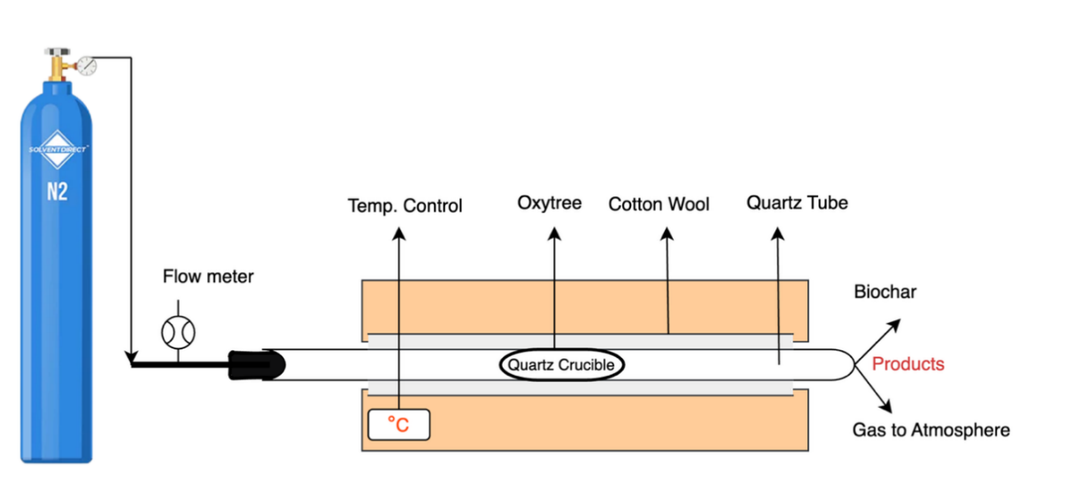
(b)
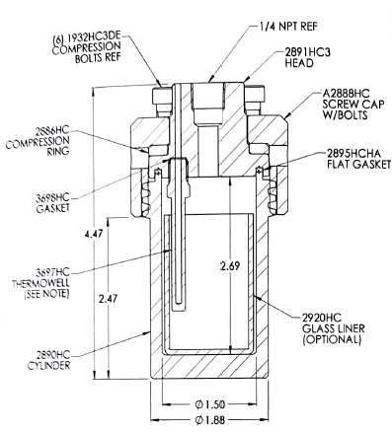 | 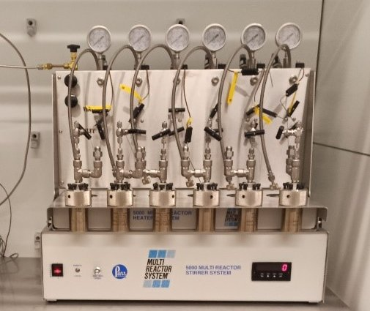

Fig. S1. Schematic representations of oxytree torrefaction processes: (a) DT; (b) WT using batch reactors (Parr 5000 Multiple Reactor System).

Table S1. Analytical results of raw and DT oxytree.
Time  (min) | Temp  (°C) | C  (%) | H  (%) | N  (%) | Ash  (%) | O  (%) | Degree of torrefaction | HHV  (MJ/kg) | HHV_{increase}  (%) | O/C | H/C
Raw | ‒ | 45.14 | 6.29 | 0.91 | 3.24 | 44.39 | ‒ | 16.35 | ‒ | 0.74 | 1.67
30 | 200 | 48.40 | 5.78 | 1.11 | 4.20 | 40.51 | 1.06 | 17.41 | 6.48 | 0.63 | 1.43
30 | 220 | 49.30 | 5.89 | 1.23 | 4.45 | 39.13 | 1.11 | 18.12 | 10.84 | 0.60 | 1.43
30 | 240 | 50.50 | 5.77 | 1.17 | 4.76 | 37.80 | 1.14 | 18.59 | 13.73 | 0.56 | 1.37
30 | 260 | 53.60 | 5.69 | 1.44 | 5.10 | 34.17 | 1.23 | 20.18 | 23.45 | 0.48 | 1.27
60 | 200 | 48.40 | 6.00 | 1.17 | 4.92 | 39.51 | 1.10 | 17.91 | 9.53 | 0.61 | 1.49
60 | 220 | 49.80 | 5.83 | 1.24 | 5.07 | 38.06 | 1.13 | 18.40 | 12.52 | 0.57 | 1.40
60 | 240 | 51.60 | 5.68 | 1.42 | 5.34 | 35.96 | 1.17 | 19.17 | 17.24 | 0.52 | 1.32
60 | 260 | 54.20 | 5.60 | 1.54 | 5.61 | 33.05 | 1.25 | 20.46 | 25.13 | 0.46 | 1.24

Table S2. Energy analysis of raw and DT oxytree.
Time  (min) | Temp  (°C) | HHV_{increase}  (%) | O/C | H/C | Mass loss (%) | Mass yield (%) | Energy yield (%) | Carbon yield (%) | Hydrogen yield (%) | Decarbonization  (%) | Carbon enrichment
Raw | ‒ | ‒ | 0.74 | 1.67 | ‒ | 100.00 | ‒ | ‒ | ‒ | ‒ | ‒
30 | 200 | 6.48 | 0.63 | 1.43 | 25.40 | 74.60 | 79.44 | 80.00 | 72.96 | 20.00 | 1.07
30 | 220 | 10.84 | 0.60 | 1.43 | 30.68 | 69.32 | 76.83 | 75.72 | 71.91 | 24.28 | 1.09
30 | 240 | 13.73 | 0.56 | 1.37 | 38.50 | 61.50 | 69.95 | 68.82 | 64.13 | 31.18 | 1.12
30 | 260 | 23.45 | 0.48 | 1.27 | 46.78 | 53.22 | 65.70 | 63.20 | 59.40 | 36.80 | 1.19
60 | 200 | 9.53 | 0.61 | 1.49 | 27.91 | 72.09 | 78.96 | 77.30 | 75.27 | 22.70 | 1.07
60 | 220 | 12.52 | 0.57 | 1.40 | 38.09 | 61.91 | 69.66 | 68.31 | 64.53 | 31.69 | 1.10
60 | 240 | 17.24 | 0.52 | 1.32 | 51.09 | 48.91 | 57.34 | 55.92 | 51.75 | 44.08 | 1.14
60 | 260 | 25.13 | 0.46 | 1.24 | 58.54 | 41.46 | 51.88 | 49.79 | 46.16 | 50.21 | 1.20

(a) | (b)
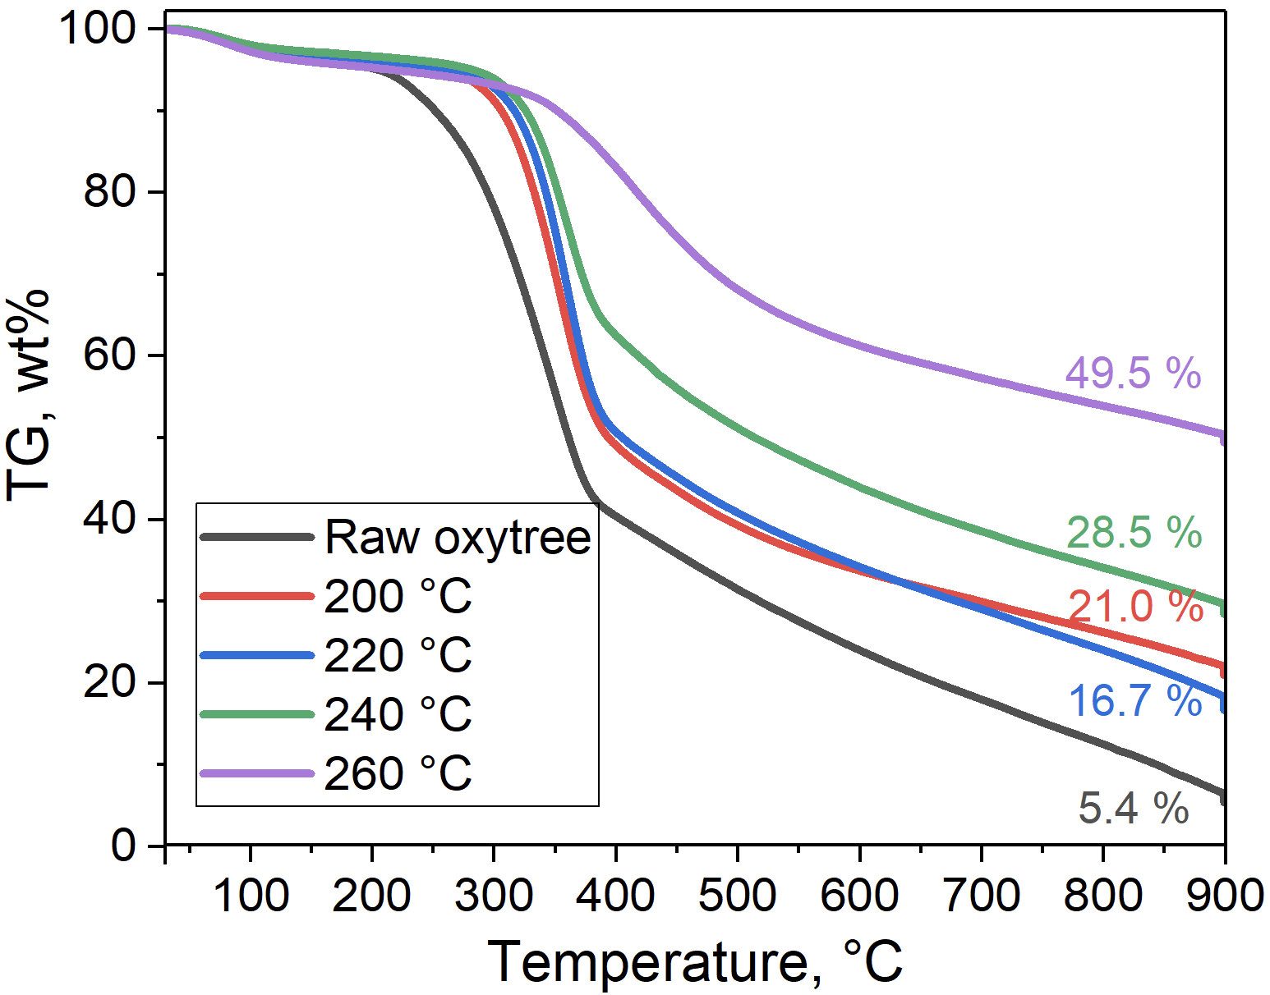 | 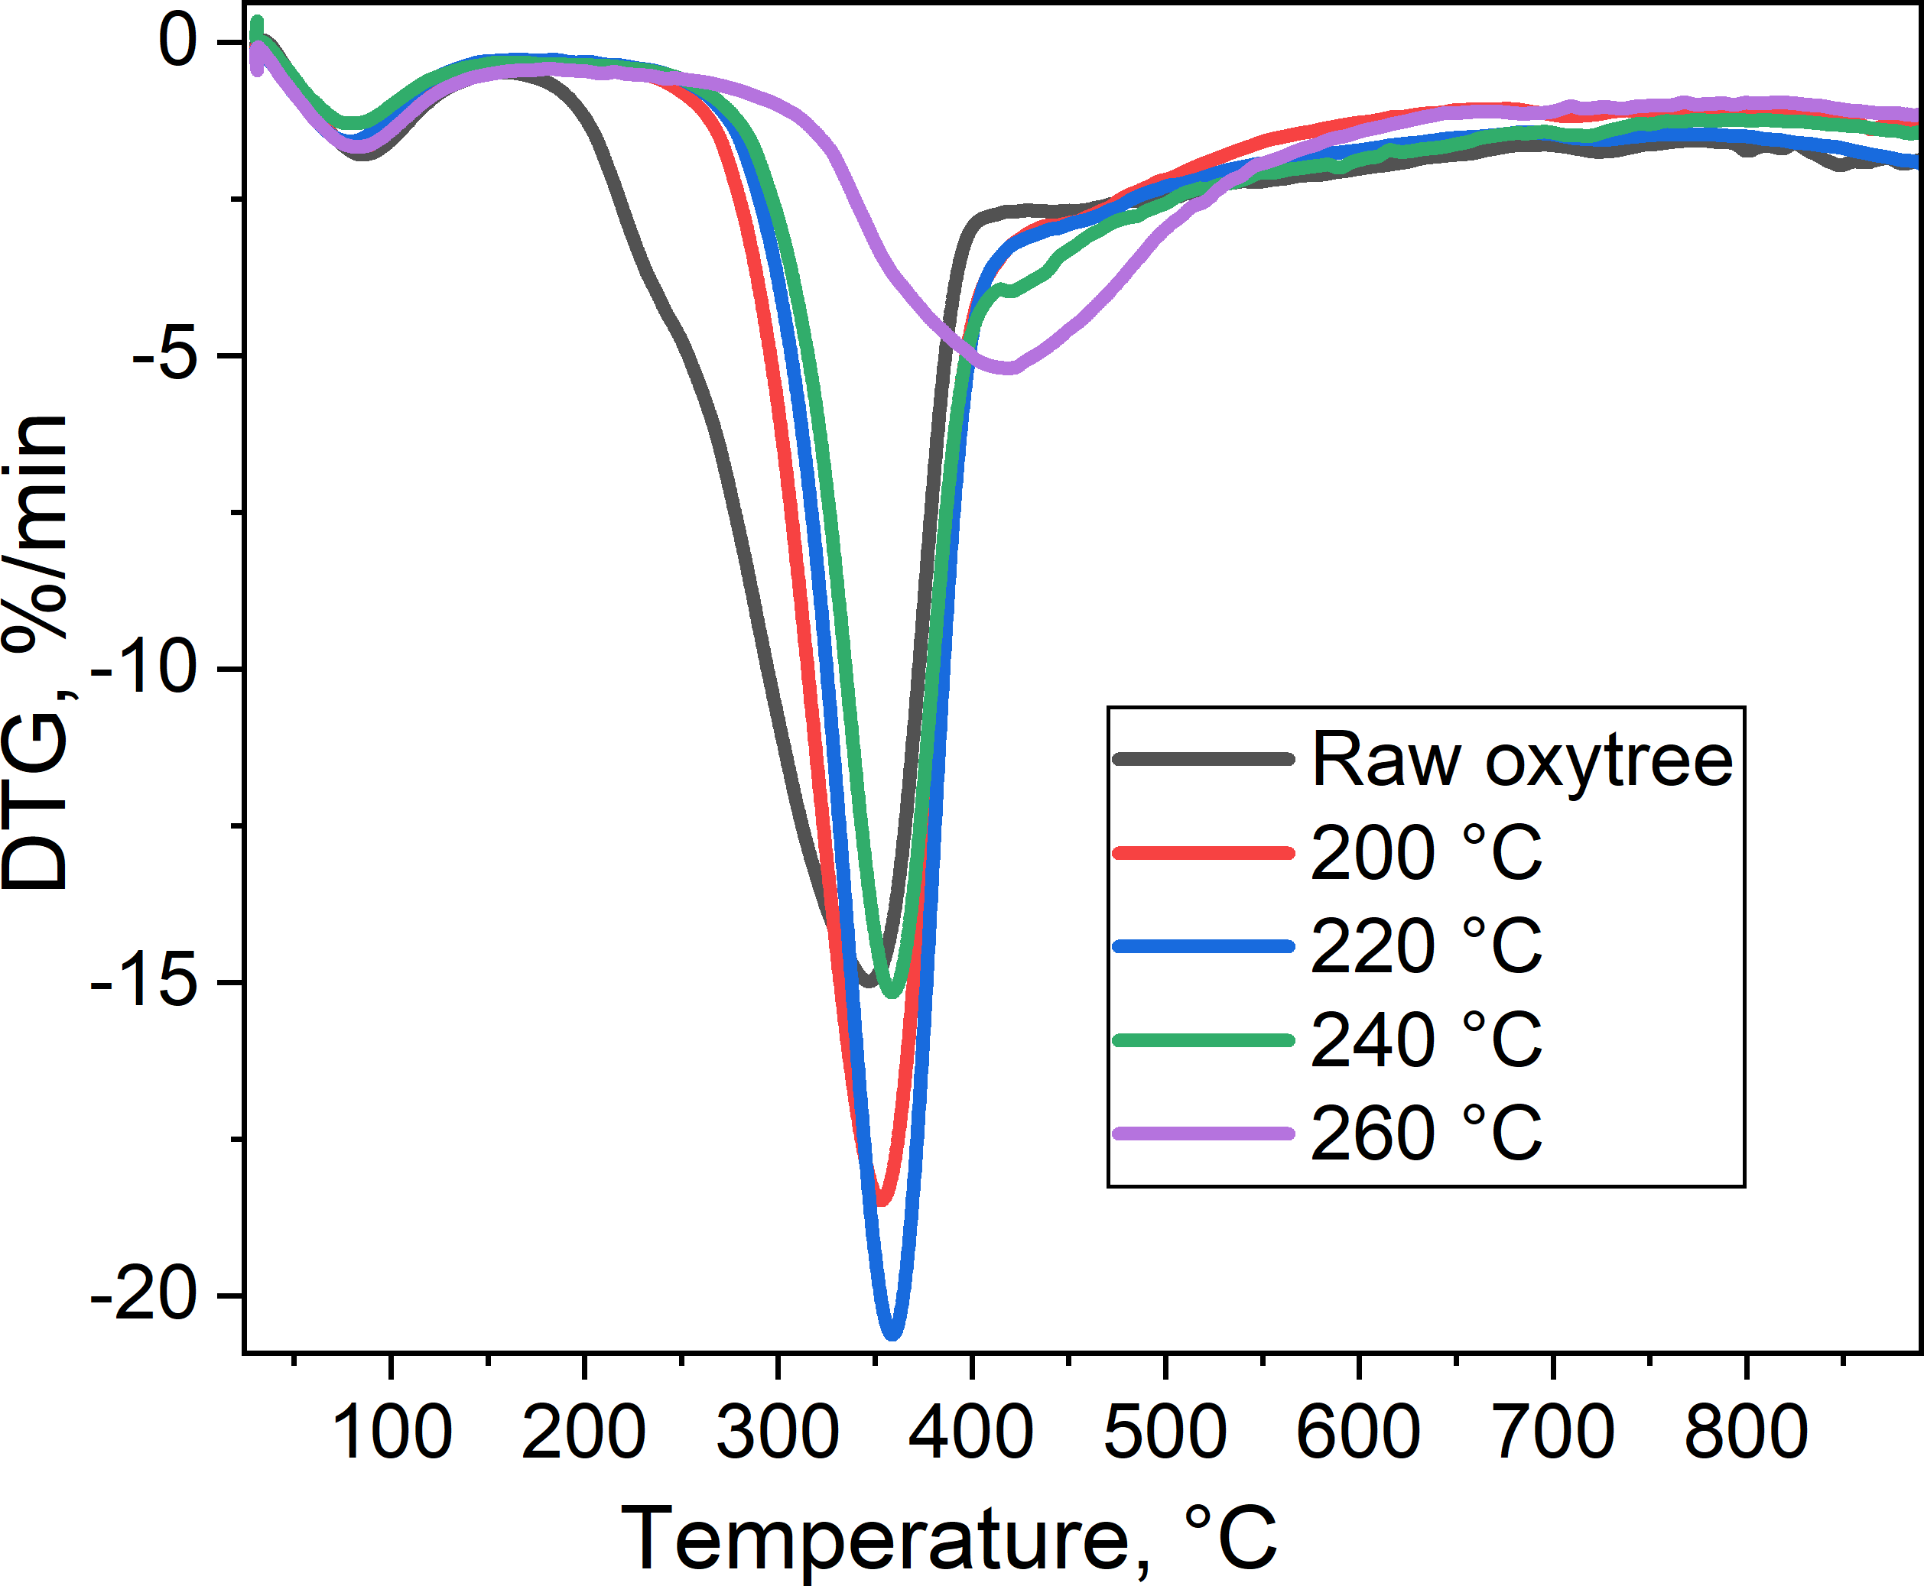
Fig. S2. Thermogravimetric analysis (TGA) and derivative thermogravimetry (DTG) curves of raw and DT oxytree biomass: (a) TGA profiles; (b) corresponding DTG curves, highlighting differences in thermal degradation behavior.

Table S3. Raw and WT oxytree biomass properties.
Time  (min) | Temp  (°C) | C  (%) | H  (%) | N  (%) | Ash  (%) | O  (%) | Degree of WT | HHV (MJ/kg) | HHV_{increase}  (%) | O/C | H/C
Raw | ‒ | 45.14 | 6.29 | 0.91 | 3.24 | 44.39 | ‒ | 16.3 | ‒ | 0.74 | 1.67
30 | 200 | 54.40 | 6.12 | 1.30 | 4.12 | 34.06 | 1.29 | 21.09 | 22.5 | 0.47 | 1.35
30 | 220 | 56.40 | 6.06 | 1.18 | 4.78 | 31.58 | 1.35 | 22.13 | 26.1 | 0.42 | 1.29
30 | 240 | 60.80 | 5.83 | 1.49 | 5.15 | 26.73 | 1.48 | 24.16 | 32.3 | 0.33 | 1.15
30 | 260 | 67.20 | 5.61 | 1.88 | 5.68 | 19.63 | 1.67 | 27.29 | 40.1 | 0.22 | 1.00
60 | 200 | 55.80 | 5.95 | 1.26 | 4.42 | 32.57 | 1.32 | 21.59 | 24.3 | 0.44 | 1.28
60 | 220 | 57.30 | 6.06 | 1.26 | 4.99 | 30.39 | 1.39 | 22.65 | 27.8 | 0.40 | 1.27
60 | 240 | 62.04 | 5.75 | 1.66 | 5.33 | 25.22 | 1.51 | 24.74 | 33.9 | 0.30 | 1.11
60 | 260 | 68.30 | 5.47 | 1.99 | 6.94 | 17.30 | 1.71 | 27.88 | 41.4 | 0.19 | 0.96

Table S4. Effect of torrefaction temperature and residence time on oxytree biomass under WT conditions.
Time  (min) | Temp  (°C) | HHV_{increase}  (%) | O/C | H/C | Mass loss (%) | Mass yield (%) | Energy yield (%) | Carbon yield (%) | Hydrogen yield (%) | Decarbonization  (%) | Carbon enrichment
Raw | ‒ | ‒ | 0.74 | 1.67 | ‒ | 100.00 | ‒ | ‒ | ‒ | ‒ | ‒
30 | 200 | 22.5 | 0.47 | 1.35 | 24.60 | 66.40 | 85.67 | 80.03 | 83.31 | 19.97 | 1.21
30 | 220 | 26.1 | 0.42 | 1.29 | 31.05 | 57.95 | 78.44 | 72.41 | 75.53 | 27.59 | 1.25
30 | 240 | 32.3 | 0.33 | 1.15 | 34.73 | 54.27 | 80.21 | 73.10 | 74.30 | 26.90 | 1.35
30 | 260 | 40.1 | 0.22 | 1.00 | 43.67 | 45.33 | 75.67 | 67.49 | 67.45 | 32.51 | 1.49
60 | 200 | 24.3 | 0.44 | 1.28 | 29.80 | 59.20 | 78.18 | 73.19 | 73.91 | 26.81 | 1.24
60 | 220 | 27.8 | 0.40 | 1.27 | 32.98 | 55.02 | 76.22 | 69.85 | 73.40 | 30.15 | 1.27
60 | 240 | 33.9 | 0.30 | 1.11 | 36.11 | 51.89 | 78.52 | 71.32 | 71.74 | 28.68 | 1.37
60 | 260 | 41.4 | 0.19 | 0.96 | 45.51 | 43.49 | 74.17 | 65.81 | 64.47 | 34.19 | 1.51

(a) | (b)
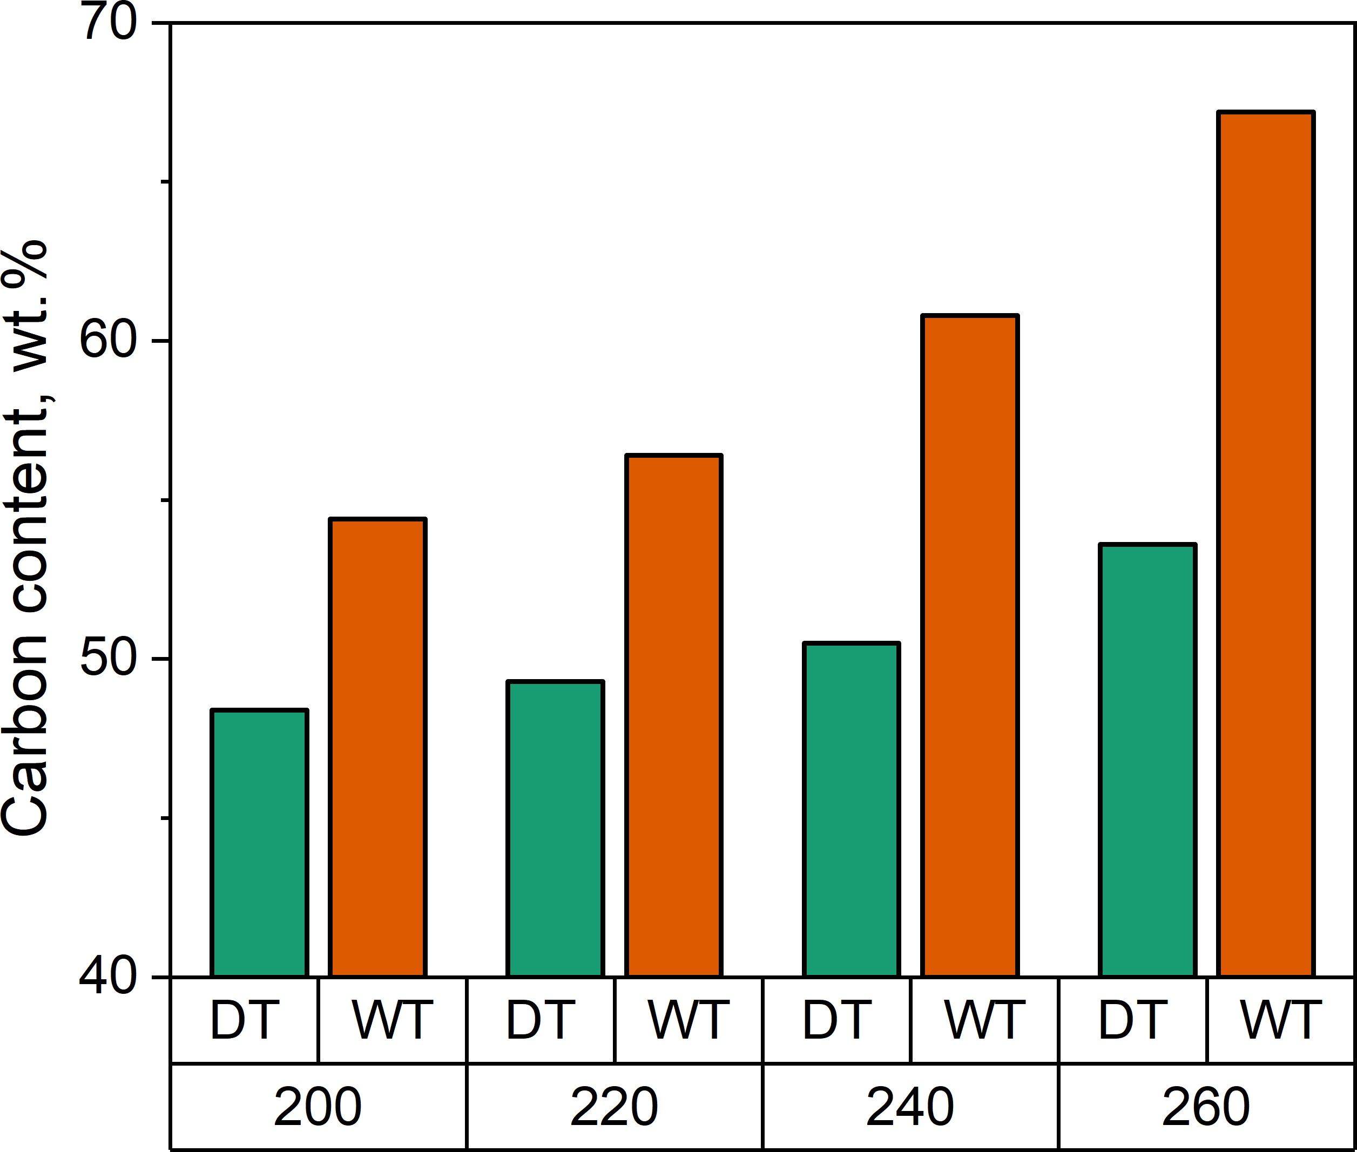 | 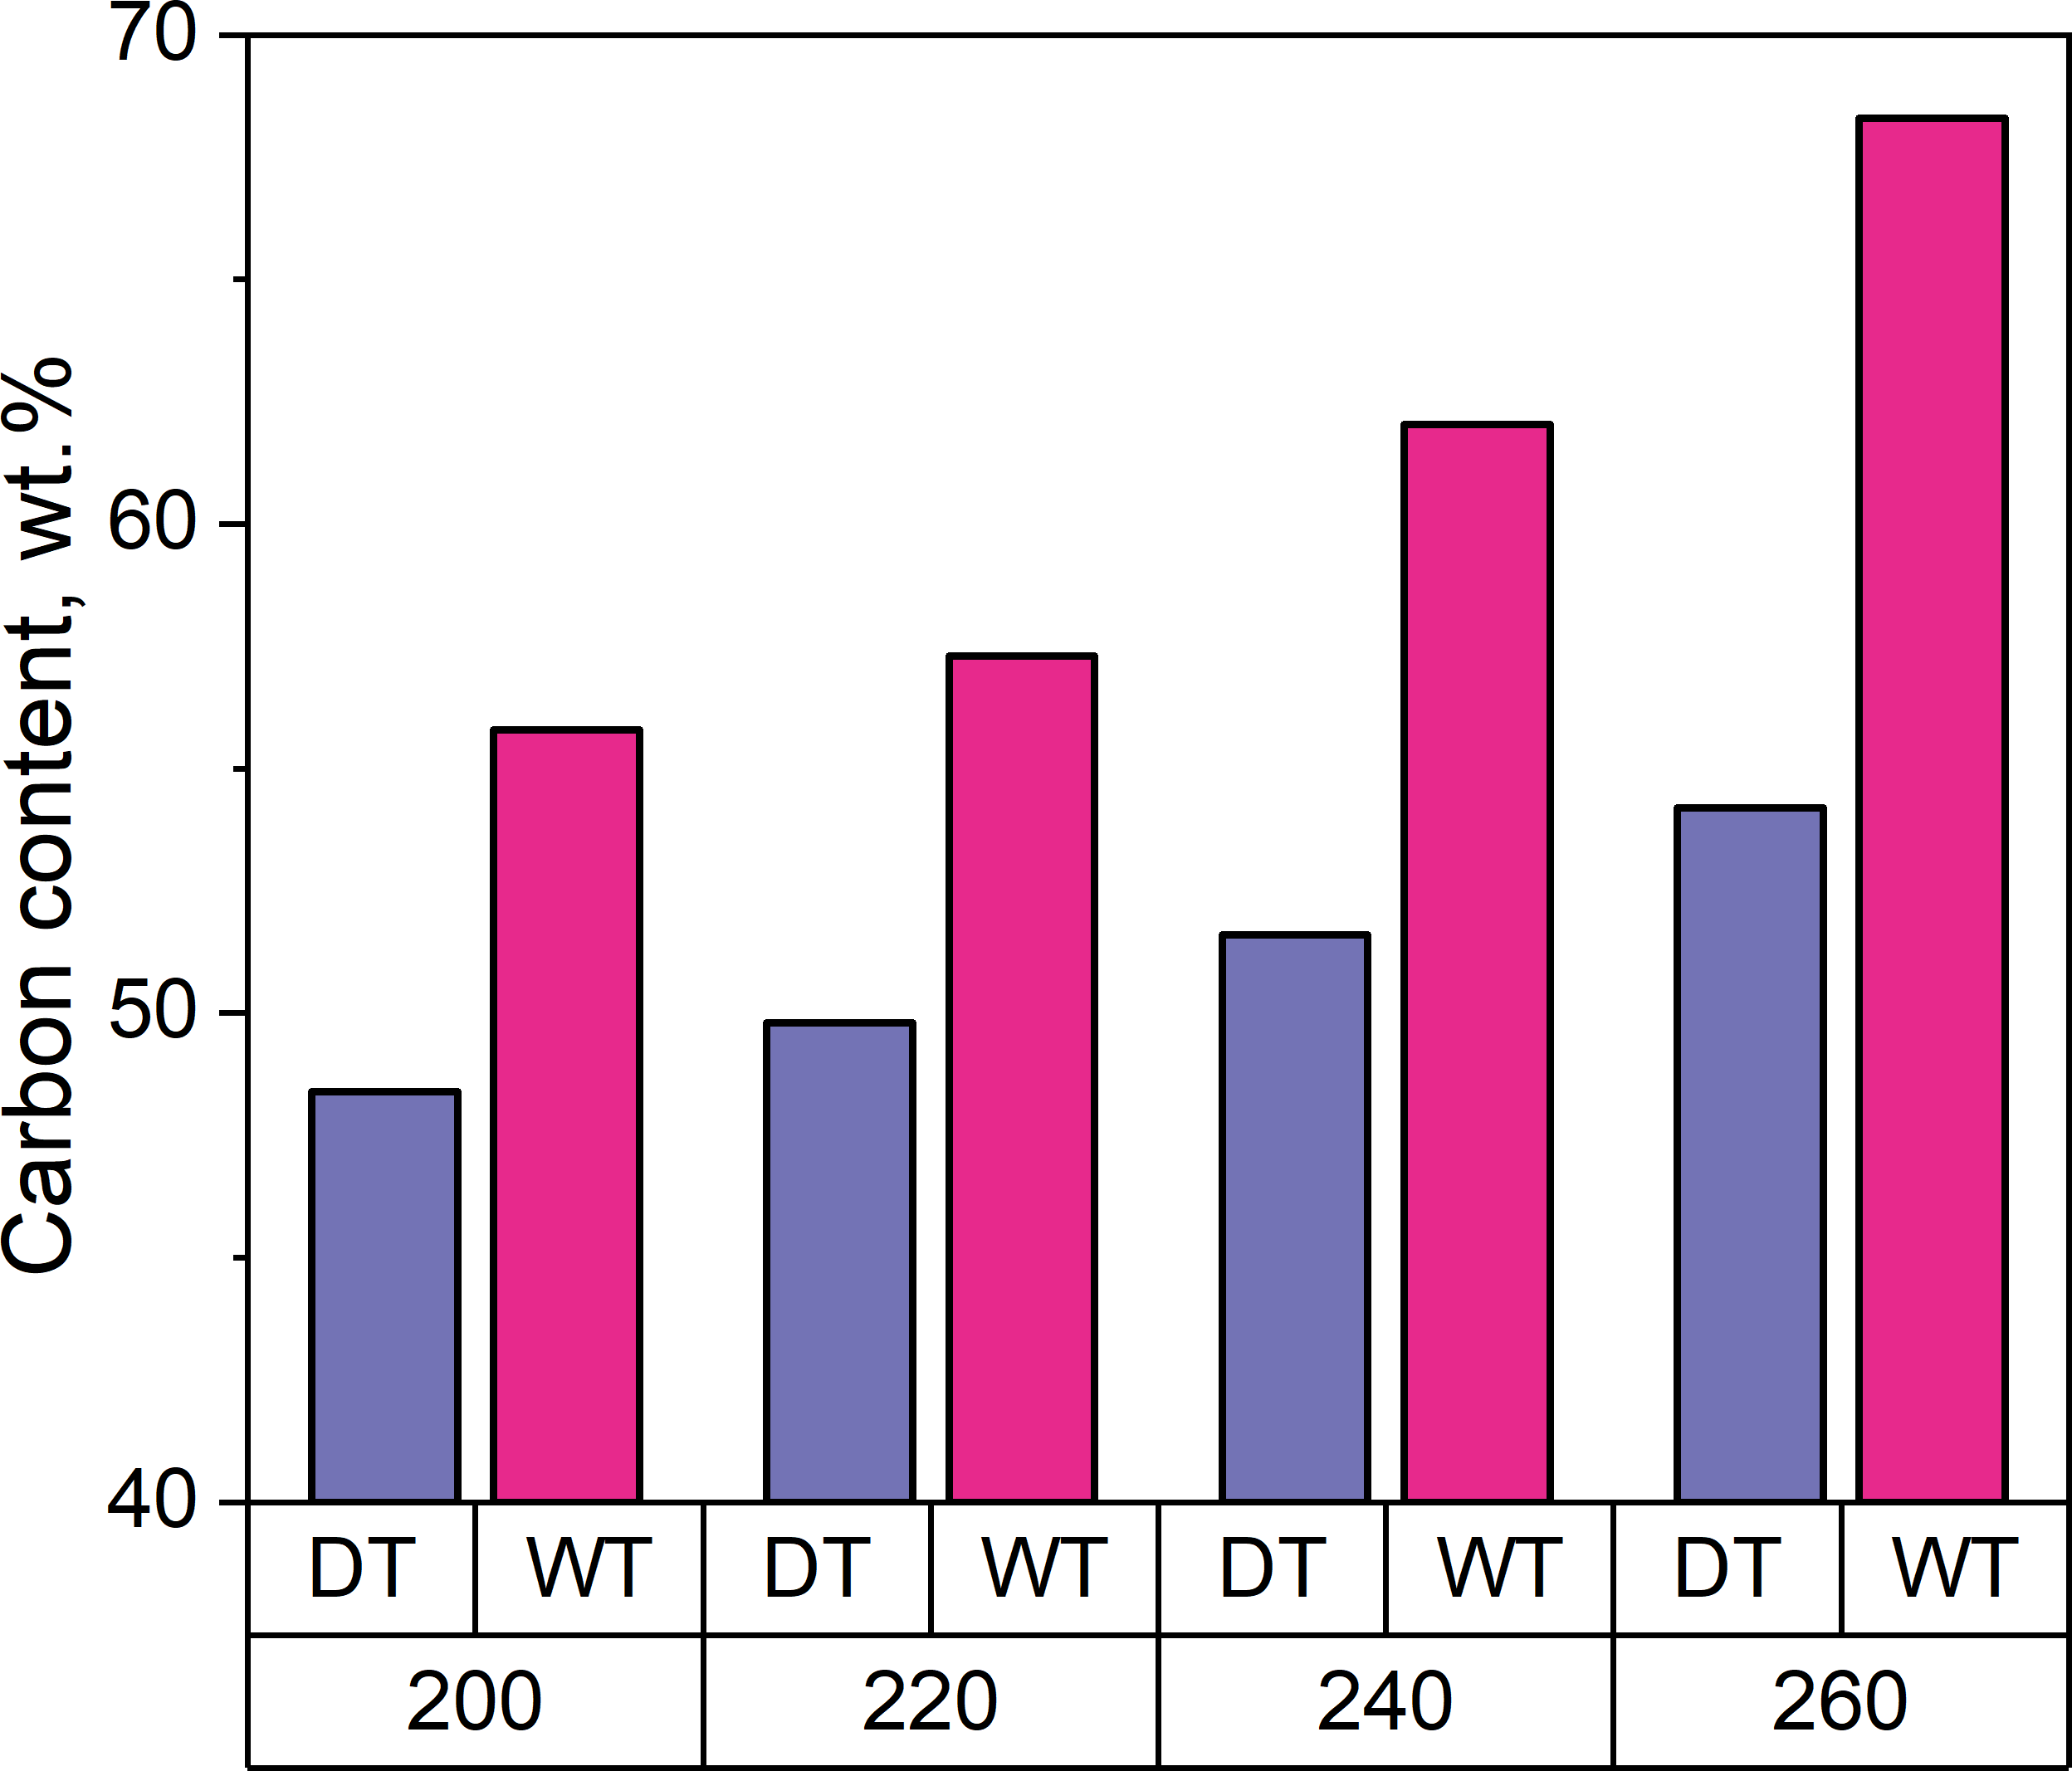
Fig. S3. Carbon content of oxytree biomass after DT and WT at various temperatures, with residence times of (a) ‒ 30 min and (b) ‒ 60 min.

(a) | (b)
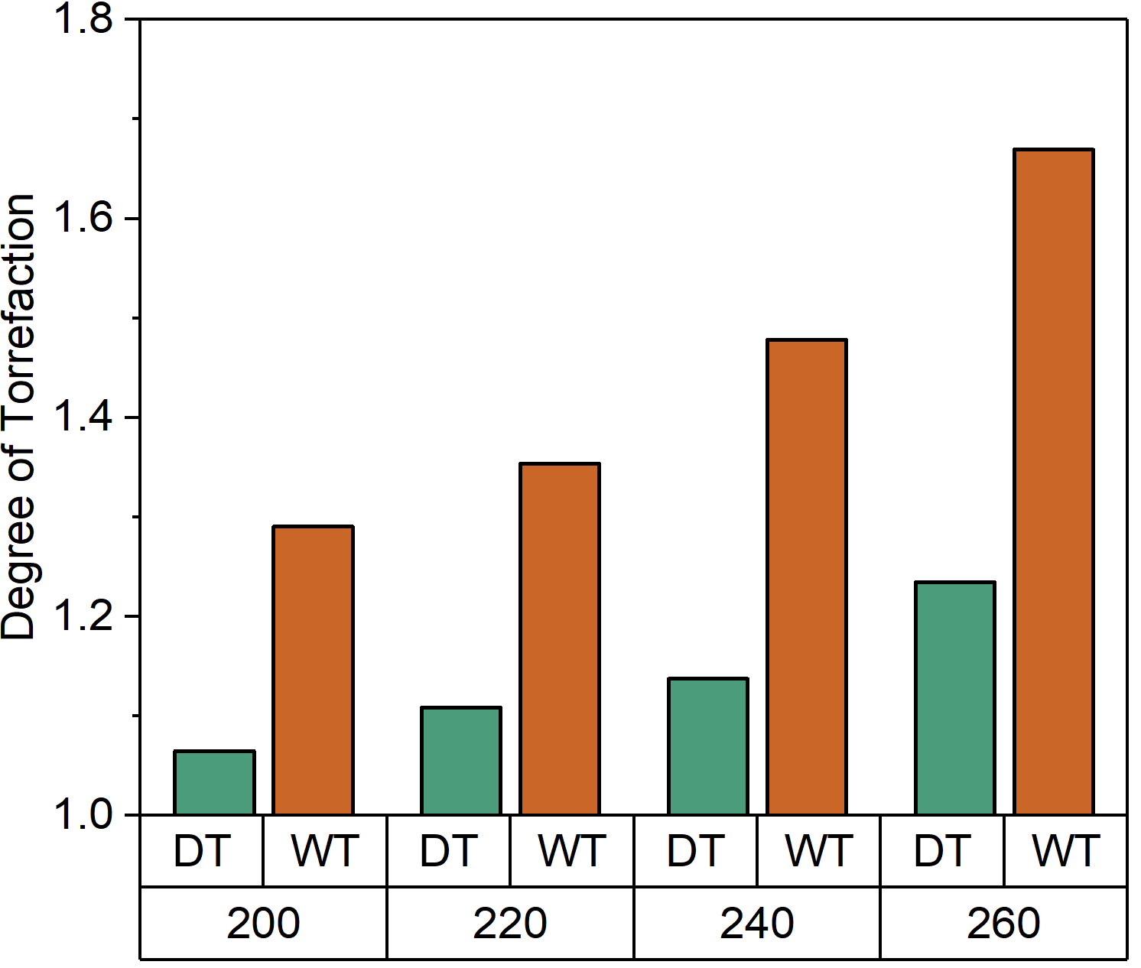 | 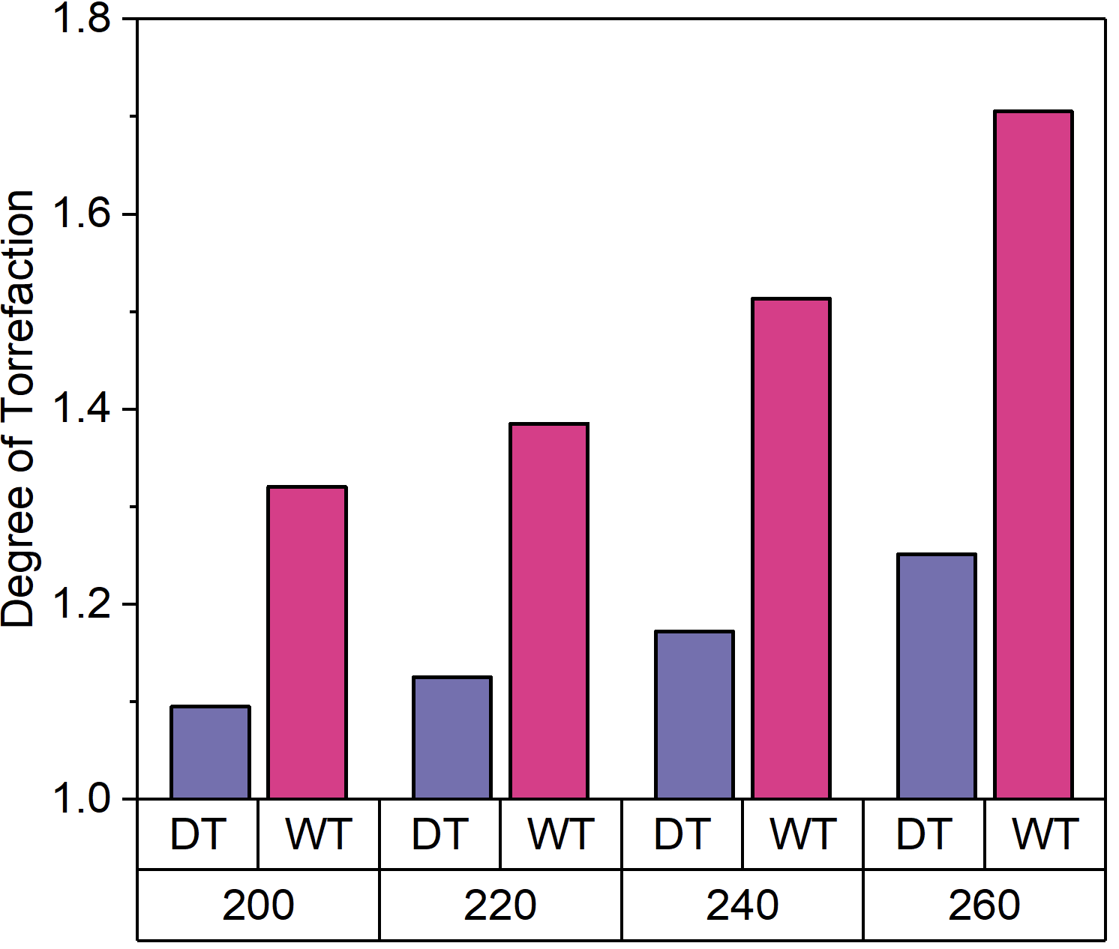
Fig. S4. Effect of torrefaction temperature and residence time, 30 min (a), 60 min (b), on the degree of torrefaction of oxytree biomass under DT and WT conditions.

Table S5. DSC calorimeter data for DT and WT samples.
Torrefaction method | Reaction Temp. [°C] | Reaction time [min] | T_{onset} [°C] | T_{avg}  [°C] | E_{a}  [kJ/mol]
DT | 200 | 30 | 297.3 | 309.4 | 52.1
DT | 200 | 60 | 299.4 | 311.3 | 52.9
DT | 220 | 30 | 298.5 | 306.8 | 50.2
DT | 220 | 60 | 298.7 | 306.2 | 48.9
DT | 240 | 30 | 298.3 | 308.3 | 43.9
DT | 240 | 60 | 289.6 | 309.0 | 46.8
DT | 260 | 30 | 290.8 | 302.2 | 44.8
DT | 260 | 60 | 287.5 | 299.1 | 43.6
WT | 200 | 30 | 302.5 | 315.3 | 45.0
WT | 200 | 60 | 297.5 | 305.3 | 45.1
WT | 220 | 30 | 303.1 | 317.4 | 43.3
WT | 220 | 60 | 297.8 | 309.3 | 45.3
WT | 240 | 30 | 298.6 | 311.2 | 42.1
WT | 240 | 60 | 300.1 | 309.0 | 39.5
WT | 260 | 30 | 287.2 | 301.5 | 41.2
WT | 260 | 60 | 272.1 | 283.4 | 41.7

Table S6. WT effect on the HHV values of several types of lignocellulosic biomass.
Substrate | Method | HHV (MJ/kg) | Ref.
Oxytree | DT-200 | 17.41 | This work
Oxytree | DT-220 | 18.12 | This work
Oxytree | DT-240 | 18.59 | This work
Oxytree | DT-260 | 20.18 | This work
Oxytree | WT-200 | 21.09 | This work
Oxytree | WT-220 | 22.13 | This work
Oxytree | WT260 | 24.16 | This work
Oxytree | WT-260 | 27.29 | This work
Mischantus | WT-160 | 18.15 | [1]
Mischantus | WT-180 | 18.78 | [1]
Mischantus | WT-200 | 19.28 | [1]
Norway Spruce | DT-275 | 22.10 | [2]
Norway Spruce | WT-210 | 22.40 | [2]
Norway Birch | WT-200 | 21.20 | [3]
Norway Birch | WT-225 | 24.00 | [3]
Tahoe Mix | WT-215 | 22.58 | [4]
Tahoe Mix | WT-235 | 24.27 | [4]
Tahoe Mix | WT-255 | 28.26 | [4]
Sugarcane bagasse | WT-215 | 19.57 | [4]
Sugarcane bagasse | WT-235 | 20.46 | [4]
Sugarcane bagasse | WT-255 | 23.37 | [4]
Rice Hulls | WT-215 | 16.36 | [5]
Rice Hulls | WT-235 | 16.15 | [5]
Rice Hulls | WT-255 | 17.89 | [5]
Corn Stover | WT-215 | 20.04 | [2]
Corn Stover | WT-235 | 21.33 | [2]
Corn Stover | WT-255 | 24.74 | [2]
Palm Kernel Shell | WT-220 | 23.40 | [6]

References

[1] Park J-H, Choi Y-C, Lee Y-J, Kim H-T. Characteristics of Miscanthus Fuel by Wet Torrefaction on Fuel Upgrading and Gas Emission Behavior. Energies 2020;13:2669. https://doi.org/10.3390/en13102669.
[2] Bach QV, Skreiberg O. Upgrading biomass fuels via wet torrefaction: A review and comparison with dry torrefaction. Renew Sustain Energy Rev 2016;54:665–77. https://doi.org/10.1016/j.rser.2015.10.014.
[3] Bach QV, Tran KQ, Khalil RA, Skreiberg Ø, Seisenbaeva G. Comparative assessment of wet torrefaction. Energy and Fuels 2013;27:6743–53. https://doi.org/10.1021/ef401295w.
[4] Hoekman SK, Broch A, Robbins C. Hydrothermal Carbonization (HTC) of Lignocellulosic Biomass. Energy & Fuels 2011;25:1802–10. https://doi.org/10.1021/ef101745n.
[5] Hoekman SK, Broch A, Robbins C, Zielinska B, Felix L. Hydrothermal carbonization (HTC) of selected woody and herbaceous biomass feedstocks. Biomass Convers Biorefinery 2013;3:113–26. https://doi.org/10.1007/s13399-012-0066-y.
[6] Gan MJ, Lim WS, Ng HX, Ong MH, Gan S, Lee LY, et al. Enhancement of Palm Kernel Shell Fuel Properties via Wet Torrefaction: Response Surface, Optimization, and Combustion Studies. Energy & Fuels 2019;33:11009–20. https://doi.org/10.1021/acs.energyfuels.9b02229.

